

**Change in Gender and Ethnicity in Law School Admissions**

From: Pascal Caraccioli, Student Consultant

Quincy Robinson, Student Consultant

Henry Hillebrandt, Student Consultant

Michael Grandinetti, Student Consultant

To: Tabrez Y. Ebrahim

# **Executive Summary**

The legal profession in the United States has been modifying its practices and policies to increase the representation of historically underrepresented ethnic/racial groups and gender identities in the legal profession. These policies extend to law schools, seeking to attract these historically excluded groups. This change in the University legal system is important since the American Bar Association (ABA) has implemented Standard 601, which outlines standards for diversity that schools must follow to obtain and keep accreditation. Regardless of these collective efforts, a more detailed description of the change in the student body and faculty members in the accredited schools is required before reviewing the effectiveness of the policies. Therefore, this project aims to perform a descriptive analysis of the distribution and change of ethnicity and gender in U.S. law schools between 2017 and 2023.

Our objectives are to identify national trends for first-year students by gender and ethnicity for each year, from 2017 – 2023. We aim to identify the schools that have changed their student body and faculty members the most and the least.

From our research we found a statistically significant correlation (~0.8) between the proportion of BIPOC faculty and students and a weak relationship between the gender identity of faculty and students. Although these findings do not imply a causal relationship, they show that faculty profiles match students' profiles and that higher diversity in faculty is associated with higher diversity in students (and vice versa).

# 

# 

# **Table of Contents**

**Executive Summary 2**

**Table of Contents 3**

**1. Project Description 5**

1.1 Background and Definitions 5

1.2 Research Questions 6

1.3 Summary of Available Data 6

**2. Data Cleaning and Pre-Processing 9**

2.1 Raw Data 9

2.2 Data Pre-Processing 11

2.3 Final Datasets 13

2.4 Time Range Consideration 15

**3. Exploratory Data Analysis 15**

3.1 Student Data 16

3.1.1 National Trends 16

3.1.2 Trends by State 19

3.2 Faculty Data 22

3.2.1 National Trends 22

3.2.2 Trends by State 25

4. Methodology 28

4.1 Change in ethnicity and gender 28

4.2 Faculty and Student Profiles 28

**5. Results 30**

5.1 Change in ethnicity and gender from 2017 to 2023 30

5.2 Faculty and Student Profiles 38

5.2.1 Student-Faculty Ethnicity Profiles 38

5.2.2 Student-Faculty Gender Profiles 41

**6. Conclusions 44**

**7. Considerations and Data Limitations 46**

**8. References 48**

**Appendices 49**

Appendix A: List of Law Schools 49

Appendix B: Detailed Maps for Ethnicity for Student Data 54

Appendix C: Detailed Maps for gender identity data (women) for Student Data 58

Appendix D: Detailed Maps for Ethnicity for Faculty Data 62

Appendix E: Detailed Maps for gender identity data (women) for Faculty Data 66

Appendix F: Methodology (Continuation) 70

Appendix G: Kullback–Leibler divergence distance plots for student-faculty ethnicity profiles by state 72

Appendix H: Kullback–Leibler divergence distance plots for student-faculty gender profiles by state 73

Appendix I: Kullback–Leibler divergence distance plots for student-faculty gender profiles including the AGI gender category 74

Schools with the 10 highest and lowest KL-divergence distance: 74

KL-divergence distance by state: 75

# 

# **1. Project Description**

The legal profession in the United States is modifying its practices and policies to increase the representation of historically underrepresented ethnic/racial groups and gender identities in the legal profession (ABA, n.d.). Efforts by the American Bar Association (ABA) to support diversity, equity, and inclusion included the revision of Standard 601 (Standard and Rules of Procedure for Approval of Law Schools (ABA, 2021)) which specify the standards for diversity, equity, and inclusion that law schools must follow to obtain accreditation. Furthermore, the ABA requires ABA-accredited law schools in the United States to submit annual reports of admission data (e.g., GPA, test scores, admission rate, demographic information), faculty demographics (e.g., full-time, part-time and non-teaching faculty), enrollment data (e.g., degrees awarded, enrollment numbers per year), and financial aid, among others, as part of the requirements for accreditation. These reports, known as Disclosure 509, are publicly available and provide the general public transparency on the composition of faculty and students in the various ABA-accredited law schools (ABA, n.d).

These collective efforts to *diversify* and make transparent the composition of students and faculty demonstrate a wish to change the landscape of the legal profession. However, a more detailed description of the change in the student body and faculty members of ABA-accredited law schools is required before reviewing the effectiveness of the policies.

Therefore, this report herein aims to perform a descriptive analysis of the Disclosure 509 data from 2017 to 2023 to identify national and regional trends in the change of ethnicity and gender for first-year students and faculty.

## **1.1 Background and Definitions**

Given this project's scope, we will start by defining key terms: diversity, gender, and BIPOC. The ABA (ABA, 2020), as well as various authors (Carbado and Gulati, 2003; Deo, 2003) in the legal literature, define the terms as follows:

1. **Gender:** The individual’s sense of identity as a woman, man, or another gender.
2. **Diversity**: Pertains to demographic numbers and ensuring historically marginalized populations are adequately represented.
3. **BIPOC**: People who identify as Black, Indigenous, or Person of Color. It should be noted that some in the legal literature prefer POC over BIPOC, but the authors of this report stick to the normal usage of the term.

## **1.2 Research Questions**

The project aims to answer the following general questions:

1. How has ethnicity and gender for students and faculty changed among ABA-accredited law school admissions?
2. Which U.S. law schools’ student ethnicity and gender profiles match more closely to the ethnicity and gender profiles of their faculty?

We seek to identify schools outside a general national trend that have changed their student body and faculty members the most and the least regarding ethnicity and gender. We also explore the correlation between faculty and studentdiversity.

## **1.3 Summary of Available Data**

The available data corresponds to the publicly available 509 Disclosure report data from the American Bar Association website (ABA, n.d) from 2017 to 2023. The website contains the standard 509 reports for each ABA-accredited school divided by year and it can be retrieved as a PDF document (Fig. 1.1). Compiled reports with the data from all schools for a given year can be obtained as a spreadsheet.

The first section of the 509 Disclosure identifies the school. It includes information about the application process (e.g., application fees and application deadline), academic information (e.g., number of credits required to obtain the *Juris Doctor* degree and academic calendar system), and curricular offerings (e.g., typical class size and number of upper division classes).

The second section identifies the students, starting with the first-year class metrics (e.g., number of applications, number of students admitted, number of students enrolled (all students), average GPA, and test score percentiles. For years prior to 2017, the Disclosure 509 data reported all the student body as one without individually identifying first, second, third and fourth-year students.

The third section characterizes the student’s body ethnicity and gender. For non-international students, ethnicity is reported using 8 categories: 1) Hispanics of any race; 2) American Indian or Alaska Native; 3) Asian; 4) Black or African American; 5) Native Hawaiian or Other Pacific Islander; 6) Two or more races; 7) White; and 8) Race and Ethnicity Unknown. International students’ ethnicity is reported in a column named ‘US non-resident’, without specifying the country of citizenship or ethnicity.

Students’ gender is reported consistently with three available options (Male, Female, Another Gender Identity) from 2017 to 2021. From 2022, students’ gender expanded to include a “Prefers not to answer” column.

The fourth section characterizes the faculty’s ethnicity and gender. Faculty is divided into teaching (full-time and part-time) and non-teaching faculty (e.g., librarians) and each section contains information about gender and ethnicity. However, ethnicity for faculty is reported only as the number of “People of Color” without further subdivisions. Faculty’s gender is reported equally to student’s gender and, therefore, it contains three variables (Male, Female, Another Gender Identity) from 2017 to 2021, but expanded to include a “Prefers not to Answer” column in 2022.

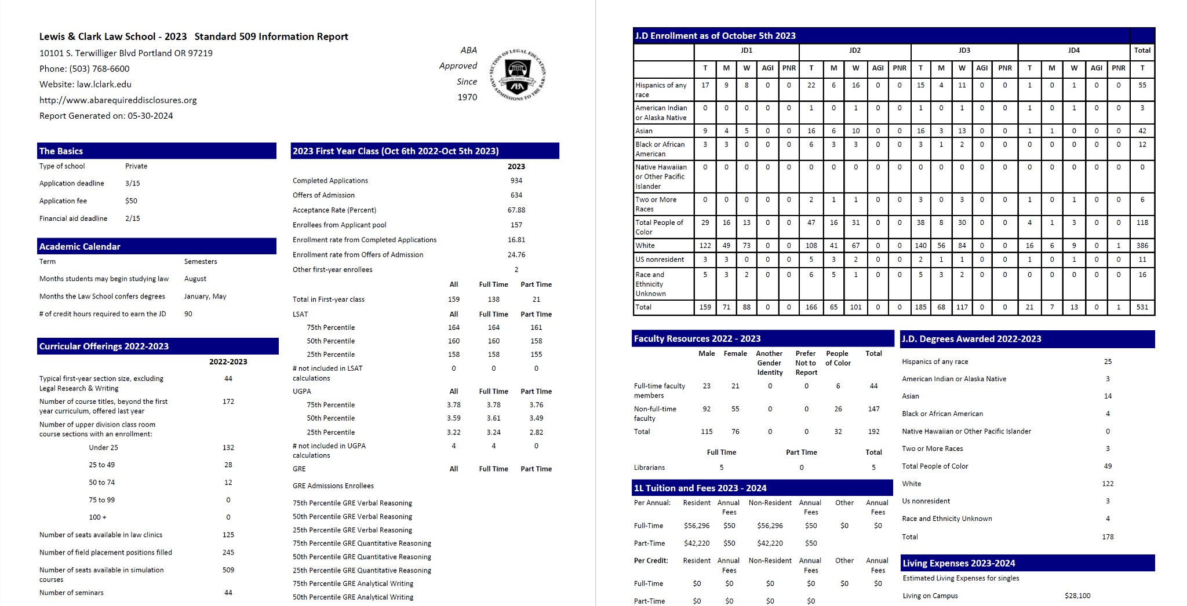

**Figure 1.1. A standard 509 Disclosure report data for the Lewis and Clark Law School, in the year 2023. The report includes demographic information for enrolled students (J.D Enrollment) and faculty (Faculty Resources). The document was cropped to fit into the report.**

## 

# 

# **2. Data Cleaning and Pre-Processing**

## **2.1 Raw Data**

This section describes the raw datasets used for the report and the data cleaning and pre-processing methods.

The data corresponds to the compiled version (See 1.3) of the Disclosure 509 reports between the years 2017 and 2023 obtained from the American Bar Association website. Each year contains a separate dataset for student and faculty demographics and consequently, the total number of datasets in this report is 14.

The summaries of the raw datasets (Table 2.1, Table 2.2) show the number of columns (i.e., variables) is one order of magnitude bigger than the number of columns in the faculty dataset. This difference is due to the student data containing detailed information on ethnicity for first, second, third, and fourth-year students. The number of columns increases consistently between faculty and students datasets from 2017 to 2018, and then again from 2021 to 2022 with the latter attributed to the addition of a column for gender (“Prefers not to respond”).

The number of schools (i.e., the number of unique occurrences of a school name in the dataset) varies consistently from 2017 to 2018, 2019 to 2020, 2021 to 2022, and 2022 to 2023.

***Table 2.1. Faculty data summary. The column denoted “Number of Columns” corresponds to the number of variables in the dataset while the column “Number of schools” contains the number of unique occurrences of a school name in the dataset.***

|  |  |  |
| --- | --- | --- |
| **Year** | **Number of Columns** | **Number of Schools** |
| 2017 | 16 | 202 |
| 2018 | 22 | 203 |
| 2019 | 22 | 203 |
| 2020 | 22 | 197 |
| 2021 | 22 | 197 |
| 2022 | 23 | 198 |
| 2023 | 23 | 196 |

***Table 2.2. Student Data summary. The column denoted “Number of Columns” corresponds to the number of variables in the dataset while the column “Number of schools” contains the number of unique occurrences of a school name in the dataset.***

|  |  |  |
| --- | --- | --- |
| **Year** | **Number of Columns** | **Number of Schools** |
| 2017 | 155 | 202 |
| 2018 | 199 | 203 |
| 2019 | 199 | 203 |
| 2020 | 199 | 197 |
| 2021 | 199 | 197 |
| 2022 | 244 | 198 |
| 2023 | 244 | 196 |

## **2.2 Data Pre-Processing**

The findings in the previous section highlight some of the inconsistencies found in the dataset. Fundamentally, we addressed two challenges to create consistent faculty and student datasets: 1) Selecting a consistent number of schools for the 2017 - 2023 range; 2) Consolidating the number of columns from student and faculty data to compare demographic profiles at the various schools.

For our research, we make various assumptions about the data. First, we assume that the first-year enrollment was correctly reported with minimal errors. Second, we assume that the data only corresponds to new incoming students and does not include students admitted and enrolled in previous years but who failed to complete all the requirements to move to the second year. Thus, we infer that each year’s data (from 2017 to 2023) are independent and have non-overlapping students.

The first challenge was finding a consistent number of schools. To do this we used the archival accreditation data from the American Bar Association (ABA, 2024b). The website lists the dates and institutions that have gained or lost accreditation, changed names, merged with other schools, or separated into two different institutions. We found a total of 11 schools that either gained or lost accreditation between 2017 and 2023 (Table 2.3) and were not consistent for the selected period. We removed these 11 schools from the datasets. Additionally, we found a total of 31 schools that either changed names or were reported inconsistently in the dataset (e.g., In 2017 one school was reported as Southern Illinois University and in 2023 as Southern Illinois University-Carbondale). These schools were not removed, and instead, we modified the names to be consistent across all the data. The total number of schools after preprocessing equals 195. A detailed list of the schools can be found in Appendix A.

The second challenge in the data consisted, as previously described (1.3), of the way student and faculty ethnicities were reported. In short, students were allowed to self-identify using 8 categories while faculty were allowed to self-identify using 2 categories (Person of Color and White). Given that one of the main objectives of the project was to compare the ethnic information of faculty and students, we consolidated the ethnic categories in the student data as one designated “*BIPOC Student”*. A BIPOC student was defined using the definitions in the legal literature as a student who identifies as part of an ethnic group that is not white. By doing this, we created a variable containing all the BIPOC students.

The third challenge was deciding whether to use the entire student population data (first year, second year, third year, and fourth year) or a reduced version (e.g., only first-year, only second-year). Because one of the main goals of the project was to identify the changes in ethnicity and gender, utilizing exclusively first-year students allowed us to track the change more efficiently. In addition, including more senior-year students would require us to consider factors such as transfer rates and attrition. Moreover, not all schools offer part-time programs (fourth-year).

The fourth challenge we tackled was the way gender was reported. From 2022 the data included an option to decline to respond to the question. We chose to exclude participants who declined to answer from the datasets.

To perform a geographic analysis of the trends, we added the location of the various schools (latitude, longitude, and state) using Google Earth GPS coordinates.

***Table 2.3. Law schools that either gained or lost accreditation between 2017 and 2023. Schools that got their accreditations withdrawn in 2023 (University of La Verne College of Law, Florida Coastal School of Law, Thomas Jefferson School of Law) didn’t file a report for that year.***

| **School Name** | **Accreditation Approved** | **Accreditation Withdrawn** |
| --- | --- | --- |
| Arizona Summit (formerly Phoenix) | 2007 | 2020 |
| Charlotte School of Law | 2008 | 2018 |
| Concordia University School of Law | 2015 | 2020 |
| Florida Coastal School of Law | 1999 | 2023 |
| Indiana Tech Law School | 2016 | 2017 |
| University of La Verne College of Law | 2006-2011, 2012 | 2023 |
| Thomas Jefferson School of Law | 1996 | 2023 |
| Jacksonville School of Law | 2023 | - |
| UNT Dallas School of Law | 2017 | - |
| Valparaiso University School of Law | 1929 | 2020 |
| Whittier Law School | 1978 | 2020 |

## **2.3 Final Datasets**

The data cleaning and pre-processing resulted in two final datasets with 1365 columns for 195 ABA-accredited law schools with consistent accreditation from 2017-2023.

The faculty data consists of full-time and part-time faculty who 1) self-identify as BIPOC or white, and 2) self-identify as either male, female, or another gender identity.

A brief description of the variables is shown below:

**School Name**

**Faculty BIPOC** - Total number of faculty (full-time and part-time) who identify as BIPOC

**Faculty White** - Total number of faculty (full-time and part-time) who identify as White.

**Faculty Women** - Total number of faculty (full-time and part-time) who identify as female.

**Faculty Men** - Total number of faculty (full-time and part-time) who identify as male.

**Faculty Another Gender Identity** - Total number of faculty (full-time and part-time) who do not identify either as female or male.

**Faculty Total** - Total number of faculty teaching at the institution as full-time and part-time

**State** - State where the school is located

**Latitude** - In decimal degrees

**Longitude** - In decimal degrees

**Year** - Year of the report

The student data consists of first-year law students who 1) self-identify as BIPOC (Hispanics of any race, American Indian or Alaska Native, Asian, Black or African American, Native Hawaiian or Other Pacific Islander, Two or more races) or white, and 2) self-identify as either male, female or another gender identity.

A brief description of the variables is shown below:

**School Name**

**Student BIPOC** - Consolidated variable that has the total number of first-year students who identify as BIPOC

**Student White** - Total number of first-year students who identify as White

**Student Women** - Total number of first-year students who identify as female

**Student Men** - Total number of first-year students who identify as male

**Student Other** - Total number of first-year students who do not identify as female or male

**Student Total** - Total number of first-year enrolled students (first-year class).

**State** - State where the school is located

**Latitude** - In decimal degrees

**Longitude** - In decimal degrees

**Year** - Year of the report

## **2.4 Time Range Considerations**

In section 1.3, we refer to inconsistencies on datasets prior to 2017. The ABA provides data starting from 2011, but students demographics are reported for the totality of the student body, and do not include the individual information for first, second, third and fourth-year students.

One of the main objectives of the project is to evaluate the change in ethnicity and gender in law schools. We consider first-year law students to give a clearer idea of how cohorts are changing across the years. Including information on returning students (non-first year) results in issues such as double counting transfer students, drop-out students (schools might admit a higher amount of BIPOC students, but because of the socio-eco-cultural factors surrounding BIPOC and gender diverse students, they may be more likely to drop), and retention rates per school. These factors may obfuscate the pattern for new cohorts. This is particularly true considering that the sum of second, third and fourth year students surpasses the number of first-year students. Thus, non-first year students would dominate the trends.

# 3. Exploratory Data Analysis

## **3.1 Student Data**

A summary of the student data is shown in Table 3.1. The highest number of students corresponded to 2021 with a total of 39,691.

***Table 3.1 Summary of student data. Total number of first-year students peaked in 2021. The highest number of BIPOC students was in 2021.***

|  |  |  |
| --- | --- | --- |
| **Year** | **Total First-Year Students** | **Total BIPOC** |
| 2017 | 37,186 | 12,874 |
| 2018 | 36,133 | 12,206 |
| 2019 | 36,235 | 12,070 |
| 2020 | 36,615 | 12,678 |
| 2021 | 39,834 | 13,957 |
| 2022 | 36,691 | 13,620 |
| 2023 | 35,923 | 13,562 |

### 3.1.1 National Trends

The percentage of BIPOC students by year (i.e., the total number of first-year students in all ABA-accredited law schools who identified as BIPOC divided by the total number of first-year students in all ABA-accredited law schools) is shown in Figure 3.1. BIPOC-identified students constitute approximately between 30% and 36% of the total student body. In general, we observe an upward trend from 2017 to 2023 with the minimum value occurring in 2019 (31.94%) and the maximum is found in 2023 (36.23%). The percentual difference between the maximum and the minimum is 4.29%. The slope between the years 2017 to 2019 is relatively flat and the percentage of BIPOC students at a national level remains essentially the same.

Figure 3.2 shows the gender profile of students.Women constitute the majority of first-year law students with values between 51-56%. Similarly to ethnicity, we observe an upward trend from 2017 to 2023 in the percentage of students who identify as women. The minimum value of women students corresponds to 2017 (51.67%), and the maximum value to 2021 (56.3%) with a difference of 4.63%.

Students who identify as AGI (another gender identity) constitute a small percentage of the students, with a maximum value of 0.49% in 2023. The minimum value occurred in 2017 (0.04%) and corresponds to approximately 15 students. A comparison of the average percentage of male-identified students and female-identified students is shown in Figure 3.3.

#### 

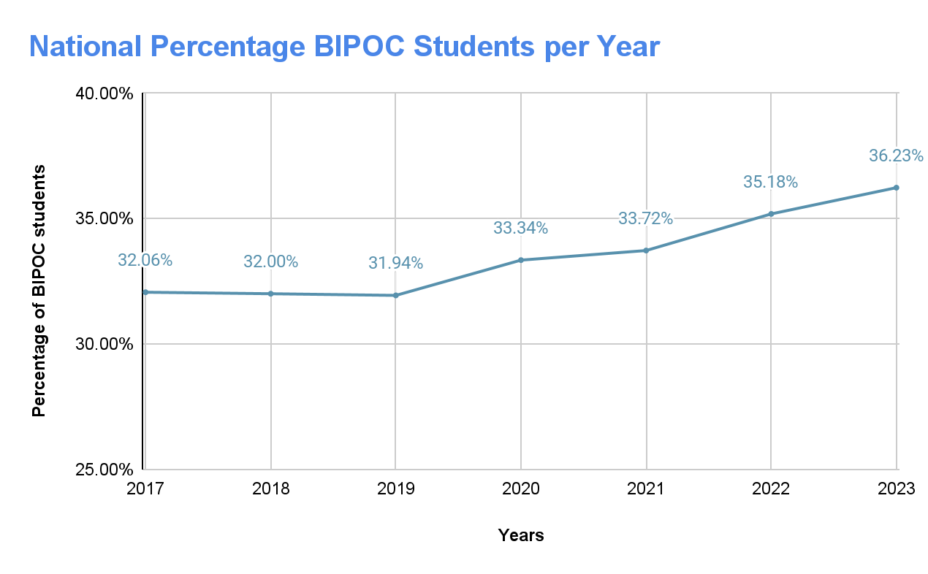**Figure 3.1. National percentage of BIPOC-identified students. The minimum value corresponds to the year 2019, while the maximum value is found in 2023. The slope between 2017 and 2019 is relatively flat.**

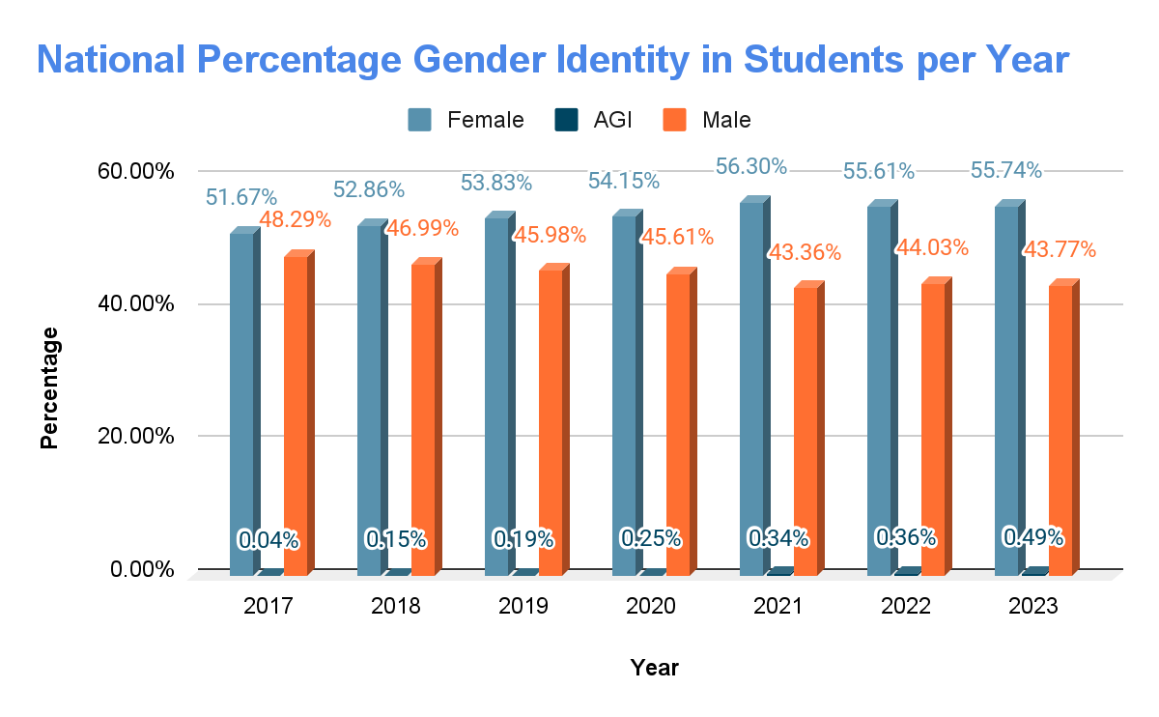**Figure 3.2. National percentage of students grouped by gender identity. Women consistently constitute the majority of first-year enrolled students.**

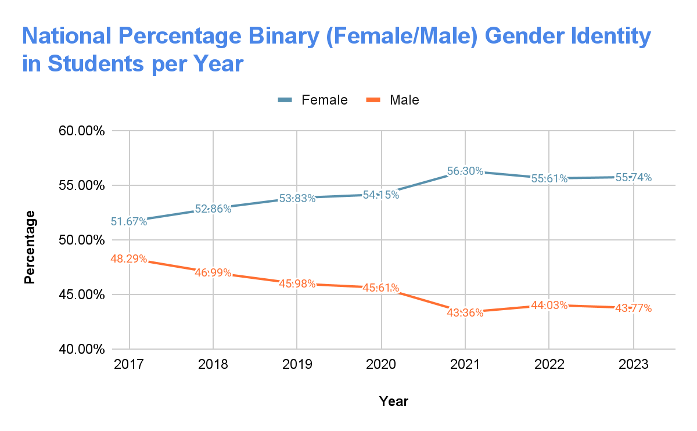

**Figure 3.3. National percentage of first-year students identified as binary gender identities (female or male).**

### 3.1.2 Trends by State

The national percentage of BIPOC students by state in the years 2017 and 2023 is shown in Figure 3.4. Maps for missing years (2018, 2019, 2020, 2021, 2022) can be found in Appendix B. For both 2017 and 2023, New Mexico and Hawaii are the states with the highest percentage of BIPOC students. In 2017, New Mexico had an average of 51.81% of BIPOC students. This number increased to 60.2% by 2023. Similarly, Hawaii had an average of 67.27% of BIPOC students, increasing to 70.32% by 2023. By 2023, only 5 states (Colorado, Iowa, Michigan, Mississippi, and New Jersey ) decreased the average percentage of BIPOC students compared to 2017.

In addition to New Mexico and Hawaii, California, Nevada, Texas, and Florida show consistent values in the upper 85th percentile for BIPOC students (over 40.53% for 2017, and 43% for 2023). For 2023, Maryland, and Connecticut, increased the percentage of BIPOC students from 33.48% and 29.1% in 2017 to 40% and 41.5%, respectively.

The average percentage of female students in 2017 and 2023 by state is shown in Figure 3.5. Maps for missing years (2018, 2019, 2020, 2021, 2022) can be found in Appendix C. In 2017, only 20 states had less than 50% of the student body composed of women. By 2023, women constituted the majority of first-year law school enrolled students, with the exceptions of 7 states: North Dakota, South Dakota, Nebraska, Kansas, West Virginia, Utah, and New Hampshire. Two states are worth highlighting: The first is Arkansas, which increased the percentage of women from 45.9% in 2017 to 61.3% in 2023, and the second is North Dakota which ranked at the bottom in 2017 with 34.92% and borders 50% in 2023. The number of students who identify outside the female/male binary is not included in the maps as some states do not have students with that corresponding gender category.

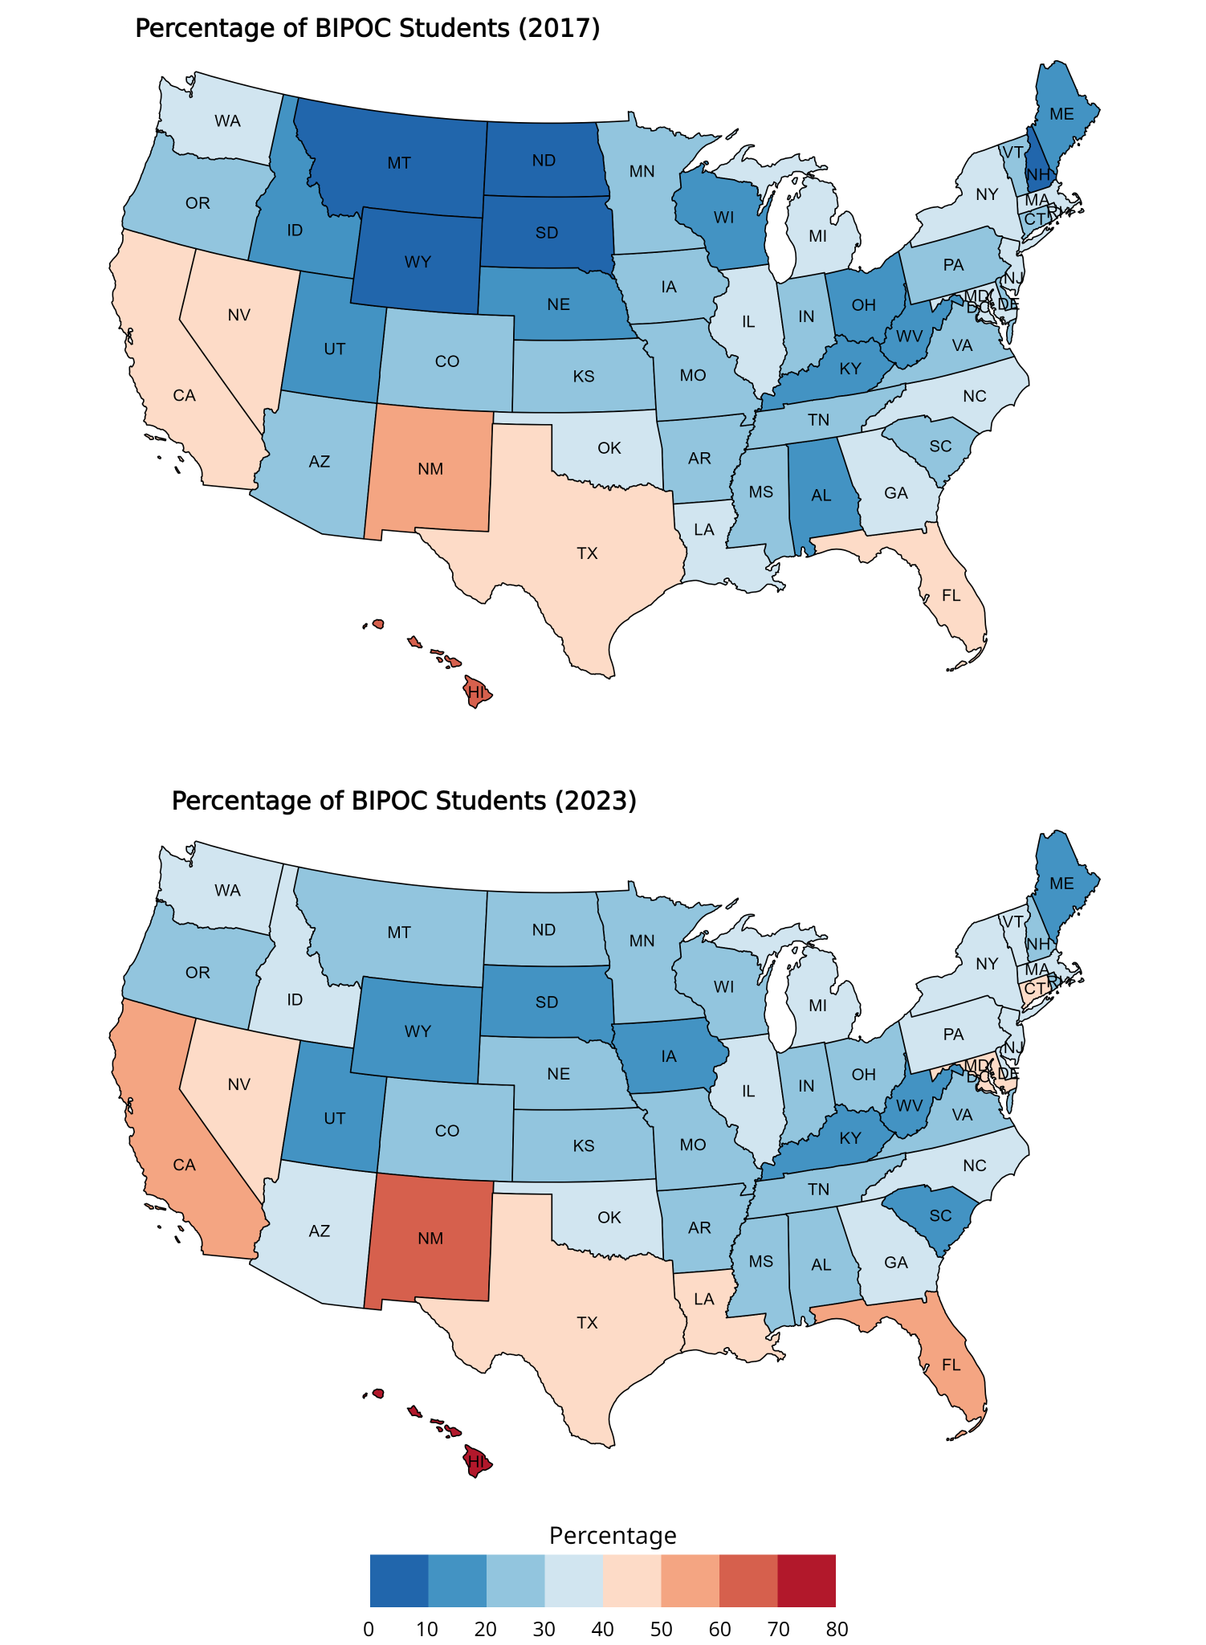

**Figure 3.4. Percentage of BIPOC students by state in 2017 and 2023. By 2023, only 5 states (Colorado, Iowa, Michigan, Mississippi, and New Jersey ) decreased the average percentage of BIPOC students compared to 2017. Some changes in the map are not visible due to binning.**

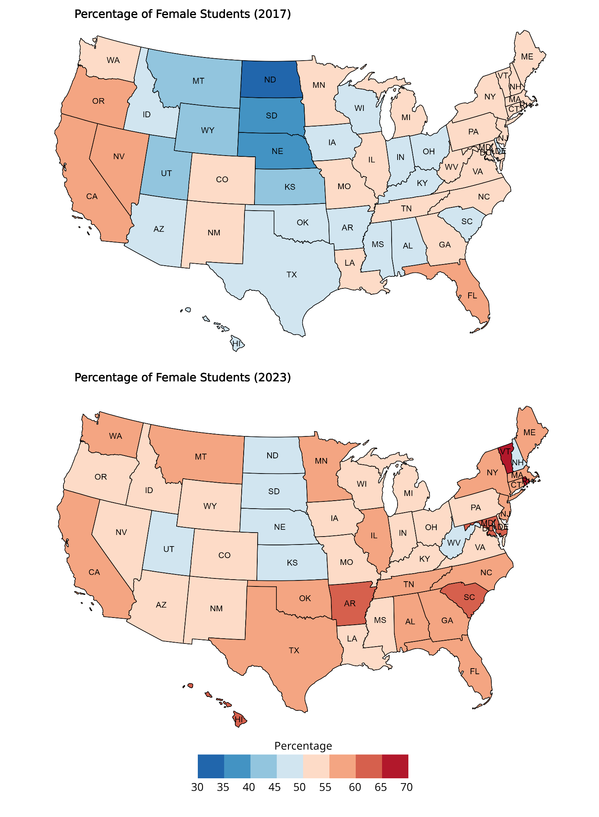

**Figure 3.5. Percentage of female students by state in 2017 and 2023. By 2023, only 5 states (Colorado, Iowa, Michigan, Mississippi, and New Jersey ) decreased the average percentage of BIPOC students compared to 2017. Some changes in the map are not visible due to binning.**

## **3.2 Faculty Data**

A summary of the faculty data is shown in Table 3.2. The highest number of students corresponded to 2021 with a total of 39,691.

***Table 3.2 Summary of student data. The highest number of BIPOC faculty occurred in 2023.***

|  |  |  |
| --- | --- | --- |
| **Year** | **Total Faculty** | **Total BIPOC** |
| 2017 | 26,739 | 4,050 |
| 2018 | 25,605 | 4,016 |
| 2019 | 25,718 | 4,270 |
| 2020 | 25,492 | 4,380 |
| 2021 | 24,822 | 4,731 |
| 2022 | 26,372 | 5,158 |
| 2023 | 27,711 | 5,832 |

### 3.2.1 National Trends

The percentage of BIPOC-identified faculty is consistently less than one-quarter for the entire faculty body from 2017 to 2023 (Figure 3.6). However, the percentage of BIPOC faculty has been increasing consistently from a minimum of 16.33% in 2017, to 21.51% in 2023. Although these values are at least 10% under the minimum percentage of BIPOC students in 2017 (32.06%), the difference between the maximum and minimum percentage of BIPOC faculty is greater (5.18%) than BIPOC students.

The gender breakdown of faculty (Figure 3.7) shows that men are the dominant group for every year. In 2017, 61.01% of faculty identified as male, but by 2023 this percentage decreased to 56.14%. Conversely, women increased their participation as faculty from 38.89% to 43.82%, representing an approximately 5% increase. Faculty who identify outside the binary gender identities is below 0.3%. A comparison of the average percentage of male-identified and female-identified faculty is shown in Figure 3.8.

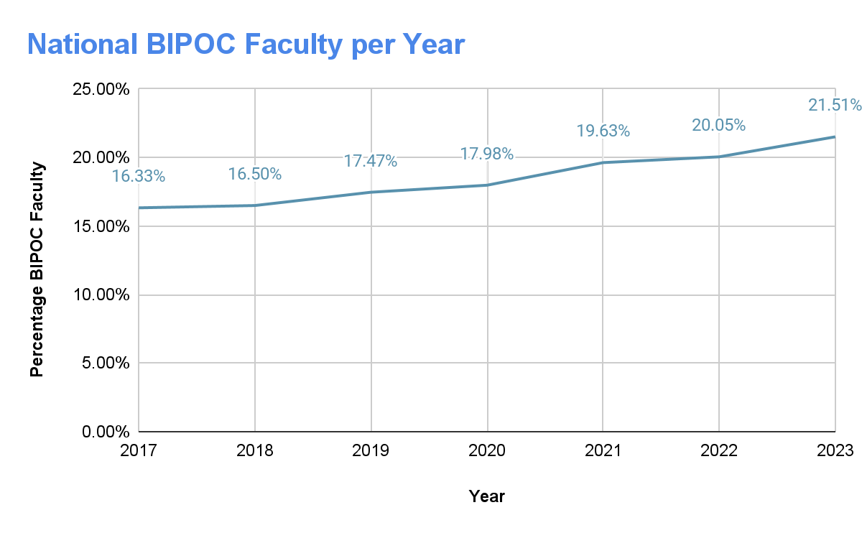

**Figure 3.6. Average percentage of BIPOC-identified faculty. The minimum value corresponds to the year 2017, while the maximum value is found in 2023.**

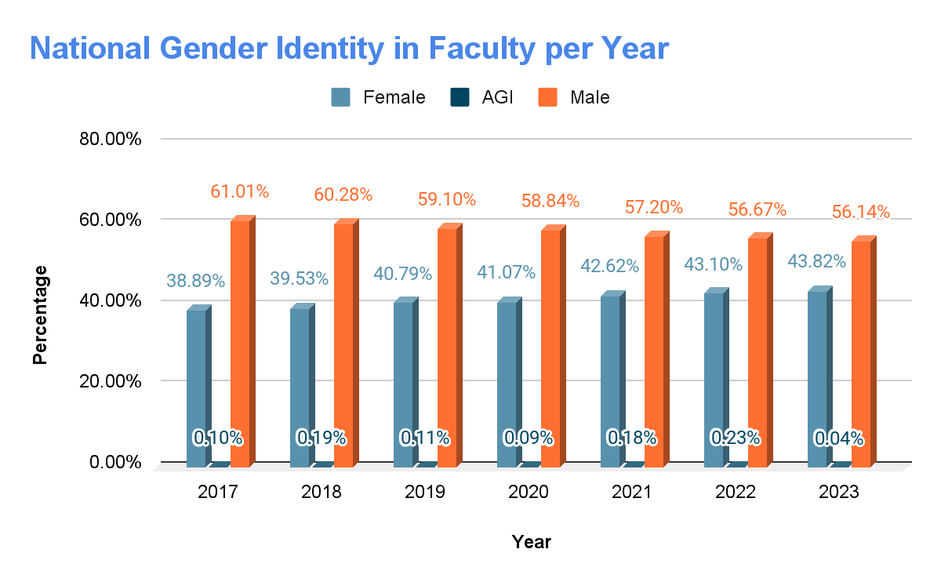

**Figure 3.7. Gender identity in faculty percentage.**

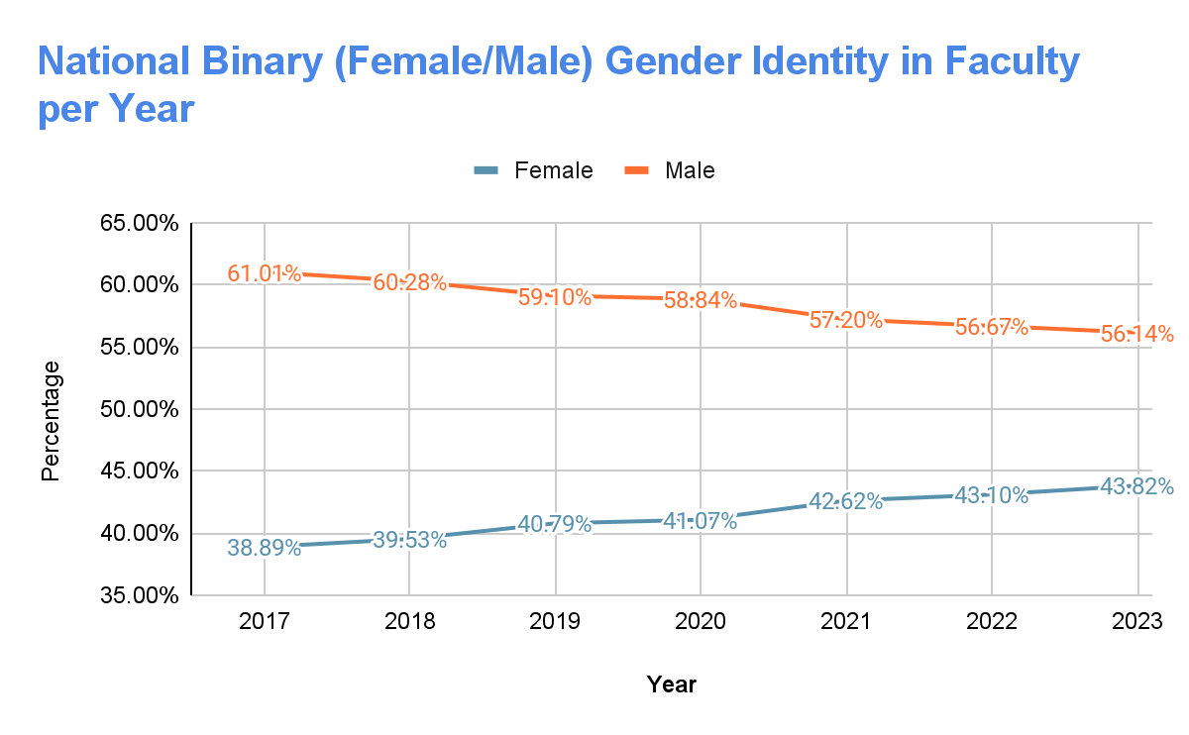

**Figure 3.8. Percentage of faculty identified as binary gender identities (female or male) by year. Minimum values for women occur in 2017, while maximum values occur in 2023.**

### 3.2.2 Trends by State

The percentage of BIPOC faculty by state in 2017 and 2023 is shown in Figure 3.9. For 2017 and 2023, Hawaii is the state with the highest percentage of BIPOC faculty with 43.9% and 48.1% respectively, followed by New Mexico with 33.7% of BIPOC faculty in 2017 and 39.6% in 2023. Similar to the results found at a national level, there’s an increasing percentage of BIPOC faculty teaching at law schools. One big exception is the State of Idaho which decreased the percentage from 12.5% in 2017, to 0% in 2023. The State of Louisiana, as well as Florida, have BIPOC faculty averages at the upper 10% percentile (values greater than 19.8% for 2017, and 26.9% for 2023).

The average percentage of female faculty in 2017 and 2023 by state is shown in Figure 11. Similar to the results found in the student data, the percentage of female faculty in law schools has increased from 2017 to 2023, on average. In 2017, South Dakota and Nebraska were the states with the lowest percentage of women as faculty members. North Dakota, however, follows a behavior contrary to the general trend as the female faculty percentage decreased from 52.9% in 2017, to 41.2% in 2023.

The number of faculty who identify outside the female/male binary is not included in the map plots, as some states do not have students with that corresponding gender category.

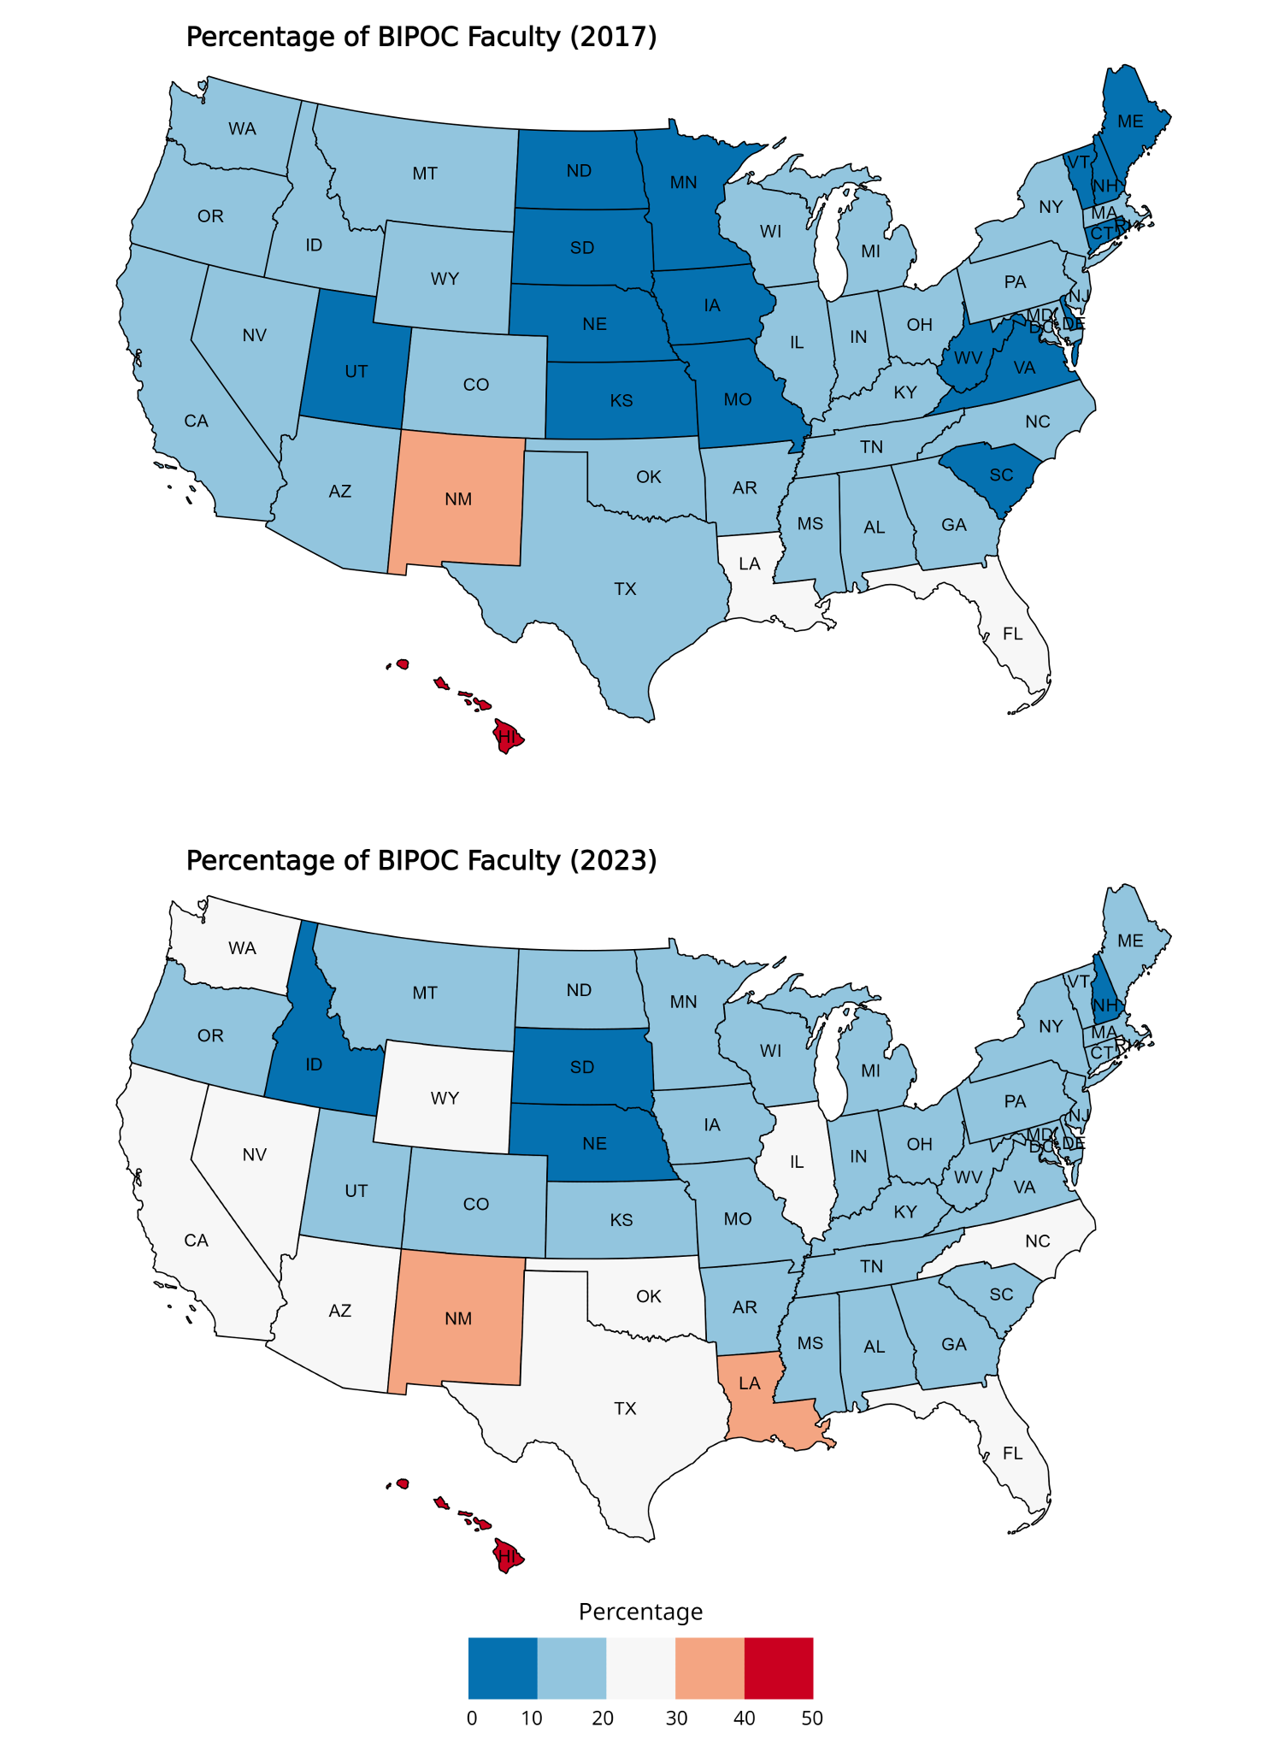

**Figure 3.9. Percentage of BIPOC students by state in 2017 and 2023.**

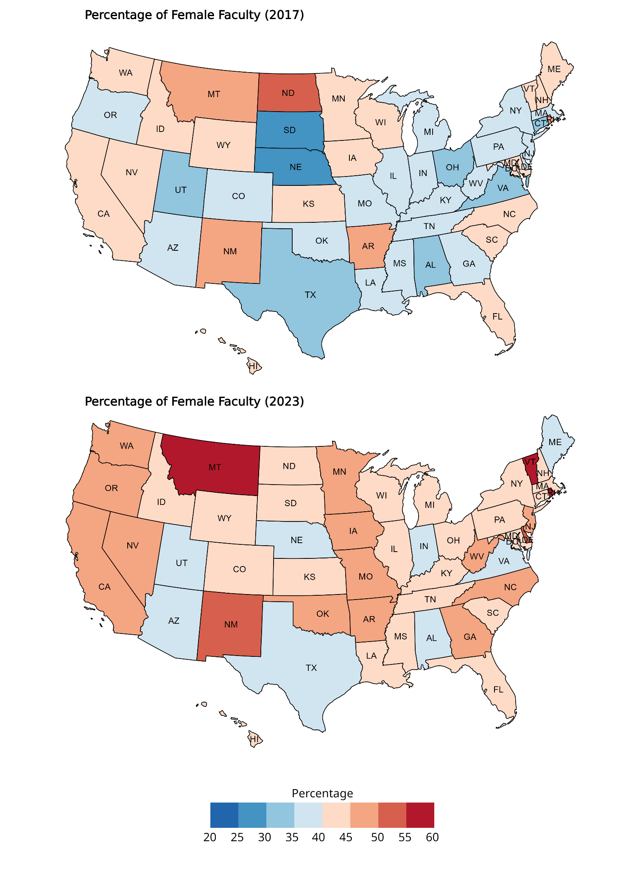

**Figure 3.10. Percentage of female faculty by state in 2017 and 2023.**

# 4. Methodology

## **4.1 Change in ethnicity and gender**

Our first objective was to examine the overall change in gender and ethnicity and identify which schools increased or decreased regarding ethnicity and gender. We achieved this by comparing the proportions for both gender and ethnicity with the overall distribution across the 195 ABA-accredited schools. We used proportions instead of the number of enrolled students to prevent larger schools (e.g., schools with higher enrollment numbers and faculty members) from dominating the trends. We then selected five schools from each category that had the largest increase and decrease in those proportions between 2017 and 2023.

## **4.2 Faculty and Student Profiles**

Our second objective was to compare faculty profiles and student profiles. We achieved this by calculating the statistical distance between our two populations using the Kullback–Leibler divergence technique (see Appendix F for more information). KL divergence is a non-symmetric metric that measures the relative difference in information represented by two distributions. It can be thought of as measuring the distance between two data distributions, showing how different the two distributions are from each other. It should be noted that during this process we filtered out Puerto Rico, since such colleges can cause misleading results (see section 7).

The resulting distances were then used to rank the top 10 schools with the highest KL divergence and the bottom 10 schools with the lowest KL divergence to help identify which schools have faculty and student profiles that match closely, or differ for both ethnicity and gender proportions. The results for the KL-divergence differ significantly if the AGI variable is included in the gender analysis for the KL-divergence distances, however the population of student/faculty AGI is 0 for both student and faculty for most schools. So, for the KL divergence calculations gender was treated as a binary variable. However, the results of the KL divergence calculations including the AGI gender category are shown in Appendix I. In addition, we analyze the correlation between the proportion of faculty BIPOC with the proportion of student BIPOC and include confidence intervals at the 95% significance level. By including confidence intervals, we are able to conclude whether or not the relationship between faculty and student gender and ethnicity is statistically significant.

# 

# 5. Results

## **5.1 Change in ethnicity and gender from 2017 to 2023**

Table 5.1 contains the schools that experienced the largest increase and decrease in BIPOC students. Stanford University, in California ranks first in the change of its student body with a 21.08% increase in the proportion of BIPOC students between the years 2017 and 2023. Conversely, Cooley Law School, in Michigan decreased from having almost half of its first-year students identifying as BIPOC in 2017, to 33.85% in 2023. In general, the starting percentage of BIPOC students varied greatly between the schools with the largest increase, with Drexel starting at 16.9% and Stanford starting at 38.01%.. While the schools with the largest decrease also vary between each other, they have a higher average starting percentage of BIPOC students than the schools with the largest increase.

***Table 5.1: Law schools with the largest increase/decrease in BIPOC students***

|  |  |  |  |  |
| --- | --- | --- | --- | --- |
| **School** | **State** | **% BIPOC (2017)** | **% BIPOC (2023)** | **Total Change** |
| Stanford | California | 38.01 | 59.09 | 21.08 |
| Penn State - Dickinson Law | Pennsylvania | 21.21 | 41.49 | 20.28 |
| Drexel University | Pennsylvania | 16.9 | 36.69 | 19.79 |
| Washington And Lee University | Virginia | 23.2 | 42.39 | 19.19 |
| Emory University | Georgia | 29.41 | 48.29 | 18.88 |

|  |  |  |  |  |
| --- | --- | --- | --- | --- |
| **School** | **State** | **% BIPOC (2017)** | **% BIPOC (2023)** | **Total Change** |
| Cooley Law School | Michigan | 50.97 | 33.85 | -17.12 |
| Regent University | Virginia | 32.65 | 16.67 | -15.99 |
| Charleston School of Law | South Carolina | 27.19 | 13.55 | -13.64 |
| Atlanta's John Marshall Law School | Georgia | 68.31 | 56.41 | -11.9 |
| University of Mississippi | Mississippi | 33.33 | 24.1 | -9.24 |

***Table 5.2: Law schools with the largest increase/decrease in BIPOC Faculty***

|  |  |  |  |  |
| --- | --- | --- | --- | --- |
| **School** | **State** | **% BIPOC (2017)** | **% BIPOC (2023)** | **Total Change** |
| George Washington University | D.C. | 12.14 | 36.87 | 24.73 |
| Penn State - Dickinson Law | Pennsylvania | 13.04 | 33.33 | 20.29 |
| Gonzaga University | Washington | 6.84 | 26.32 | 19.48 |
| University of Tulsa | Oklahoma | 9.8 | 26.56 | 16.76 |
| University of Illinois Chicago School Of Law | Illinois | 12.85 | 28.72 | 15.87 |

|  |  |  |  |  |
| --- | --- | --- | --- | --- |
| **School** | **State** | **% BIPOC (2017)** | **% BIPOC (2023)** | **Total Change** |
| University of Idaho | Idaho | 12.5 | 0 | -12.5 |
| Texas Tech University | Texas | 16.67 | 11.76 | -4.9 |
| Western State College Of Law | California | 28.85 | 24.53 | -4.32 |
| Florida International University | Florida | 45.45 | 41.75 | -3.71 |
| Howard University | D.C. | 81.58 | 78.18 | -3.4 |

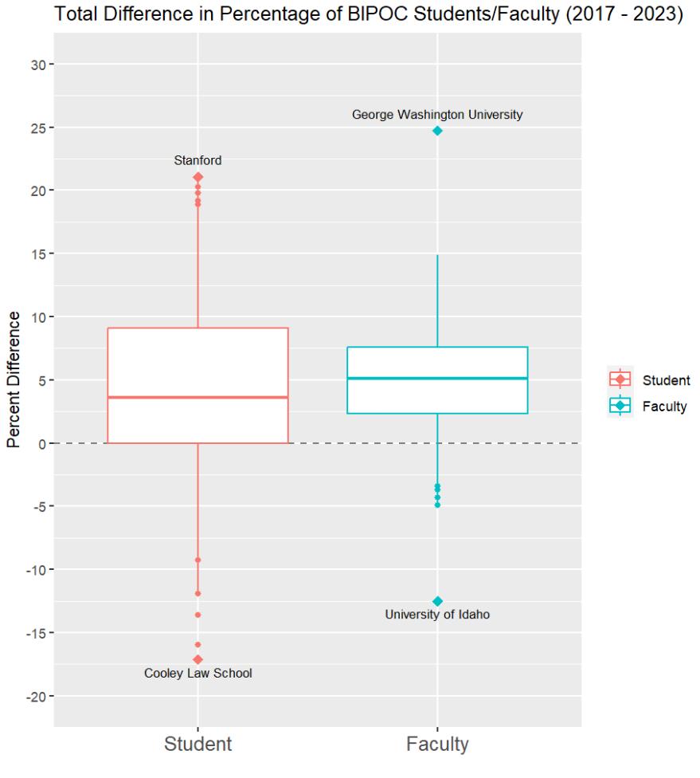

**Figure 5.1. Total difference in percentage of BIPOC Students and Faculty from 2017 - 2023**

**Student Mean: 4.17%**

**Student Median: 3.61%**

**Faculty Mean: 5.18%**

**Faculty Median: 5.13%**

Figure 5.1 shows the total change in the percentage of BIPOC Students and Faculty from 2017 - 2023, across all schools. The schools with the highest and lowest change are labeled with a diamond and the school’s name, and the next four highest and lowest schools are represented by the other points along the boxplots. The plots show us that from 2017 to 2023, there was an overall increase in the percentage of BIPOC students and faculty. While the mean and median change are both higher for faculty, the interquartile range was smaller for faculty than it was for students. Half of schools had a change between 0% and 9% for students, and between 2.3% and 7.6% for faculty. In total, 143 out of the 195 schools (73.33%) had an increase in the proportion of BIPOC students in their first-year classes from 2017 - 2023, and 172 schools (88.2%) had an increase in the proportion of BIPOC faculty over the same period.

***Table 5.3: Law schools with the largest increase/decrease in male students:***

|  |  |  |  |  |
| --- | --- | --- | --- | --- |
| **School** | **State** | **% Men (2017)** | **% Men (2023)** | **Total Change** |
| Ave Maria School Of Law | Florida | 36.26 | 56.82 | 20.55 |
| George Mason University | Virginia | 49.1 | 65.85 | 16.75 |
| Howard University | D.C. | 30.22 | 44.75 | 14.54 |
| Liberty University | Virginia | 47.89 | 60.58 | 12.69 |
| Catholic University Of America | D.C. | 39.36 | 50.91 | 11.55 |

|  |  |  |  |  |
| --- | --- | --- | --- | --- |
| **School** | **State** | **% Men (2017)** | **% Men (2023)** | **Total Change** |
| Detroit Mercy, University Of | Michigan | 54.24 | 30.61 | -23.63 |
| Charleston School Of Law | South Carolina | 49.06 | 26.17 | -22.89 |
| Drexel University | Pennsylvania | 54.93 | 33.09 | -21.84 |
| Hawaii, University Of | Hawaii | 54.55 | 35.16 | -19.38 |
| Vermont Law School | Vermont | 48.95 | 31.05 | -17.9 |

***Table 5.4: Law schools with the largest increase/decrease in male faculty***

|  |  |  |  |  |
| --- | --- | --- | --- | --- |
| **School** | **State** | **% Men (2017)** | **% Men (2023)** | **Total Change** |
| North Dakota, University Of | North Dakota | 47.06 | 58.82 | 11.76 |
| University Of Massachusetts Dartmouth | Massachusetts | 58.54 | 69.49 | 10.95 |
| Faulkner University | Alabama | 60.78 | 70.59 | 9.8 |
| Notre Dame, University Of | Indiana | 65.36 | 74.63 | 9.27 |
| Loyola University-New Orleans | Louisiana | 55.68 | 64.21 | 8.53 |

|  |  |  |  |  |
| --- | --- | --- | --- | --- |
| **School** | **State** | **% Men (2017)** | **% Men (2023)** | **Total Change** |
| Lincoln Memorial | D.C. | 66.67 | 43.75 | -22.92 |
| Elon University | North Carolina | 60 | 37.5 | -22.5 |
| Louisiana State University | Louisiana | 79.07 | 57.28 | -21.79 |
| Vermont Law School | Vermont | 57.05 | 40.12 | -16.93 |
| Dayton, University Of | Ohio | 61.76 | 45.1 | -16.67 |

***Table 5.5: Law schools with the largest increase/decrease in female students***

|  |  |  |  |  |
| --- | --- | --- | --- | --- |
| **School** | **State** | **% Women (2017)** | **% Women (2023)** | **Total Change** |
| Detroit Mercy, University Of | Michigan | 45.76 | 69.39 | 23.63 |
| Charleston School Of Law | South Carolina | 50.94 | 73.83 | 22.89 |
| Drexel University | Pennsylvania | 43.66 | 66.19 | 22.53 |
| Hawaii, University Of | Hawaii | 45.45 | 64.84 | 19.38 |
| Oklahoma, University Of | Oklahoma | 45.45 | 62.58 | 17.12 |

|  |  |  |  |  |
| --- | --- | --- | --- | --- |
| **School** | **State** | **% Women (2017)** | **% Women (2023)** | **Total Change** |
| Ave Maria School Of Law | Florida | 63.74 | 43.18 | -20.55 |
| George Mason University | Virginia | 50.9 | 34.15 | -16.75 |
| Howard University | D.C. | 69.78 | 54.7 | -15.09 |
| California-Irvine, University Of | California | 62.32 | 47.86 | -14.46 |
| Oregon, University Of | Oregon | 54.48 | 41.06 | -13.42 |

***Table 5.6: Law schools with the largest increase/decrease in female faculty***

|  |  |  |  |  |
| --- | --- | --- | --- | --- |
| **School** | **State** | **% Women (2017)** | **% Women (2023)** | **Total Change** |
| Lincoln Memorial | D.C. | 33.33 | 56.25 | 22.92 |
| Elon University | North Carolina | 40 | 62.5 | 22.5 |
| Louisiana State University | Louisiana | 20.93 | 42.72 | 21.79 |
| Dayton, University Of | Ohio | 38.24 | 54.9 | 16.67 |
| Mississippi College | Mississippi | 36.36 | 52.17 | 15.81 |

|  |  |  |  |  |
| --- | --- | --- | --- | --- |
| **School** | **State** | **% Women (2017)** | **% Women (2023)** | **Total Change** |
| North Dakota, University Of | North Dakota | 52.94 | 41.18 | -11.76 |
| University Of Massachusetts Dartmouth | Massachusetts | 41.46 | 30.51 | -10.95 |
| Notre Dame, University Of | Indiana | 34.64 | 24.63 | -10.01 |
| Faulkner University | Alabama | 39.22 | 29.41 | -9.8 |
| Loyola University-New Orleans | Louisiana | 44.32 | 35.79 | -8.53 |

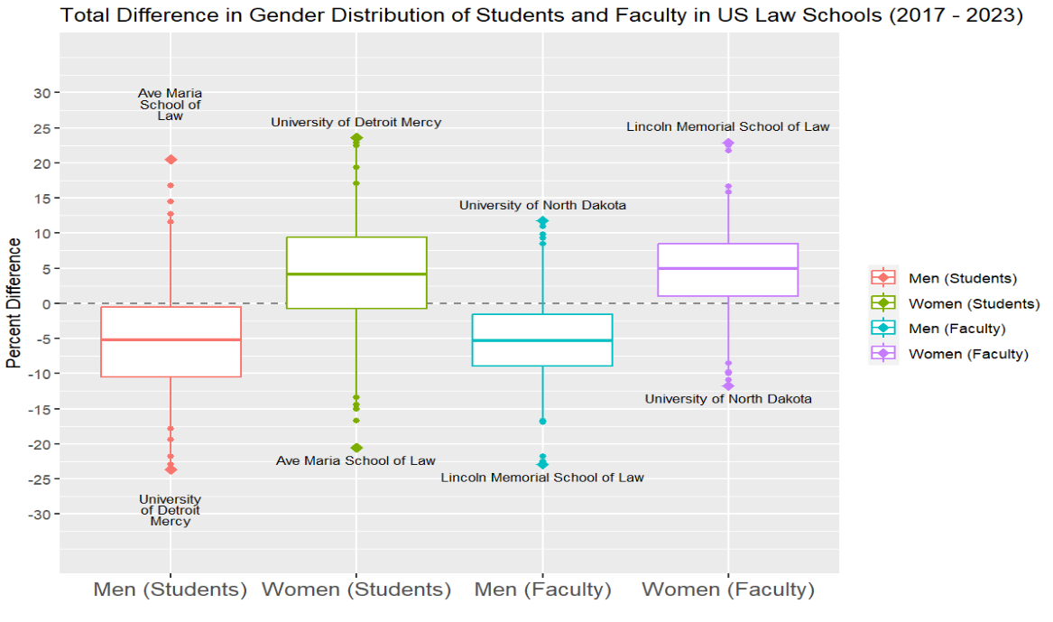

**Figure 5.2. Total change in percentage of men and women among students and faculty, from 2017 - 2023. AGI is not included in this plot because it is on a much smaller scale and has a negligible effect on the other gender proportions.**

**Student Mean (Men): -5.16%**

**Student Median (Men): -5.15%**

**Student Mean (Women): 4.07%**

**Student Median (Women): 4.11%**

**Faculty Mean (Men): -5.17%**

**Faculty Median (Men): -5.30%**

**Faculty Mean (Women): 4.93%**

**Faculty Median (Women): 4.92%**

Figure 5.2 shows an overall increase in the proportions of women first-year students and faculty from 2017 - 2023. Half of all schools had a change between a -0.6% and 9.4% for women first-year students, and between 1% and 8.4% for women faculty. In total, 142 out of 195 schools (72.82%) had an increase in the proportion of women students, and 163 schools (83.59%) had an increase in women faculty. The difference in men is almost inversely proportional to the difference in women.

***Table 5.7: Law schools with the largest increase/decrease in AGI students***

|  |  |  |  |  |
| --- | --- | --- | --- | --- |
| **School** | **State** | **% AGI (2017)** | **% AGI (2023)** | **Total Change** |
| City University Of New York | New York | 0 | 7.01 | 7.01 |
| Nova Southeastern University | Florida | 0 | 6.97 | 6.97 |
| North Carolina Central University | North Carolina | 0 | 5.51 | 5.51 |
| California-Berkeley, University Of | California | 0 | 3.62 | 3.62 |
| Pennsylvania State - Dickinson Law | Pennsylvania | 0 | 3.19 | 3.19 |

|  |  |  |  |  |
| --- | --- | --- | --- | --- |
| **School** | **State** | **% AGI (2017)** | **% AGI (2023)** | **Total Change** |
| University Of Illinois Chicago School Of Law | Illinois | 1.85 | 0 | -1.85 |
| Drexel University | Pennsylvania | 1.41 | 0 | -1.41 |
| Pittsburgh, University Of | Pennsylvania | 0.79 | 0 | -0.79 |
| Louisville, University Of | Kentucky | 0.69 | 0 | -0.69 |
| Inter American University Of Puerto Rico | Puerto Rico | 0.67 | 0 | -0.67 |

***Table 5.8: Law schools with the largest increase/decrease in AGI faculty***

|  |  |  |  |  |
| --- | --- | --- | --- | --- |
| **School** | **State** | **% AGI (2017)** | **% AGI (2023)** | **Total Change** |
| Kentucky, University Of | Kentucky | 0 | 1.35 | 1.35 |
| St. John's University | New York | 0 | 1.19 | 1.19 |
| California-Irvine, University Of | California | 0 | 0.75 | 0.75 |
| North Carolina, University Of | North Carolina | 0 | 0.6 | 0.6 |
| Seton Hall University | New Jersey | 0 | 0.6 | 0.6 |

|  |  |  |  |  |
| --- | --- | --- | --- | --- |
| **School** | **State** | **% AGI (2017)** | **% AGI (2023)** | **Total Change** |
| Santa Clara University | California | 8.33 | 0 | -8.33 |
| Emory University | Georgia | 6.31 | 0 | -6.31 |
| Cornell University | New York | 1.32 | 0 | -1.32 |
| Northeastern University School Of Law | Massachusetts | 1.01 | 0 | -1.01 |
| Puerto Rico, University Of | Puerto Rico | 0.76 | 0 | -0.76 |

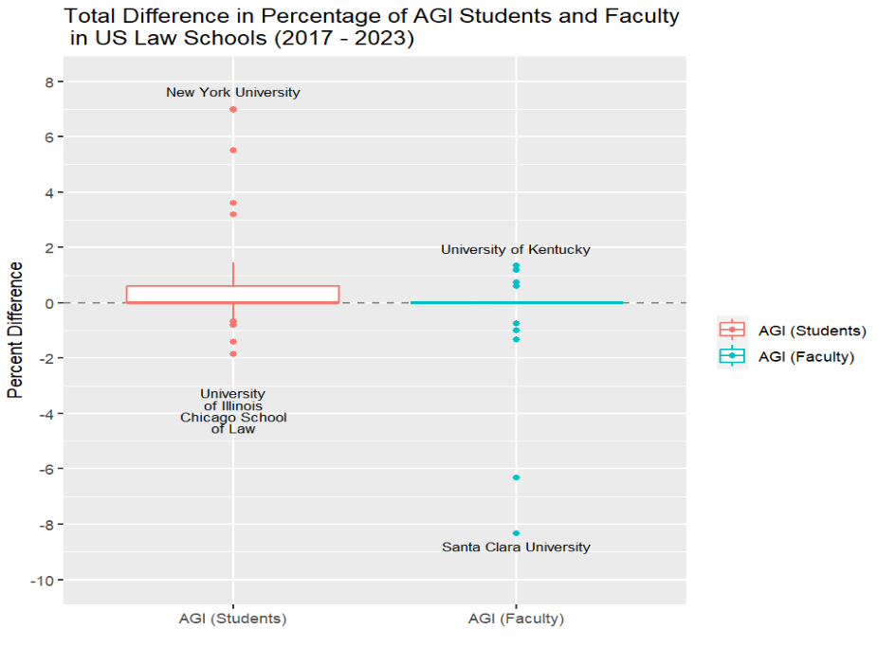

**Figure 5.3. Total change in percentage of AGI students and faculty, from 2017 - 2023.**

**Student Mean (AGI): 0.455%**

**Student Median (AGI): 0%**

**Faculty Mean (AGI): -0.059%**

**Faculty Median (AGI): 0%**

From Figure 5.3, we can see that the change in percentage of AGI students and faculty is on a much smaller scale than the other categories. Only 58 out of 195 schools (29.74%) had an increase in AGI students and only 12 out of 195 schools (6.15%) had an increase in AGI faculty.

## 

## **5.2 Faculty and Student Profiles**

For this section, we share the results for the comparison between student and faculty ethnicity and gender profiles.

### 5.2.1 Student-Faculty Ethnicity Profiles

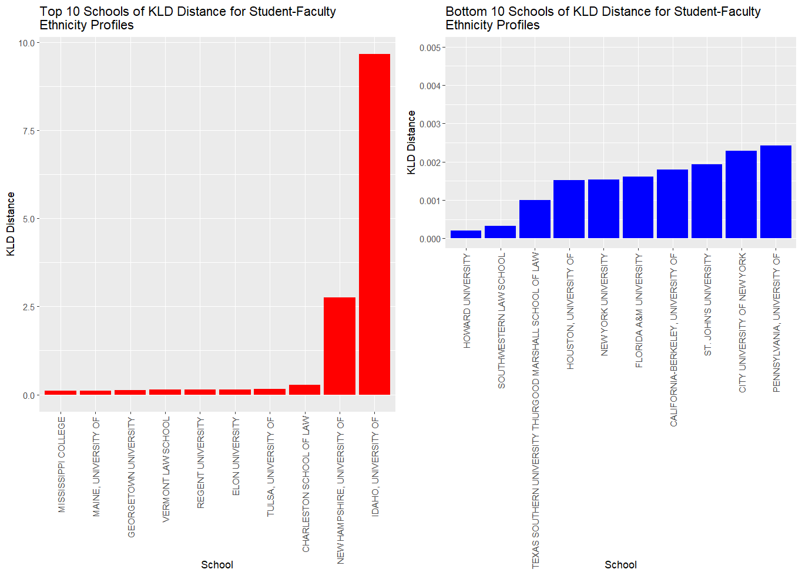

**Figure 5.4. The top and bottom 10 US Law schools for the calculated Kullback–Leibler divergence distance between the distribution of student and faculty BIPOC in those schools between 2017-2023.**

The results of the calculated Kullback–Leibler divergence (KLD) for the comparison of student-faculty ethnicity profiles shown in Figure 5.4 show that the University of Idaho and University of New Hampshire have the biggest differences between the distribution of their student and faculty BIPOC populations. The University of Idaho had a KLD distance of about 9.66, while the University of New Hampshire had a KLD distance of about 2.75. These two schools have considerably larger KLD distances than the rest of the schools, as the school with the third largest KLD distance (Charleston School of Law) had a distance calculated to be about 0.28. Howard University and Southwestern Law School have the two smallest KLD distances, with values of about 0.00020 and 0.00032 suggesting they have the smallest difference in their distributions of student and faculty BIPOC populations. It should be noted that the University of Idaho had 0% faculty BIPOC populations from 2021-2023 and the University of New Hampshire had the same for 2021 contributing to their large KLD distance measure. The average Kullback–Leibler divergence distance by state was also calculated and is shown in Appendix Gfor reference if needed**.**

***Table 5.3: Correlation coefficient and 95% confidence intervals for the correlation between the proportion of BIPOC faculty with the proportion of BIPOC students***

|  |  |  |  |
| --- | --- | --- | --- |
| **Year** | **Estimate** | **Confidence Interval Lower Bound** | **Confidence Interval Upper Bound** |
| 2017 | 0.820914 | 0.769119 | 0.861997 |
| 2018 | 0.827420 | 0.777276 | 0.867119 |
| 2019 | 0.832926 | 0.784193 | 0.871447 |
| 2020 | 0.824674 | 0.773831 | 0.864958 |
| 2021 | 0.833236 | 0.784582 | 0.871691 |
| 2022 | 0.811169 | 0.756931 | 0.854308 |
| 2023 | 0.797165 | 0.739484 | 0.843227 |
| Total | 0.822309 | 0.804344 | 0.838771 |

The correlation between the proportion of BIPOC faculty and the proportion of BIPOC students for each year is shown in Table 5.3. The estimated correlation for each year is around 0.8 with 95% confidence intervals sufficiently narrow enough to indicate a consistent positive correlation between the proportion of BIPOC faculty and the proportion of BIPOC students in US law schools from 2017-2023. The total correlation for the entire data set including all of the years is estimated to be about 0.8223 (95% confidence intervals are provided in Table 5.3), which suggests a strong positive correlation between the proportion of BIPOC faculty and the proportion of BIPOC students in US law schools. This can be seen visually in Figure 5.5, where the plot shows an increasing trend with respect to the proportions, which would align with the correlation estimate of around 0.8223 between the proportion of BIPOC faculty and the proportion of BIPOC students in US law schools.

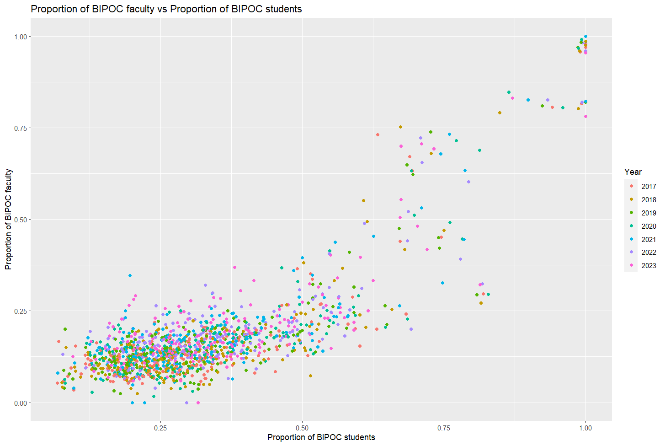

**Figure 5.5. Scatter plot of the proportion of BIPOC faculty plotted against the proportion of BIPOC students for each US Law school for the years 2017-2023.**

### 5.2.2 Student-Faculty Gender Profiles

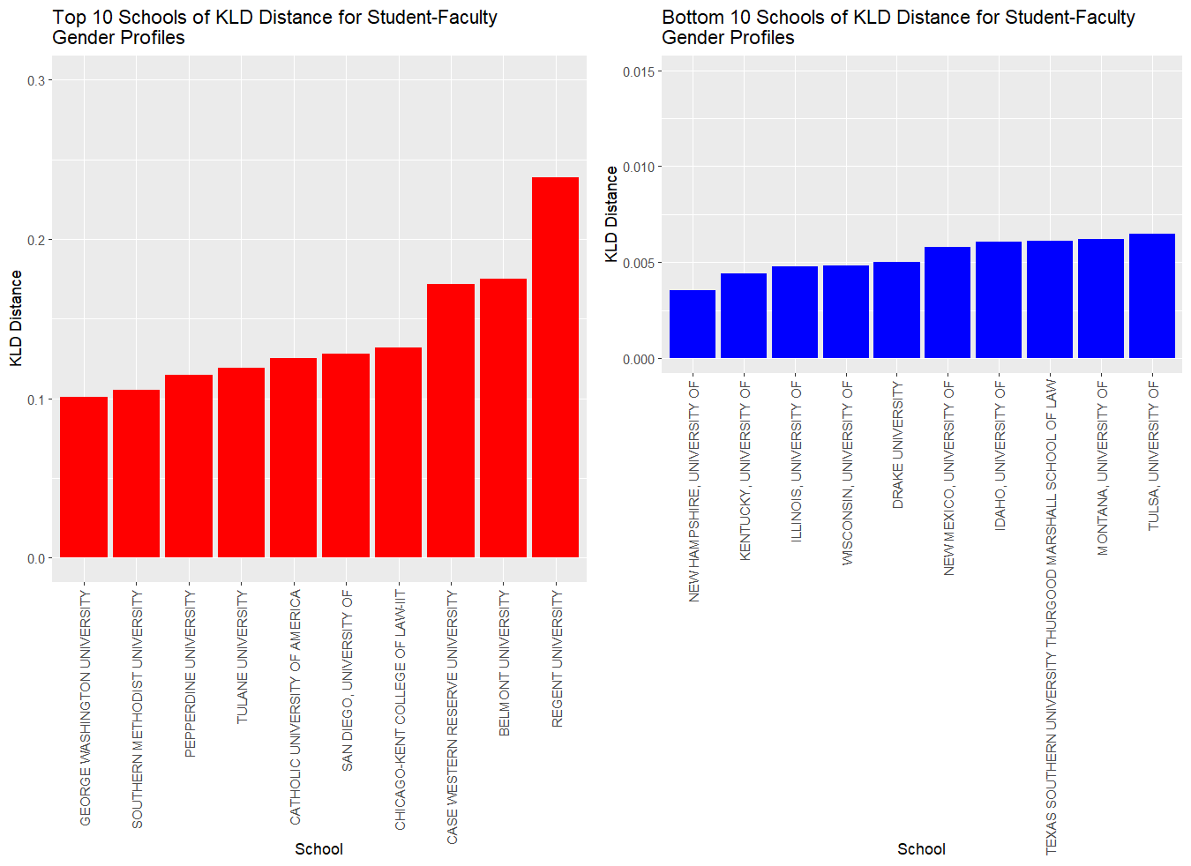

**Figure 5.6. The top and bottom 10 US Law schools for the calculated Kullback–Leibler divergence distance for the student-faculty gender profiles of US Law schools in those schools between 2017-2023.**

The KLD distance was also calculated for comparing the student-faculty gender profiles in US law schools shown in Figure 5.6, where Regent University located in Virginia had the largest KLD distance of about 0.24 followed by Belmont University in Tennessee with a KLD distance of about 0.18. The average proportion of female faculty in Regent University from 2017-2023 was around 23% in comparison to the average proportion of female students of about 55%. The differences in the distribution of faculty being male majority in comparison to the female majority student population is what contributes to Regent University having the highest KLD distance of the US law schools from 2017-2023. The school with the smallest KLD distance was the University of New Hampshire with a distance of about 0.00035, suggesting an almost identical gender distribution between students and faculty, as the distance is almost zero.

For the student-faculty gender profiles, the average Kullback–Leibler divergence distance by state is shown in Appendix H**.** The results for the Kullback–Leibler divergence distances with the inclusion of the AGI gender category are shown in the figure of Appendix I.

To identify whether there is a correlation between faculty and student gender the correlation coefficient for every year is calculated with corresponding 95% confidence intervals. The correlation between the proportion of female faculty and students is shown in Table 5.4, where the estimated correlation is low for every year indicating a weak positive correlation. The same is shown when looking at the total correlation for years ranging from 2017-2023 where a correlation of about 0.2864 is estimated. When looking at the correlation between the proportion of male faculty and students shown in Table 5.5, the correlation is again very low for every year and the total correlation from 2017-2023 was about 0.3037, suggesting a weak positive correlation between the proportion of male faculty and male students in US law schools.

***Table 5.4: Correlation coefficient and 95% confidence intervals for the correlation between proportion of female faculty with proportion of female students in US law schools.***

|  |  |  |  |
| --- | --- | --- | --- |
| **Year** | **Estimate** | **Confidence Interval Lower Bound** | **Confidence Interval Upper Bound** |
| 2017 | 0.165461 | 0.025543 | 0.299022 |
| 2018 | 0.171524 | 0.031778 | 0.304693 |
| 2019 | 0.252585 | 0.116197 | 0.379624 |
| 2020 | 0.322889 | 0.191044 | 0.443289 |
| 2021 | 0.28512 | 0.150642 | 0.409237 |
| 2022 | 0.279927 | 0.145123 | 0.404528 |
| 2023 | 0.251108 | 0.114641 | 0.378274 |
| Total | 0.286373 | 0.236914 | 0.33435 |

***Table 5.5: Correlation coefficient and 95% confidence intervals for the correlation between proportion of male faculty with proportion of female students in US law schools.***

|  |  |  |  |
| --- | --- | --- | --- |
| **Year** | **Estimate** | **Confidence Interval Lower Bound** | **Confidence Interval Upper Bound** |
| 2017 | 0.169574 | 0.029771 | 0.30287 |
| 2018 | 0.165299 | 0.025376 | 0.29887 |
| 2019 | 0.258348 | 0.122274 | 0.384889 |
| 2020 | 0.313555 | 0.181018 | 0.434906 |
| 2021 | 0.253667 | 0.117337 | 0.380613 |
| 2022 | 0.315216 | 0.182801 | 0.4364 |
| 2023 | 0.310281 | 0.177508 | 0.43196 |
| Total | 0.303664 | 0.25471 | 0.351066 |

# 

# 

# 6. Conclusions

Our research identified an overall upward trend in both gender and ethnicity in U.S. Law Schools for faculty and students. Although women constitute half of the enrolled first-year law students, this proportion is not reflected in the number of women participating as faculty where men are still a majority. However, the number of women participating as faculty has increased since 2017. Similarly, BIPOC students constitute 36.23% of first-year students. This percentage is close to the 38.37% non-white Census data. It’s important to note that some states have percentages as high as 70.4% (Hawaii) and might contribute to artificially increasing the average percentage of BIPOC students. Faculty who identify as BIPOC still represent less than 25% of teaching faculty.

The largest changes in racial/ethnic diversification for students between 2017 and 2023 correspond to Stanford University (California), Penn State - Dickinson Law School (Pennsylvania), Drexel University (Pennsylvania), Washington and Lee University (Virginia), and Emory University (Georgia), while Cooley Law School (Michigan), Regent University (Virginia), Charleston School of Law (South Carolina), Atlanta’s John Marshall Law School (Georgia), and University of Mississippi (Mississippi) decreased the percentage of non-white students. Similarly, the school that increased the percentage of women enrollment the most corresponds to the University of Detroit Mercy (Michigan).

The University of Idaho and the University of New Hampshire exhibited the highest KLD distances for ethnicity (i.e., non-matching between faculty and students profiles) with values of approximately 9.66 and 2.75 (Figure 5.4). These values indicate significant discrepancies between the proportions of BIPOC students and faculty. These high KLD distances were influenced by the absence of BIPOC faculty during certain years, notably from 2021-2023 at the University of Idaho and in 2021 at the University of New Hampshire. The school with the third highest KLD distance for ethnicity was Charleston School of Law with a value of approximately 0.28. Howard University, Southwestern Law School, and St. John’s University had the lowest KLD distances for ethnicity, with values of approximately 0.00020, 0.00032, and 0.0010 (Figure 5.4). This suggests minimal differences in their BIPOC student and faculty distributions. This indicates a more balanced representation of BIPOC individuals in both groups at these institutions.

Regent University, Belmont University, and Case Western Reserve University had the highest KLD distances for gender, with values of approximately 0.24, 0.18, and 0.17, respectively (Figure 5.6). These schools would represent the institutions with the largest discrepancies in the distribution of gender for US law schools from 2017-2023. The institutions with the lowest KLD distances were the University of New Hampshire, the University of Kentucky, and the University of Illinois, with values of approximately 0.0035, 0.0044, and 0.0048 (Figure 5.6). This suggests a closer alignment between the gender distributions of students and faculty in these institutions.

The correlation analysis showed a strong positive correlation between the proportions of BIPOC faculty and students, with an overall correlation of approximately 0.8223. This suggests that schools with higher proportions of BIPOC students tend to also have higher proportions of BIPOC faculty.

The correlation analysis for gender revealed weak positive correlations between the proportions of female and male faculty and students. The overall correlations for the years 2017-2023 were 0.2864 for female and 0.3037 for male, indicating that gender representation among faculty does not closely follow the gender distribution of students.

# 

# 7. Considerations and Data Limitations

The most important consideration for interpreting this report is that based on the nature of the data set and analysis, the results cannot establish causality between any variables in the data. E.g., we cannot establish a "rate of change" for gender and ethnicity, and can only look at how the gender and ethnicity proportions are distributed at different schools over different years. There are numerous confounding variables that could contribute to the different proportions at both the national and university-specific level, and thus it would be misleading to imply that certain schools are more or less “resistant” to change.

The scope of this report has various limitations. These limitations can be seen in schools located in the federal territory of Puerto Rico where the percentage of student and faculty BIPOC are either 100% or nearly 100% for every school. This would affect the results of the KL-divergence as the three accredited law schools from Puerto Rico would end up with disproportionately small distances. Also, when the change in ethnicity is being evaluated any change to the percentage of faculty or student BIPOC could lead to results indicating a large decrease in student/faculty BIPOC for the Law schools in Puerto Rico. This would lead to misleading results considering those schools have student/faculty BIPOC populations nearing 100%. Similar limitations can be seen in historically Black universities where a high percentage in student and faculty BIPOC populations consistently across the years of data would lead to similar misleading results. An example of this can be seen in Howard University, which is an historically Black university, where the percentage of faculty BIPOC in 2022 was about 82% and this decreased to around 78% in 2023. This would result in a decrease of around 4% in faculty BIPOC, however if you look at the total amount of faculty BIPOC it actually increased in size from 82 BIPOC faculty in 2022 to 86 BIPOC faculty in 2023. So, the decrease in faculty BIPOC could be attributed to the fact that the number of white faculty increased from 18 in 2022 to 24 in 2023, which means the number of faculty has increased overall. Thus, this negative change is not due to a “resistance” to hire BIPOC faculty.

In addition to the fact that our data does not show causality and that negative change may not be indicative of “resistance”. We also encounter limitations with the data itself. Our data has a limited range from (2017 - 2023). Unfortunately, the Disclosure 509 reports before 2017 are incompatible with the way this report is structured because the demographic data for students is reported for the full student body, and not subdivided by first, second, third, and fourth-year students. Since the goal of our research was to identify trends in U.S. law schools, we decided to observe the change in yearly enrollment, and including years before 2017 could have introduced a source of bias in the data.

We also face an issue with the granularity of the data. Since faculty was reported as a binary variable (white and non-white), we were forced to consolidate the student data into the same variables and lost information on the specific demographics. Some ethnicities, although they constitute minorities, have a higher representation in higher education. This report doesn’t assess the changes by group and it is limited to classifying students on a binary level.

# 

# 8. References

American Bar Association. Diversity and Inclusion. American Bar Association. Retrieved May 25, 2024, from <https://www.americanbar.org/groups/tort_trial_insurance_practice/committees/diversity-inclusion/>

American Bar Association. (2021). Memorandum: Proposed Changes to Standards 205 and 206, 303 and 508, and 507. Retrieved from <https://taxprof.typepad.com/files/aba-18.pdf>

American Bar Association. (n.d.). Standard 509 Disclosure. Standard 509 Disclosure. Retrieved May 29, 2024, from <https://www.abarequireddisclosures.org/Disclosure509.aspx>

American Bar Association, Member Diversity, Equity, and Inclusion Plan (2020)

American Bar Association. (2004b). *ABA-Approved Law Schools Archive*. ABA Archival Data. https://www.americanbar.org/groups/legal_education/resources/aba_approved_law_schools/archive/

Bauckhage, C. (2014). *Computing the kullback-leibler divergence between two generalized gamma distributions*. arXiv preprint arXiv:1401.6853.

Carbado, D. W., & Gulati, M. (2003). What exactly is racial diversity?., Carrington, Paul D. "Diversity." *Utah L. Rev.* (1992): 1105.

Deo, M. E. (2023). Better than BIPOC. *Law & Ineq.*, *41*, 71.

# 

# Appendices

## Appendix A: List of Law Schools

The names of the law schools used in the present report are listed below.

1. AKRON, UNIVERSITY OF
2. ALABAMA, UNIVERSITY OF
3. ALBANY LAW SCHOOL
4. AMERICAN UNIVERSITY
5. APPALACHIAN SCHOOL OF LAW
6. ARIZONA STATE UNIVERSITY
7. ARIZONA, UNIVERSITY OF
8. ARKANSAS, FAYETTEVILLE, UNIVERSITY OF
9. ARKANSAS, LITTLE ROCK, UNIVERSITY OF
10. ATLANTA'S JOHN MARSHALL LAW SCHOOL
11. AVE MARIA SCHOOL OF LAW
12. BALTIMORE, UNIVERSITY OF
13. BARRY UNIVERSITY
14. BAYLOR UNIVERSITY
15. BELMONT UNIVERSITY
16. BOSTON COLLEGE
17. BOSTON UNIVERSITY
18. BRIGHAM YOUNG UNIVERSITY
19. BROOKLYN LAW SCHOOL
20. CALIFORNIA WESTERN SCHOOL OF LAW
21. CALIFORNIA-BERKELEY, UNIVERSITY OF
22. CALIFORNIA-DAVIS, UNIVERSITY OF
23. CALIFORNIA-IRVINE, UNIVERSITY OF
24. CALIFORNIA-LOS ANGELES, UNIVERSITY OF
25. CAMPBELL UNIVERSITY
26. CAPITAL UNIVERSITY
27. CARDOZO SCHOOL OF LAW
28. CASE WESTERN RESERVE UNIVERSITY
29. CATHOLIC UNIVERSITY OF AMERICA
30. CHAPMAN UNIVERSITY
31. CHARLESTON SCHOOL OF LAW
32. CHICAGO, UNIVERSITY OF
33. CHICAGO-KENT COLLEGE OF LAW-IIT
34. CINCINNATI, UNIVERSITY OF
35. CITY UNIVERSITY OF NEW YORK
36. CLEVELAND STATE UNIVERSITY
37. COLORADO, UNIVERSITY OF
38. COLUMBIA UNIVERSITY
39. CONNECTICUT, UNIVERSITY OF
40. COOLEY LAW SCHOOL
41. CORNELL UNIVERSITY
42. CREIGHTON UNIVERSITY
43. DAYTON, UNIVERSITY OF
44. DENVER, UNIVERSITY OF
45. DEPAUL UNIVERSITY
46. DETROIT MERCY, UNIVERSITY OF
47. DISTRICT OF COLUMBIA
48. DRAKE UNIVERSITY
49. DREXEL UNIVERSITY
50. DUKE UNIVERSITY
51. DUQUESNE UNIVERSITY
52. ELON UNIVERSITY
53. EMORY UNIVERSITY
54. FAULKNER UNIVERSITY
55. FLORIDA A&M UNIVERSITY
56. FLORIDA INTERNATIONAL UNIVERSITY
57. FLORIDA STATE UNIVERSITY
58. FLORIDA, UNIVERSITY OF
59. FORDHAM UNIVERSITY
60. GEORGE MASON UNIVERSITY
61. GEORGE WASHINGTON UNIVERSITY
62. GEORGETOWN UNIVERSITY
63. GEORGIA STATE UNIVERSITY
64. GEORGIA, UNIVERSITY OF
65. GOLDEN GATE UNIVERSITY
66. GONZAGA UNIVERSITY
67. HARVARD UNIVERSITY
68. HAWAII, UNIVERSITY OF
69. HOFSTRA UNIVERSITY
70. HOUSTON, UNIVERSITY OF
71. HOWARD UNIVERSITY
72. IDAHO, UNIVERSITY OF
73. ILLINOIS, UNIVERSITY OF
74. INDIANA UNIVERSITY - BLOOMINGTON
75. INDIANA UNIVERSITY - INDIANAPOLIS
76. INTER AMERICAN UNIVERSITY OF PUERTO RICO
77. IOWA, UNIVERSITY OF
78. KANSAS, UNIVERSITY OF
79. KENTUCKY, UNIVERSITY OF
80. LEWIS AND CLARK COLLEGE
81. LIBERTY UNIVERSITY
82. LINCOLN MEMORIAL
83. LOUISIANA STATE UNIVERSITY
84. LOUISVILLE, UNIVERSITY OF
85. LOYOLA MARYMOUNT UNIVERSITY-LOS ANGELES
86. LOYOLA UNIVERSITY-CHICAGO
87. LOYOLA UNIVERSITY-NEW ORLEANS
88. MAINE, UNIVERSITY OF
89. MARQUETTE UNIVERSITY
90. MARYLAND, UNIVERSITY OF
91. MCGEORGE SCHOOL OF LAW
92. MEMPHIS, UNIVERSITY OF
93. MERCER UNIVERSITY
94. MIAMI, UNIVERSITY OF
95. MICHIGAN STATE UNIVERSITY
96. MICHIGAN, UNIVERSITY OF
97. MINNESOTA, UNIVERSITY OF
98. MISSISSIPPI COLLEGE
99. MISSISSIPPI, UNIVERSITY OF
100. MISSOURI, UNIVERSITY OF
101. MISSOURI-KANSAS CITY, UNIVERSITY OF
102. MITCHELL | HAMLINE
103. MONTANA, UNIVERSITY OF
104. NEBRASKA, UNIVERSITY OF
105. NEW ENGLAND LAW | BOSTON
106. NEW HAMPSHIRE, UNIVERSITY OF
107. NEW MEXICO, UNIVERSITY OF
108. NEW YORK LAW SCHOOL
109. NEW YORK UNIVERSITY
110. NORTH CAROLINA CENTRAL UNIVERSITY
111. NORTH CAROLINA, UNIVERSITY OF
112. NORTH DAKOTA, UNIVERSITY OF
113. NORTHEASTERN UNIVERSITY SCHOOL OF LAW
114. NORTHERN ILLINOIS UNIVERSITY
115. NORTHERN KENTUCKY UNIVERSITY
116. NORTHWESTERN UNIVERSITY
117. NOTRE DAME, UNIVERSITY OF
118. NOVA SOUTHEASTERN UNIVERSITY
119. OHIO NORTHERN UNIVERSITY
120. OHIO STATE UNIVERSITY
121. OKLAHOMA CITY UNIVERSITY
122. OKLAHOMA, UNIVERSITY OF
123. OREGON, UNIVERSITY OF
124. PACE UNIVERSITY
125. PENNSYLVANIA STATE - DICKINSON LAW
126. PENNSYLVANIA STATE - PENN STATE LAW
127. PENNSYLVANIA, UNIVERSITY OF
128. PEPPERDINE UNIVERSITY
129. PITTSBURGH, UNIVERSITY OF
130. PONTIFICAL CATHOLIC UNIVERSITY OF P.R.
131. PUERTO RICO, UNIVERSITY OF
132. QUINNIPIAC UNIVERSITY
133. REGENT UNIVERSITY
134. RICHMOND, UNIVERSITY OF
135. ROGER WILLIAMS UNIVERSITY
136. RUTGERS UNIVERSITY
137. SAINT LOUIS UNIVERSITY
138. SAMFORD UNIVERSITY
139. SAN DIEGO, UNIVERSITY OF
140. SAN FRANCISCO, UNIVERSITY OF
141. SANTA CLARA UNIVERSITY
142. SEATTLE UNIVERSITY
143. SETON HALL UNIVERSITY
144. SOUTH CAROLINA, UNIVERSITY OF
145. SOUTH DAKOTA, UNIVERSITY OF
146. SOUTH TEXAS COLLEGE OF LAW HOUSTON
147. SOUTHERN CALIFORNIA, UNIVERSITY OF
148. SOUTHERN ILLINOIS UNIVERSITY-CARBONDALE
149. SOUTHERN METHODIST UNIVERSITY
150. SOUTHERN UNIVERSITY
151. SOUTHWESTERN LAW SCHOOL
152. ST. JOHN'S UNIVERSITY
153. ST. MARY'S UNIVERSITY
154. ST. THOMAS UNIVERSITY (FLORIDA)
155. ST. THOMAS, UNIVERSITY OF (MINNESOTA)
156. STANFORD UNIVERSITY
157. STETSON UNIVERSITY
158. SUFFOLK UNIVERSITY
159. SYRACUSE UNIVERSITY
160. TEMPLE UNIVERSITY
161. TENNESSEE, UNIVERSITY OF
162. TEXAS A&M UNIVERSITY
163. TEXAS AT AUSTIN, UNIVERSITY OF
164. TEXAS SOUTHERN UNIVERSITY THURGOOD MARSHALL SCHOOL OF LAW
165. TEXAS TECH UNIVERSITY
166. TOLEDO, UNIVERSITY OF
167. TOURO UNIVERSITY
168. TULANE UNIVERSITY
169. TULSA, UNIVERSITY OF
170. UNIVERSITY OF BUFFALO-SUNY
171. UNIVERSITY OF CALIFORNIA COLLEGE OF THE LAW, SAN FRANCISCO
172. UNIVERSITY OF ILLINOIS CHICAGO SCHOOL OF LAW
173. UNIVERSITY OF MASSACHUSETTS DARTMOUTH
174. UNIVERSITY OF NEVADA - LAS VEGAS
175. UTAH, UNIVERSITY OF
176. VANDERBILT UNIVERSITY
177. VERMONT LAW SCHOOL
178. VILLANOVA UNIVERSITY
179. VIRGINIA, UNIVERSITY OF
180. WAKE FOREST UNIVERSITY
181. WASHBURN UNIVERSITY
182. WASHINGTON AND LEE UNIVERSITY
183. WASHINGTON UNIVERSITY
184. WASHINGTON, UNIVERSITY OF
185. WAYNE STATE UNIVERSITY
186. WEST VIRGINIA UNIVERSITY
187. WESTERN NEW ENGLAND UNIVERSITY
188. WESTERN STATE COLLEGE OF LAW
189. WIDENER UNIVERSITY-DELAWARE
190. WIDENER-COMMONWEALTH
191. WILLAMETTE UNIVERSITY
192. WILLIAM AND MARY LAW SCHOOL
193. WISCONSIN, UNIVERSITY OF
194. WYOMING, UNIVERSITY OF
195. YALE UNIVERSITY

## 

## 

## Appendix B: Detailed Maps for Ethnicity for Student Data

The detailed maps for the average percentage of BIPOC students organized by state and year are shown below.

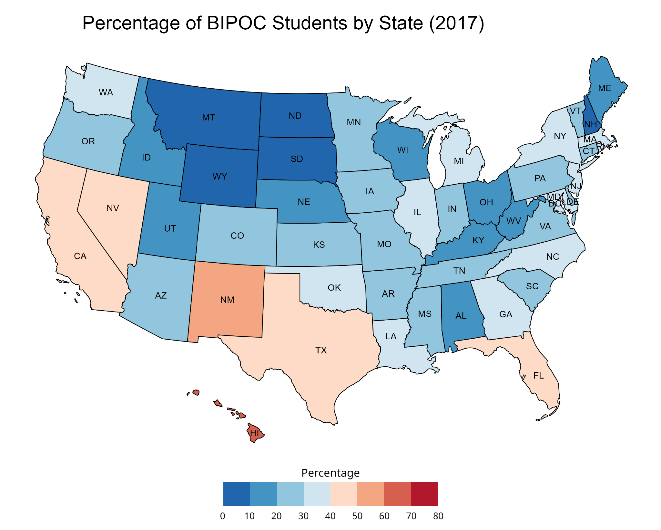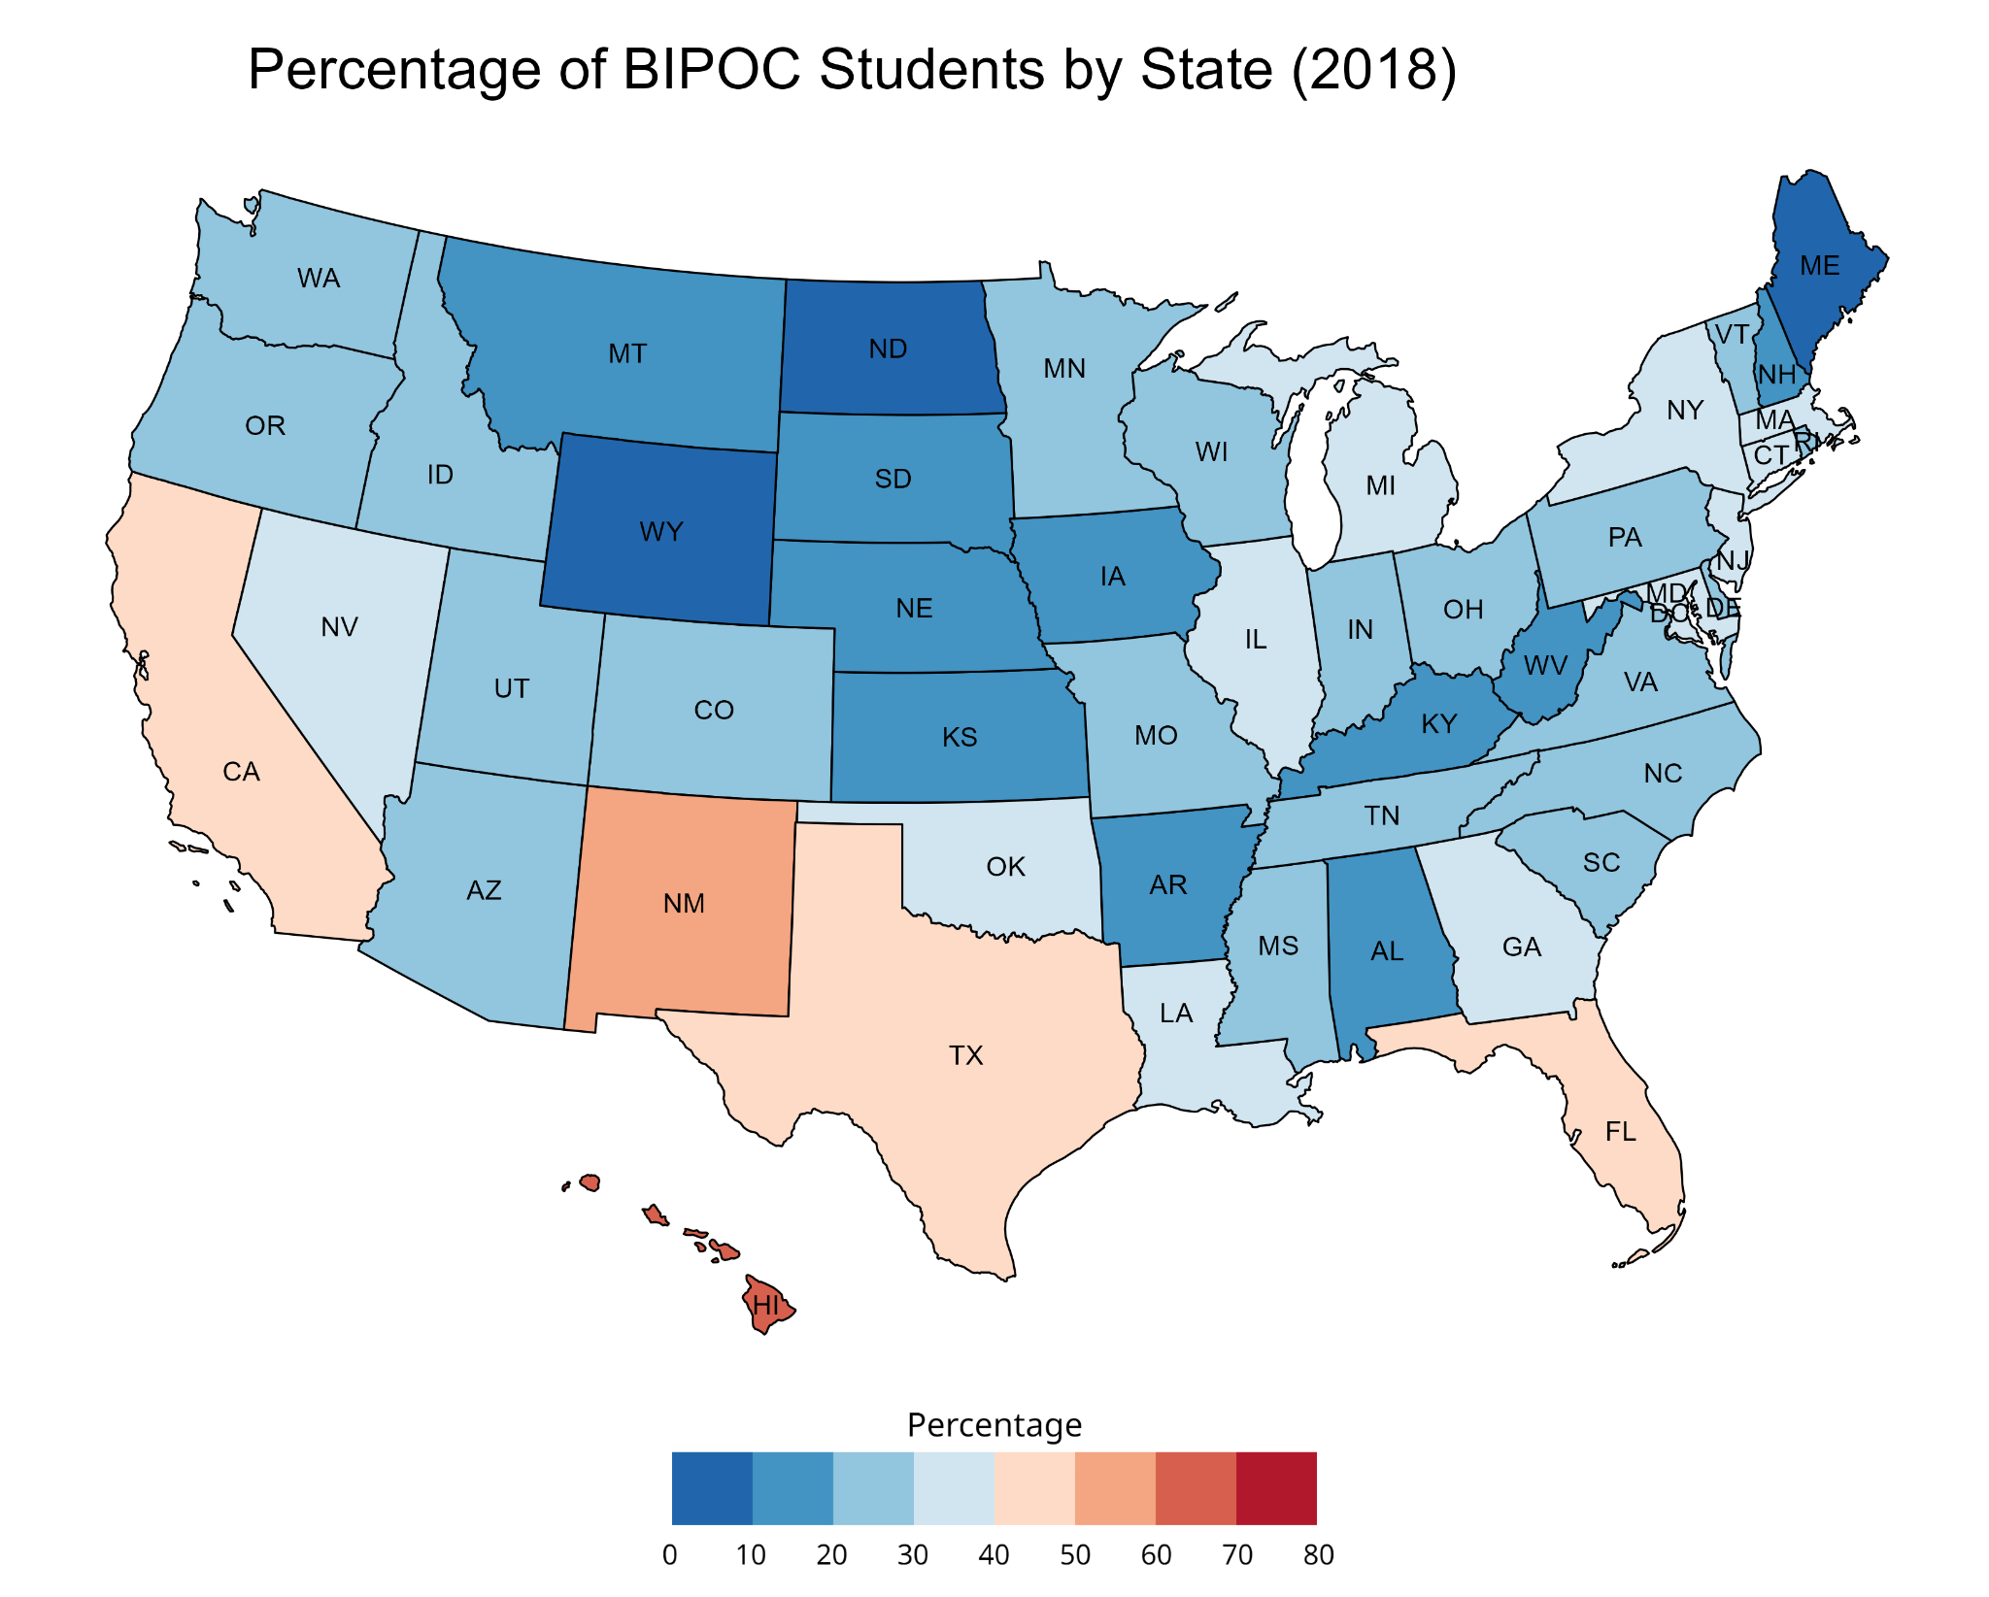

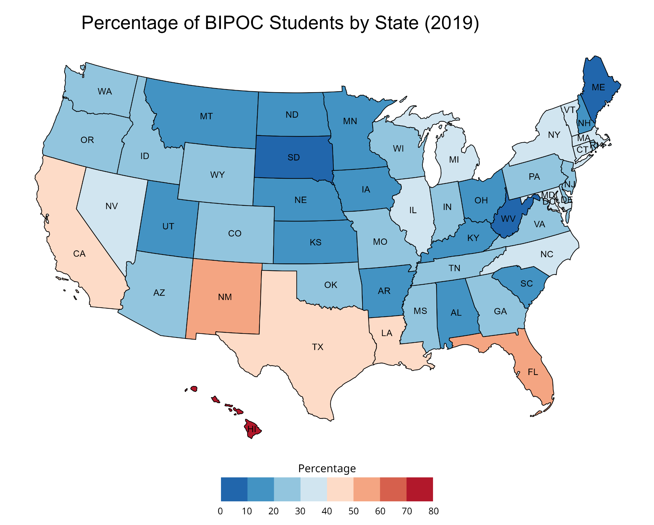

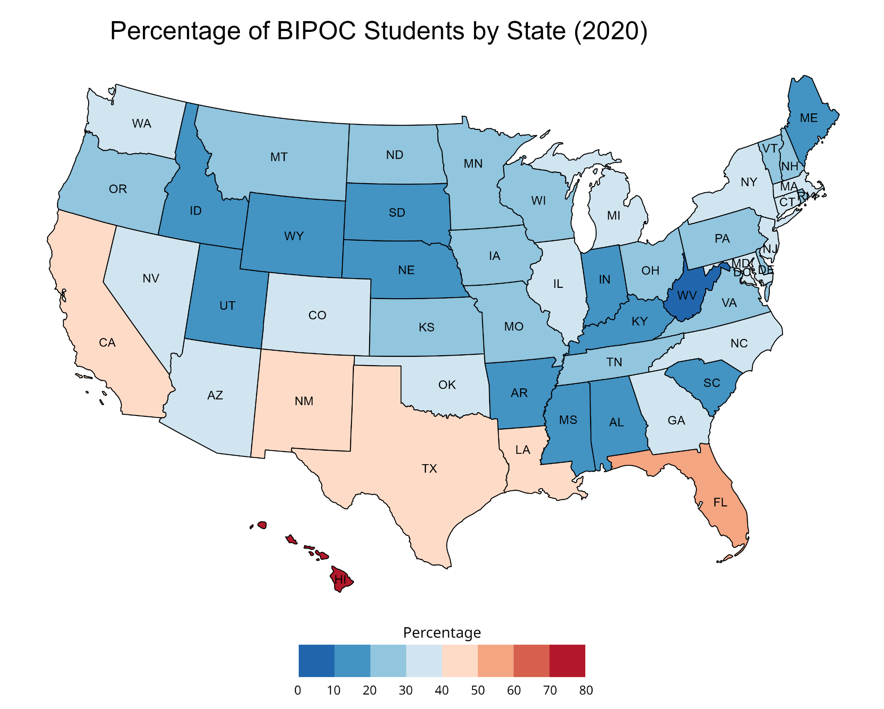

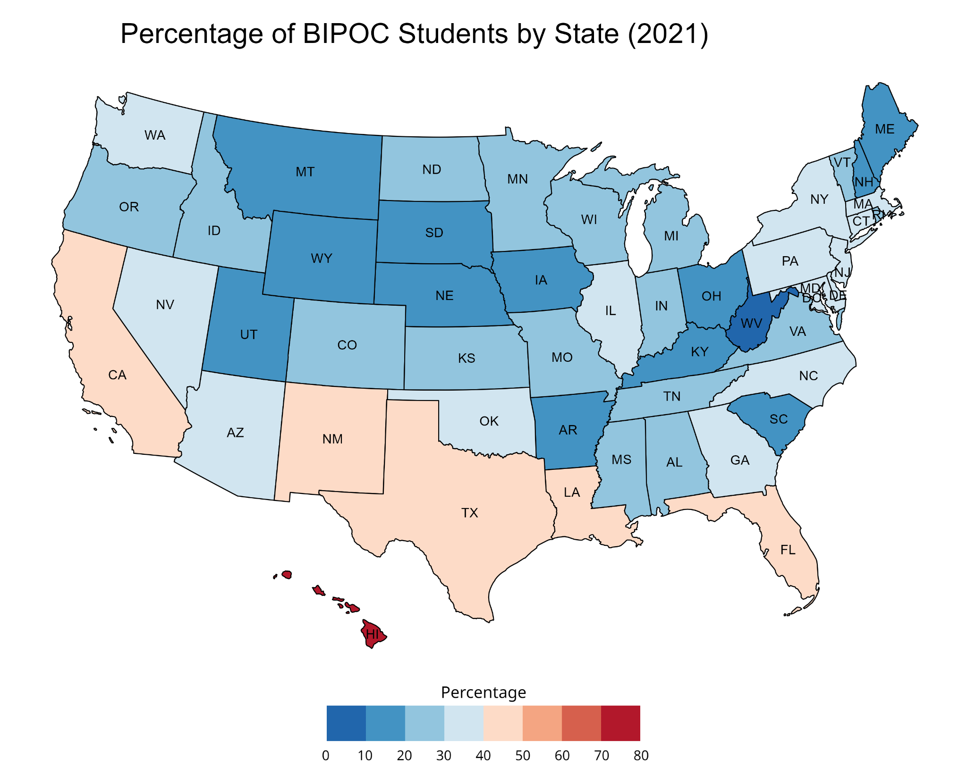

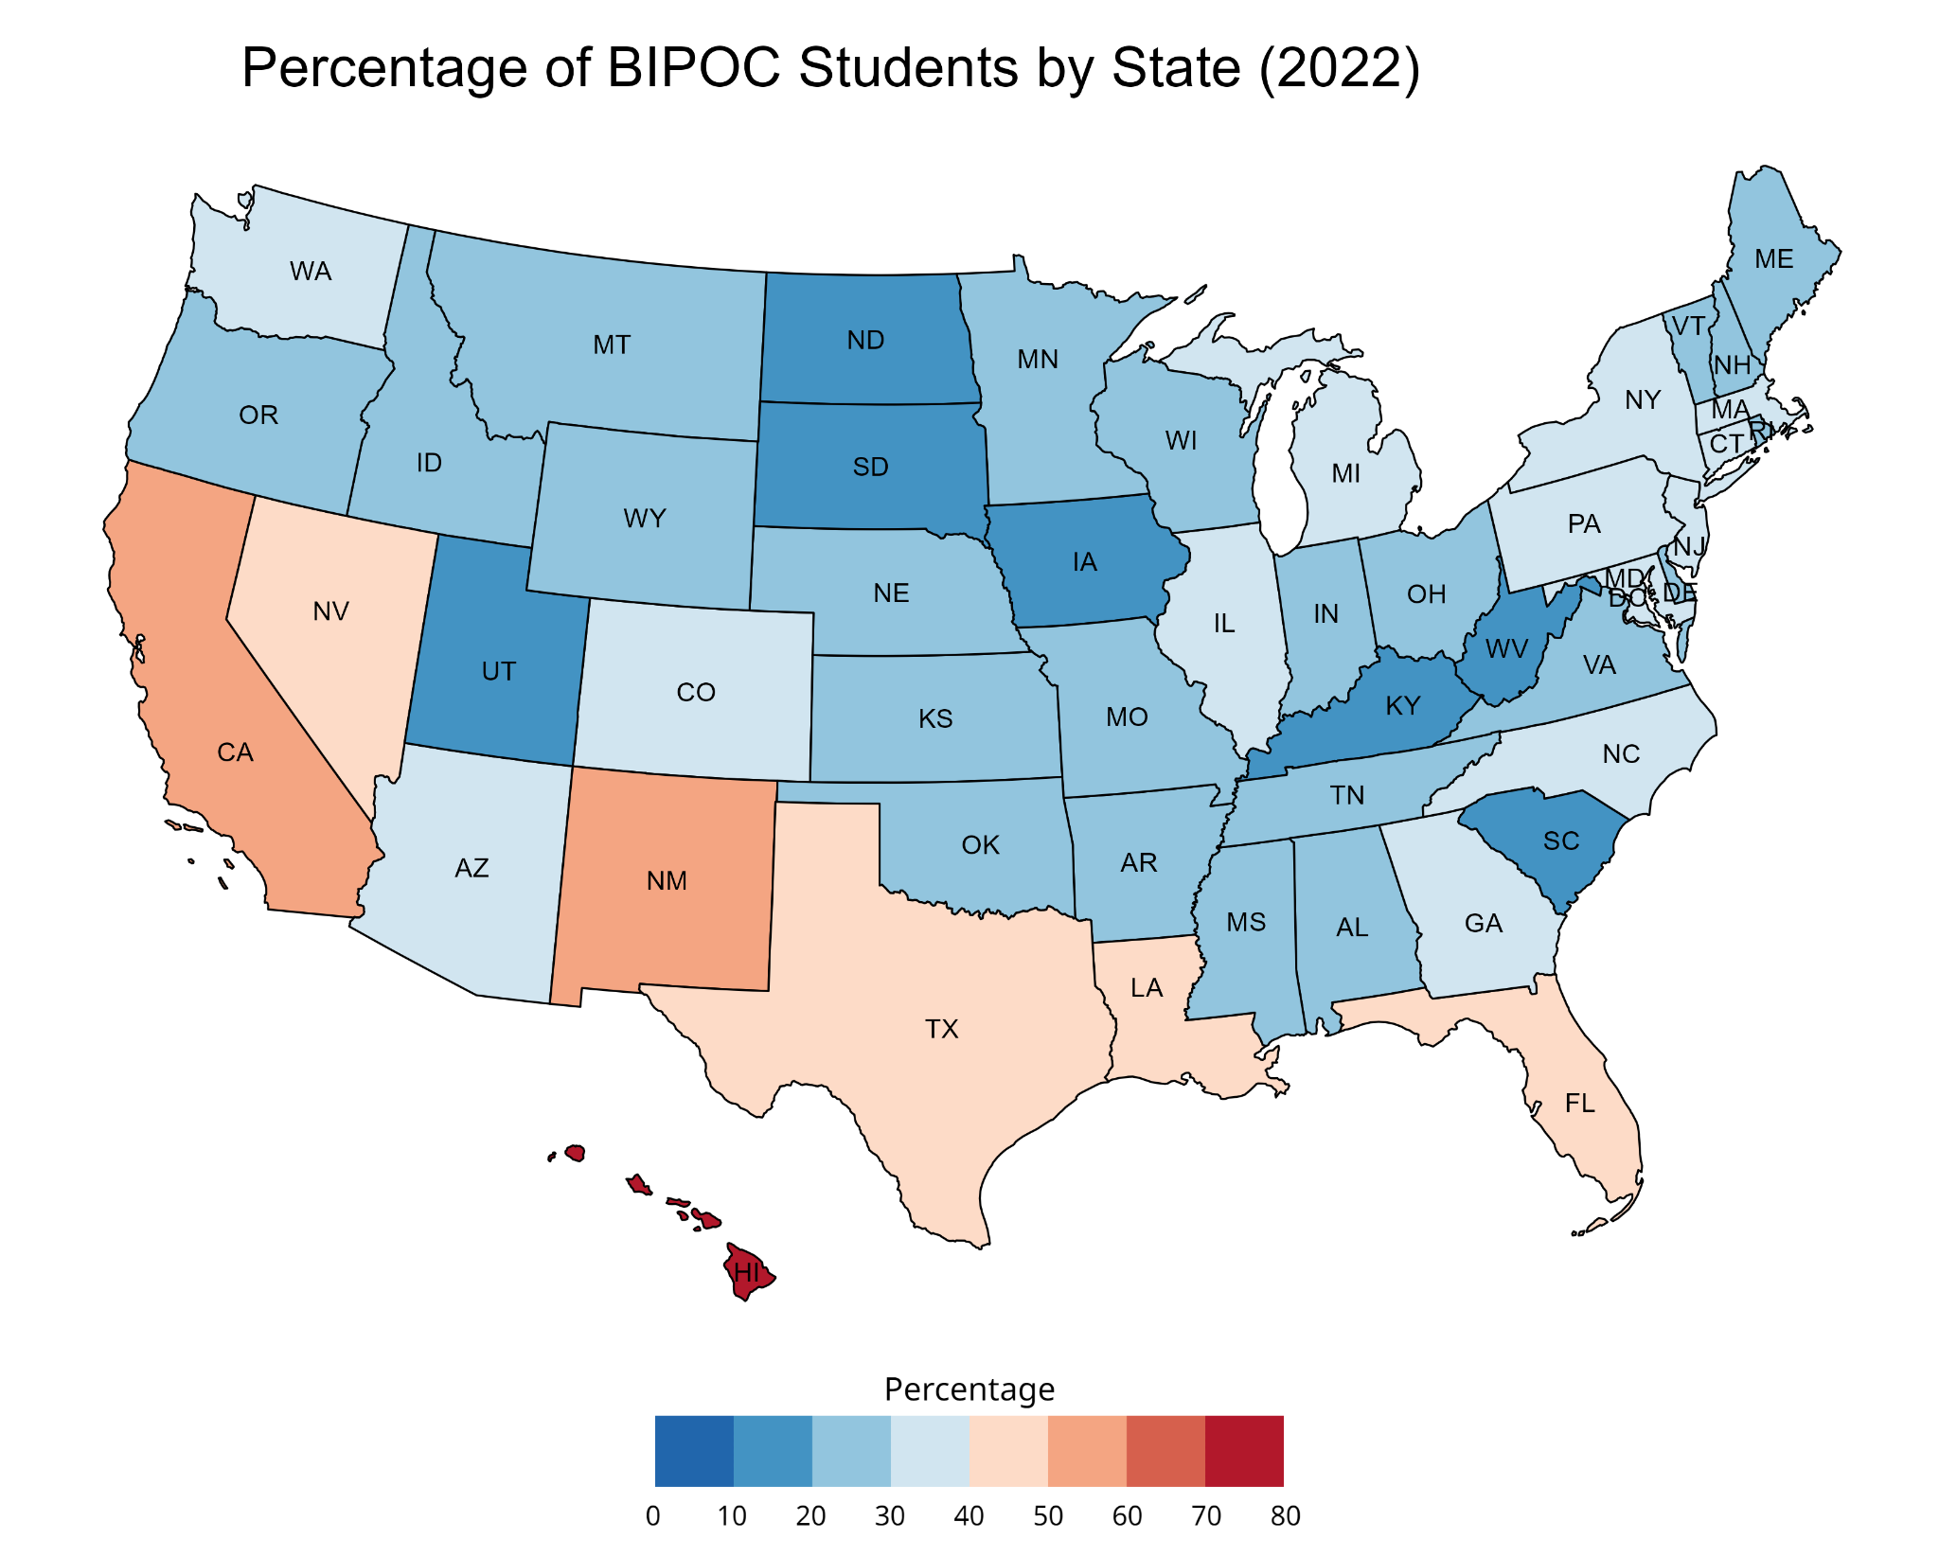

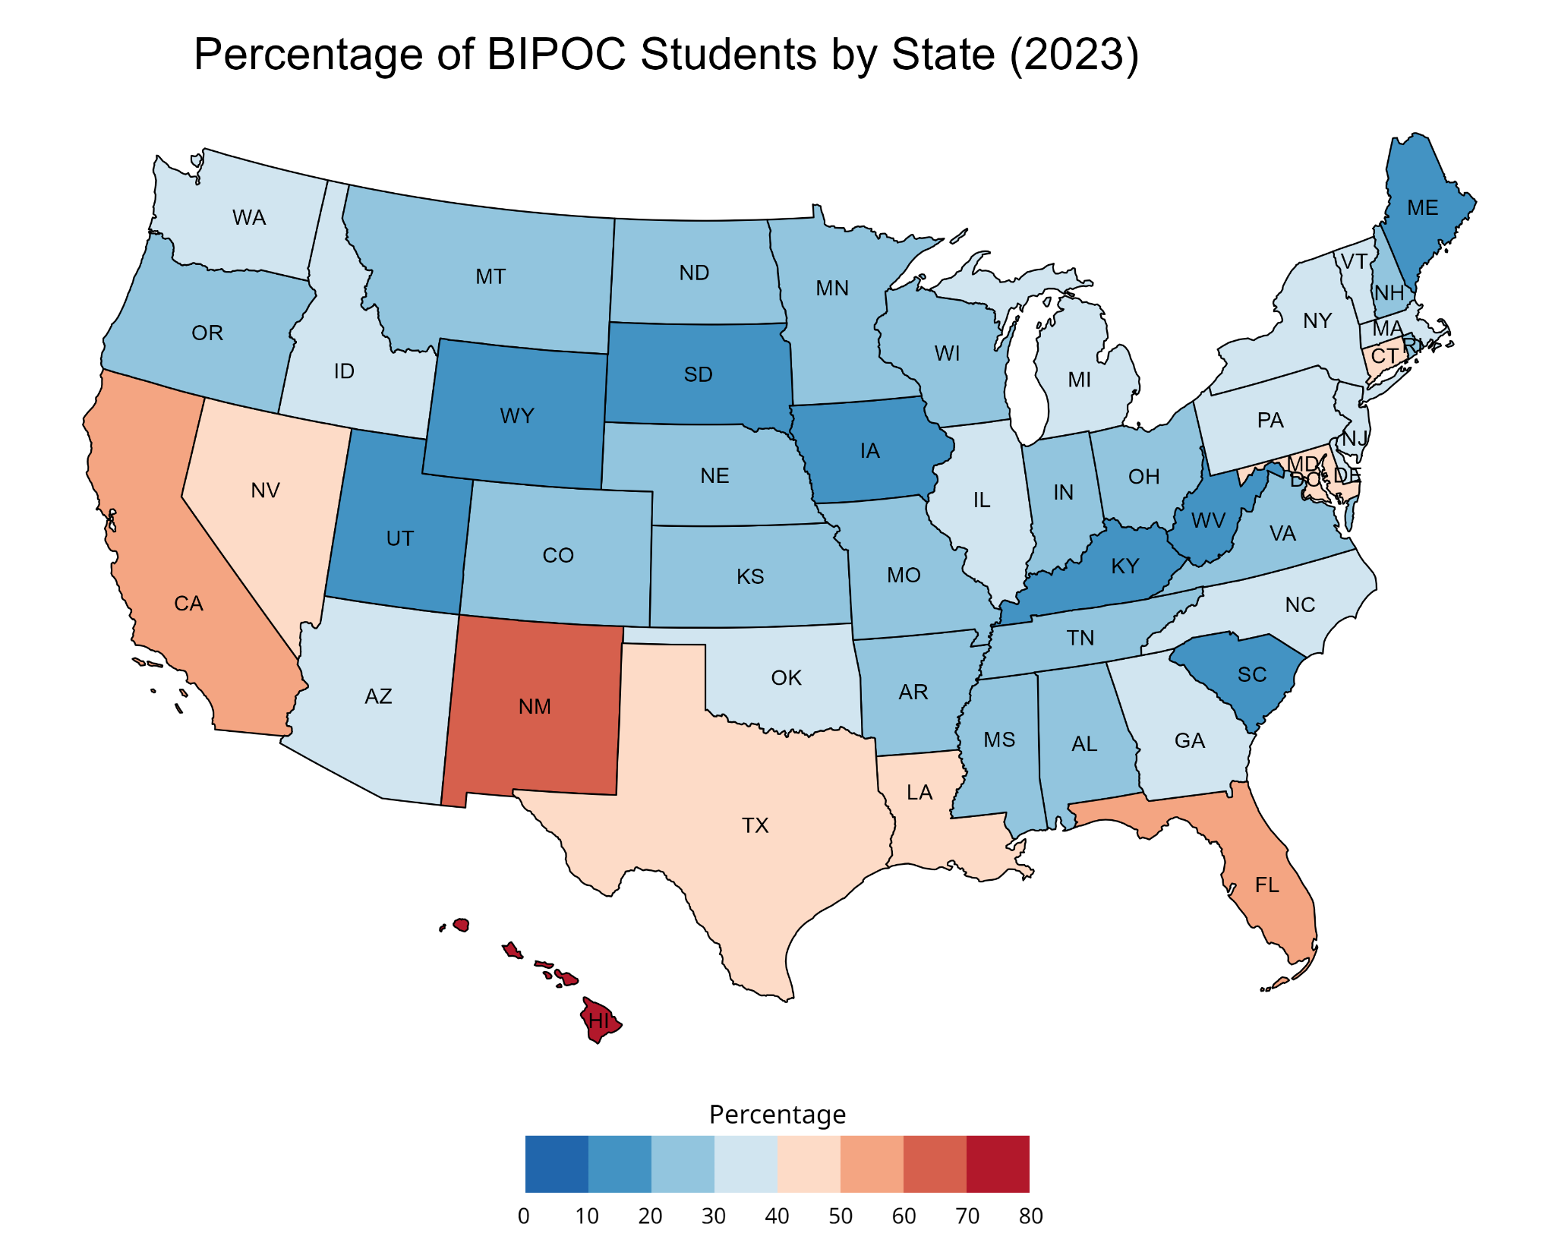

## 

## Appendix C: Detailed Maps for gender identity data (women) for Student Data

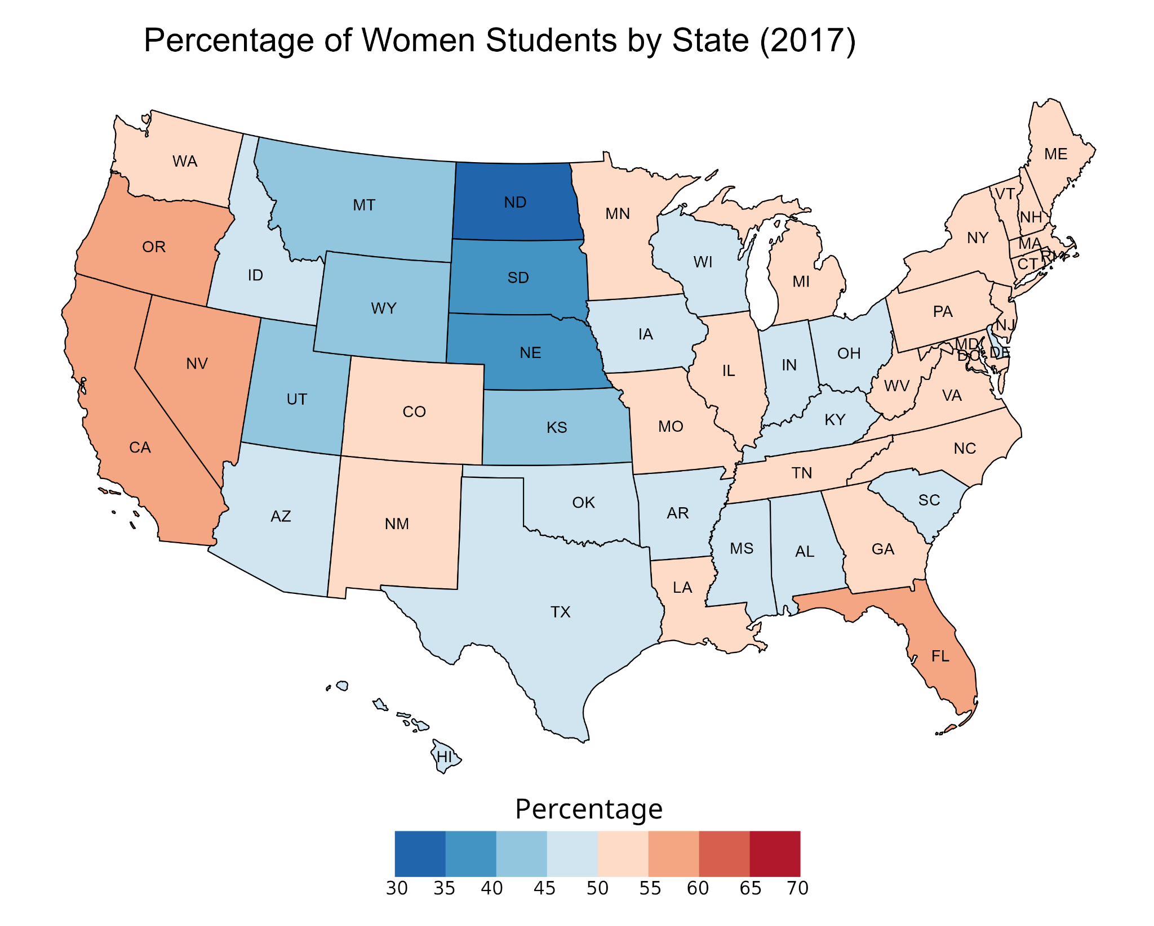

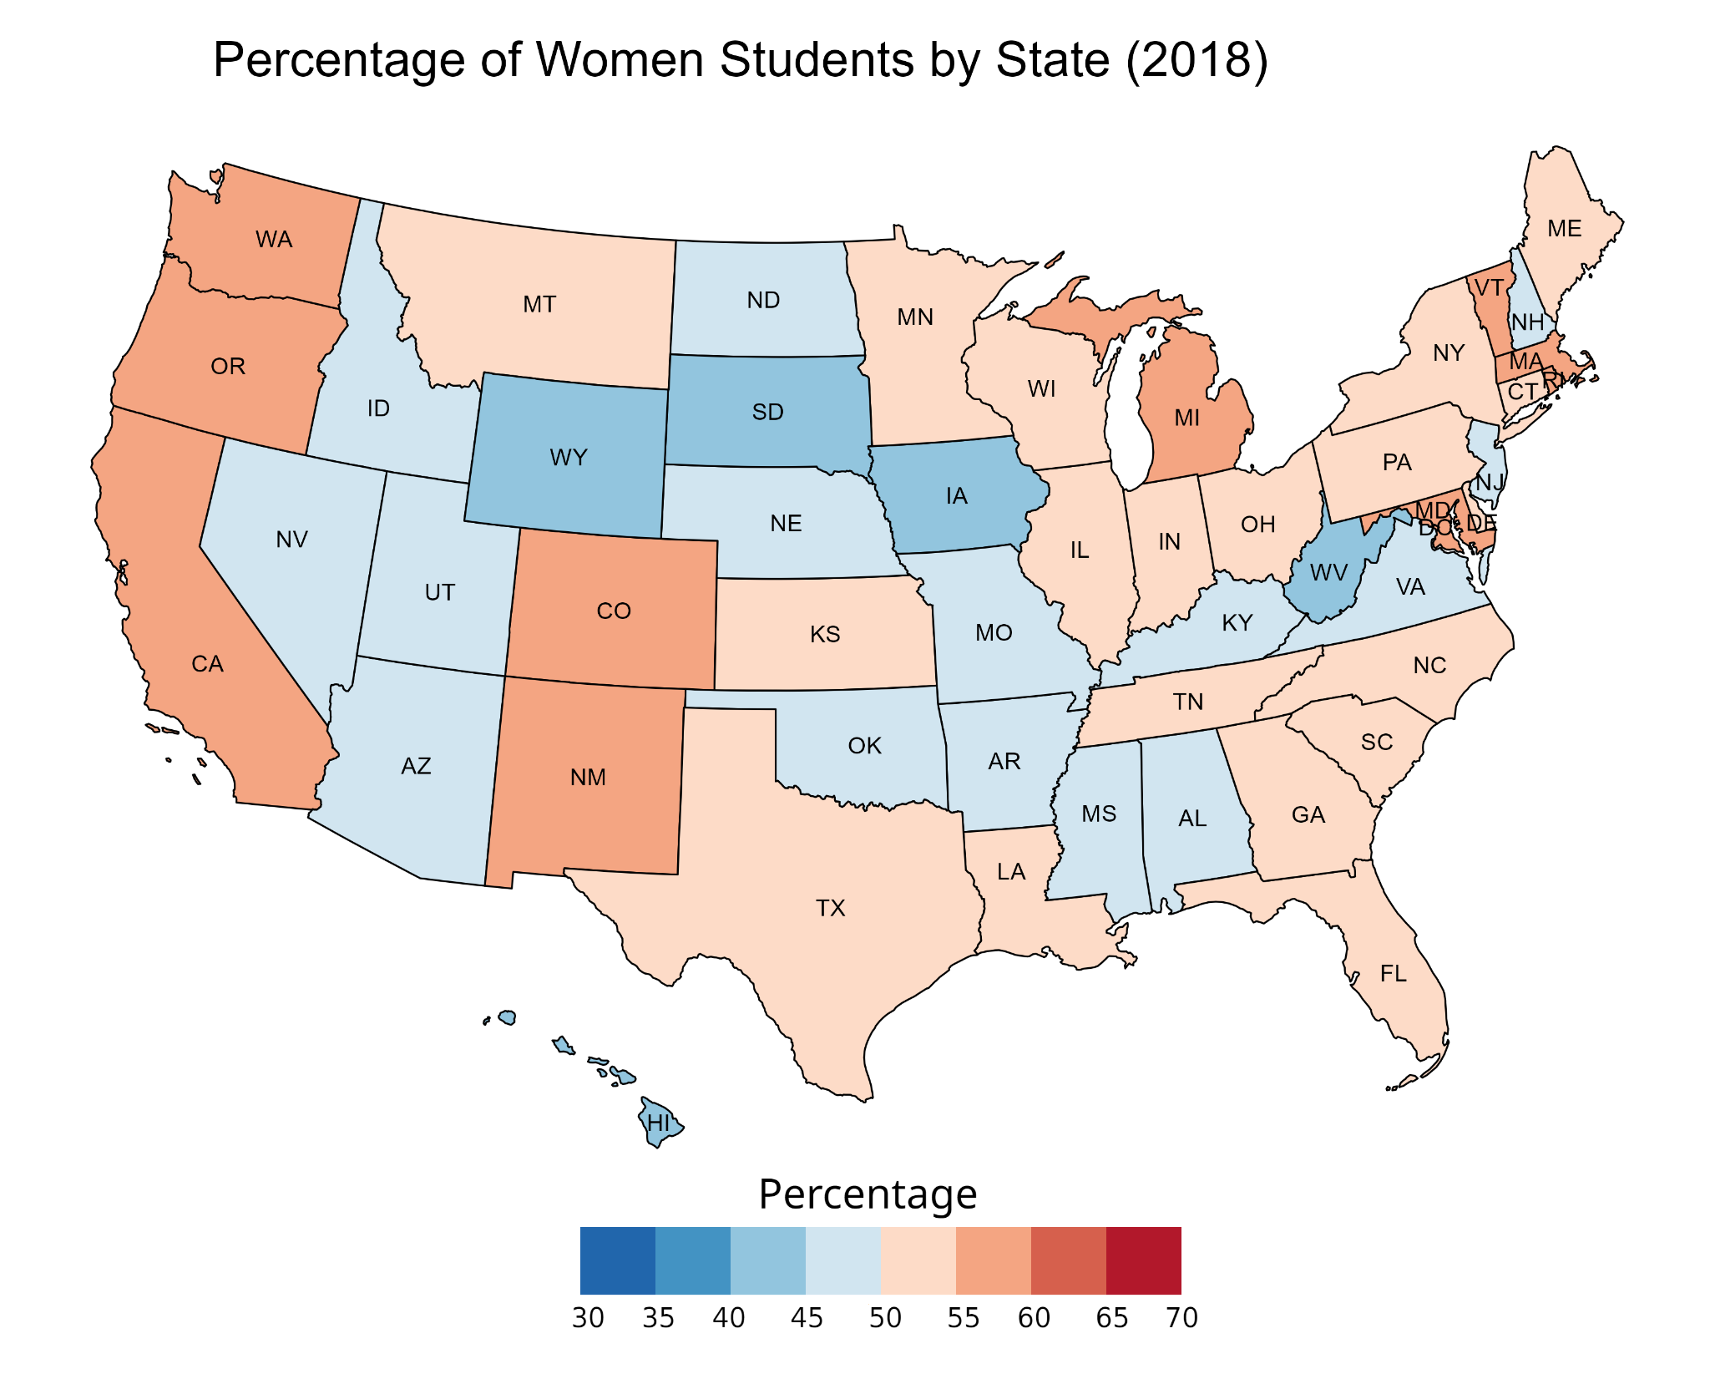

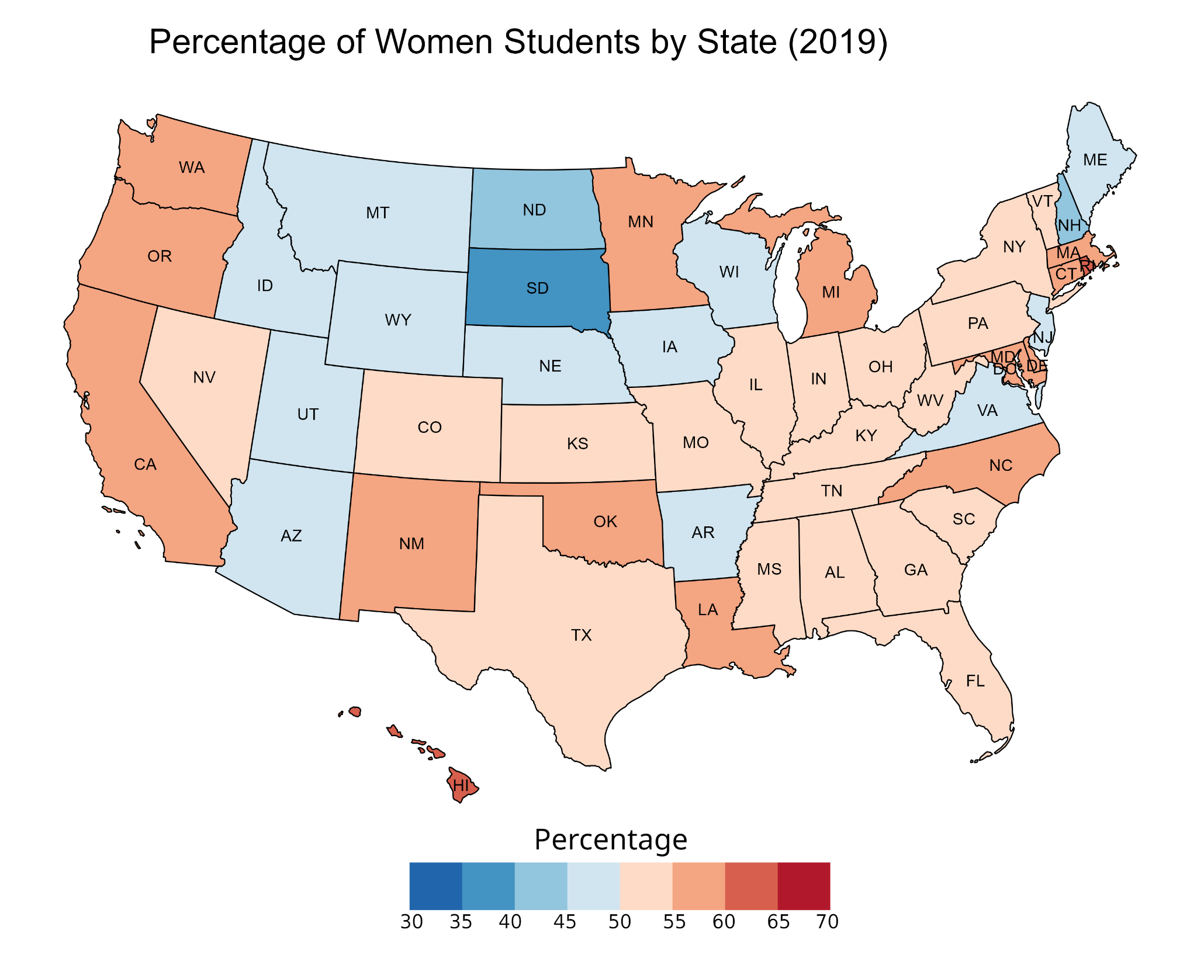

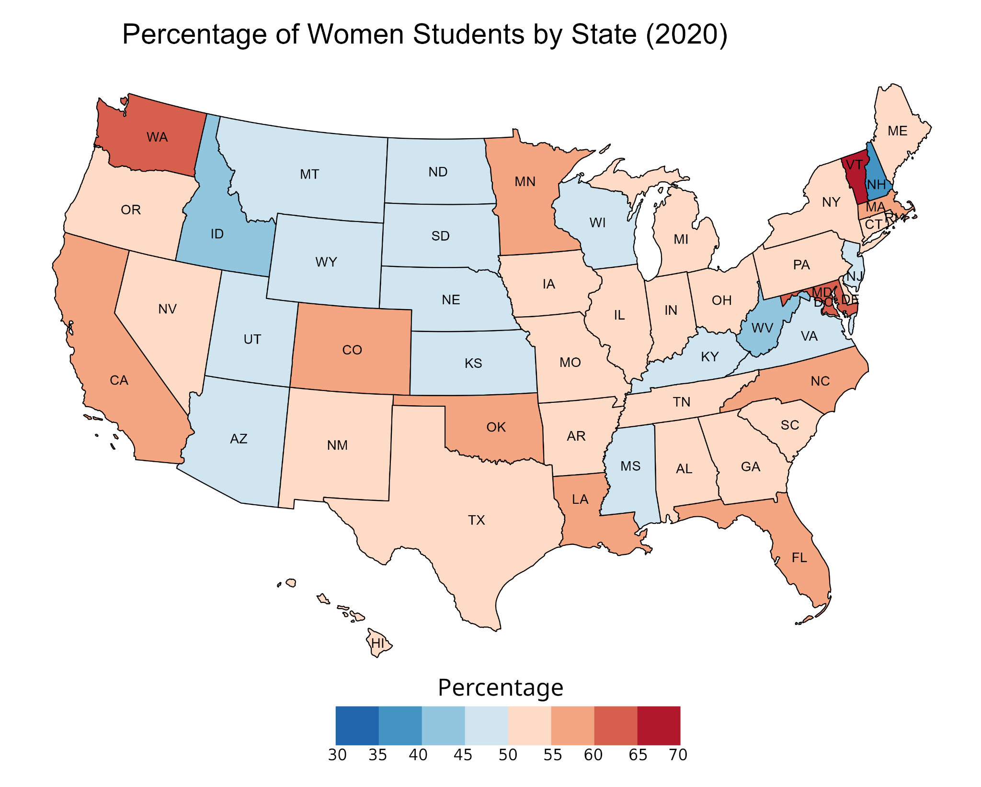

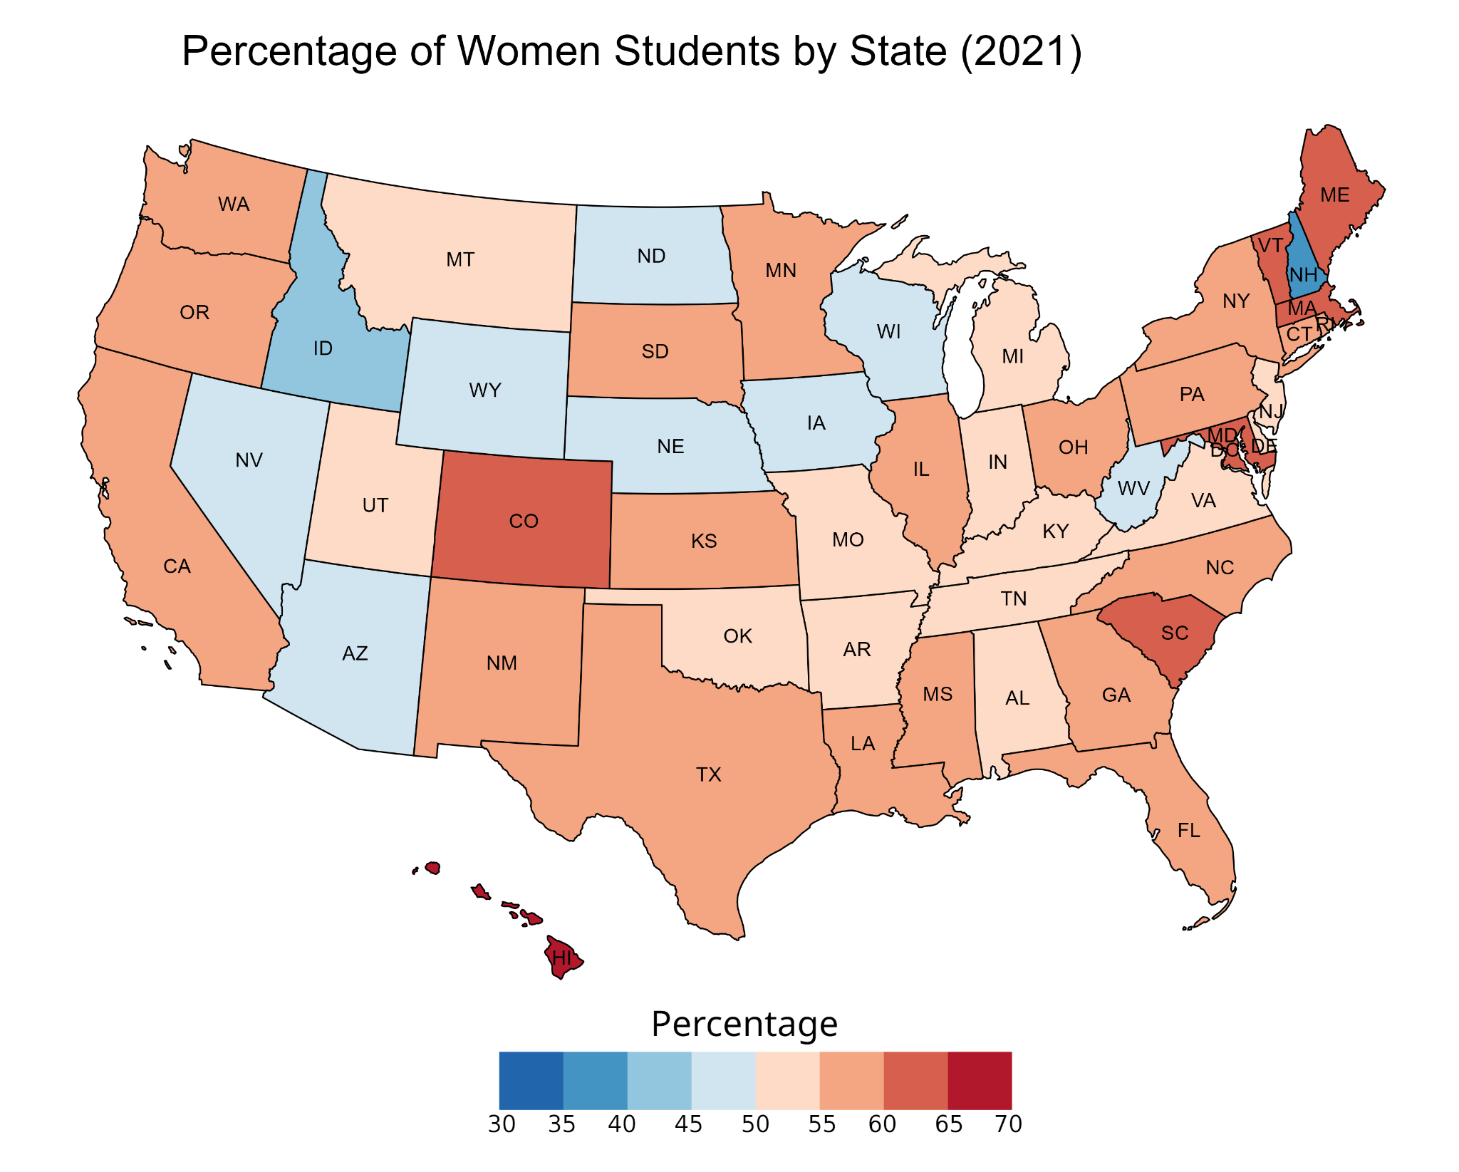

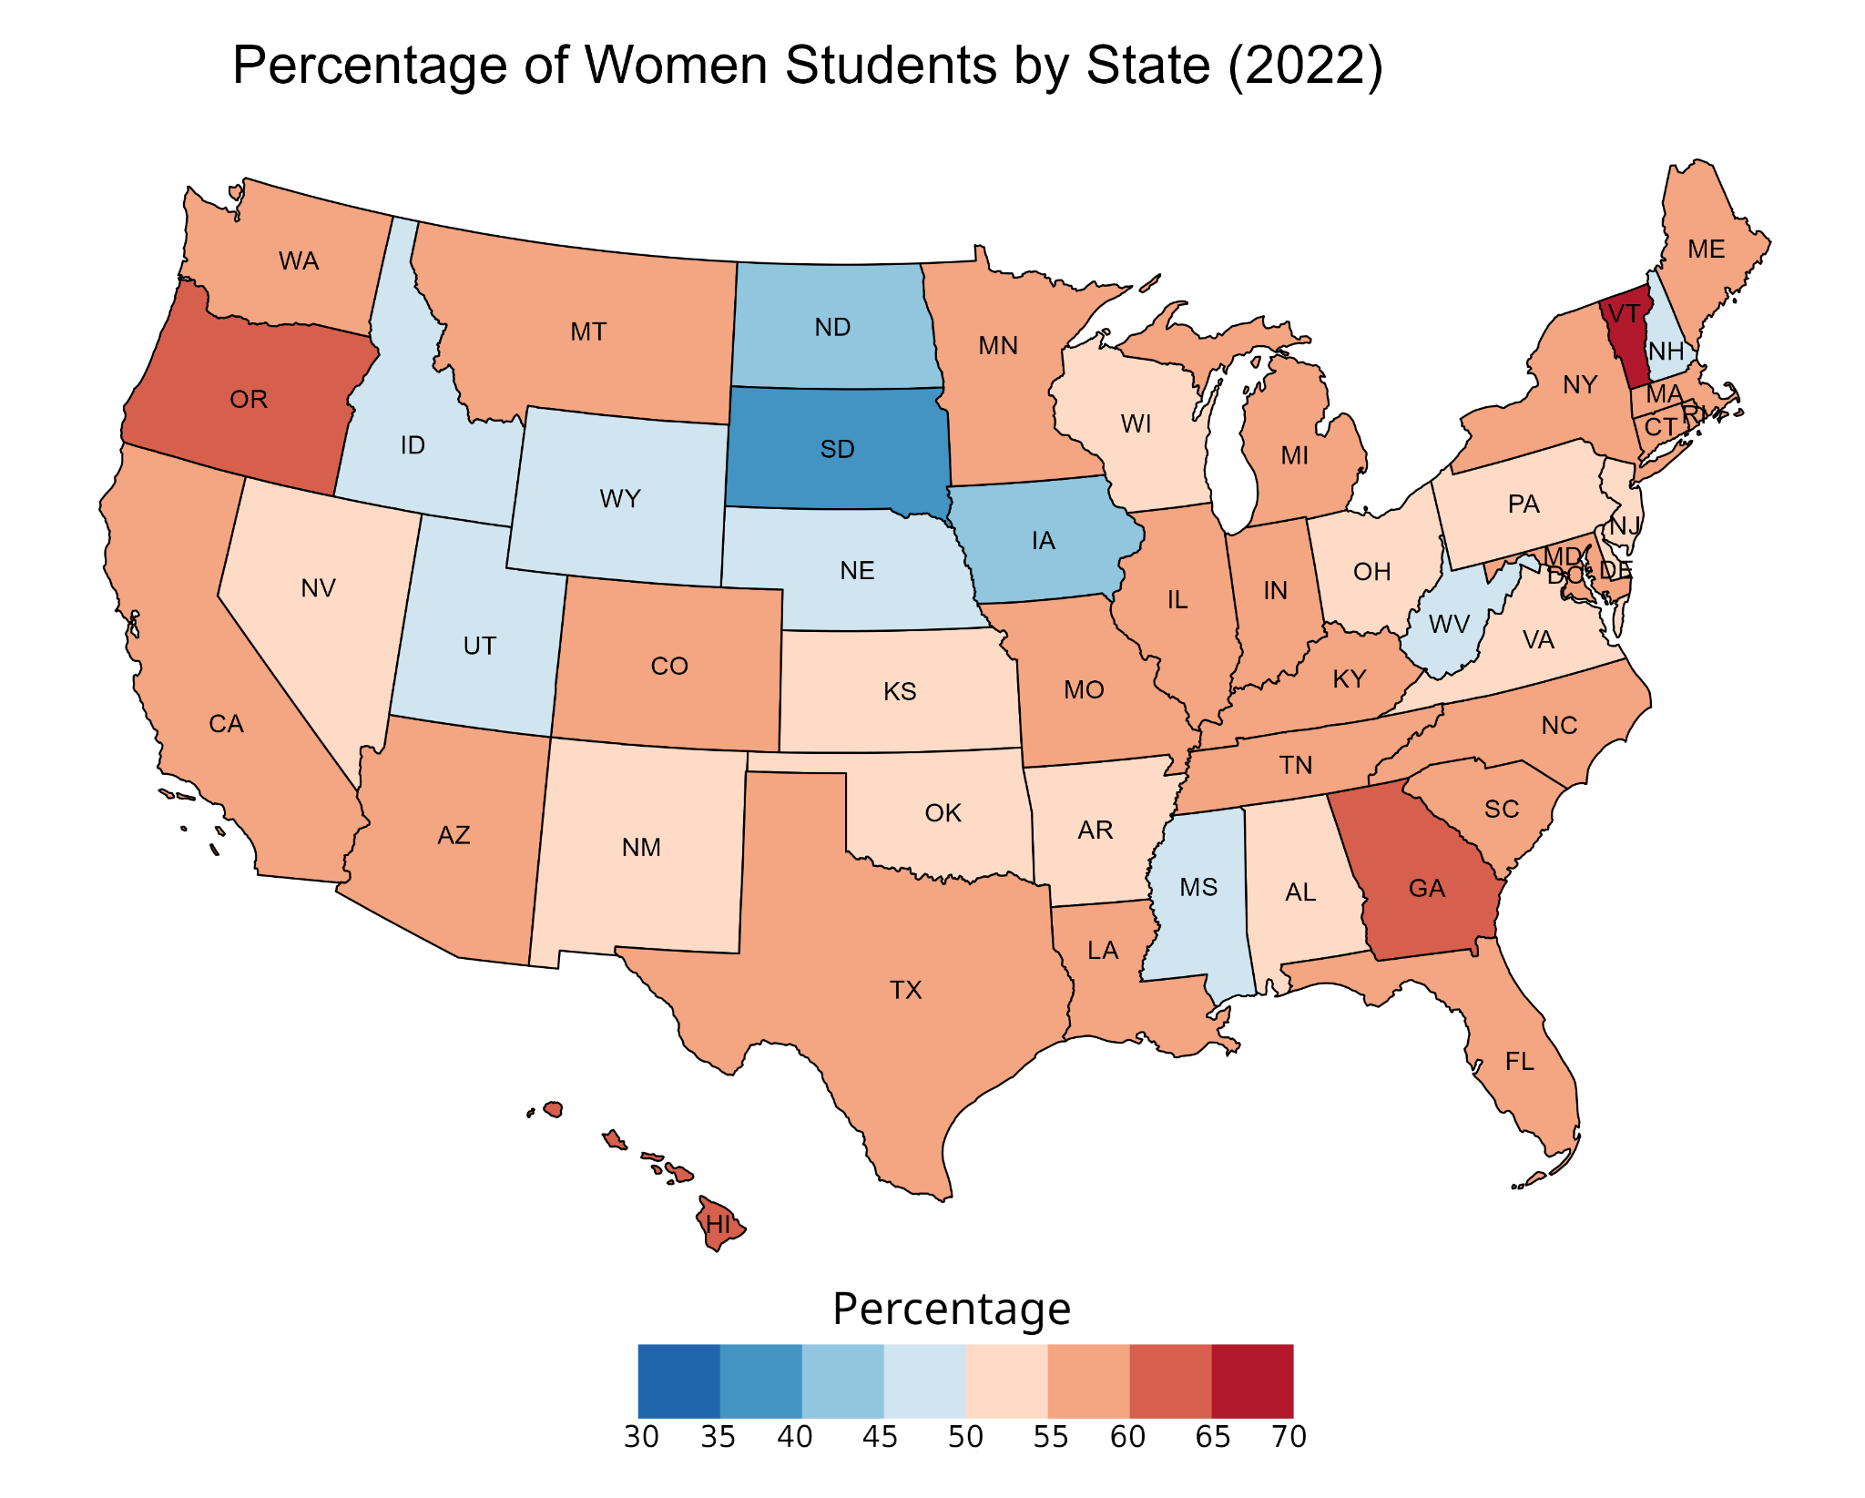

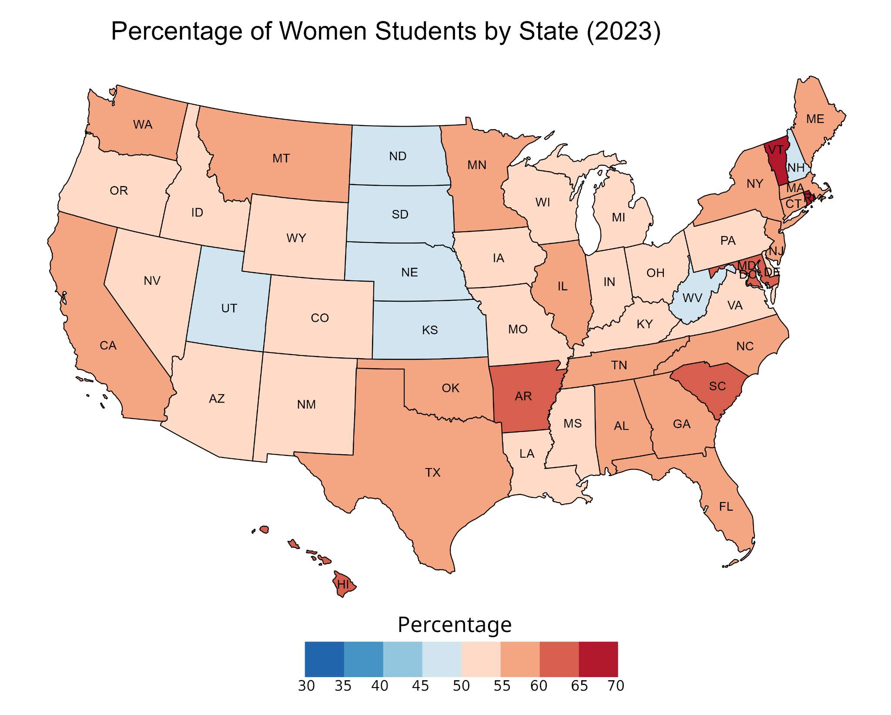

## 

## Appendix D: Detailed Maps for Ethnicity for Faculty Data

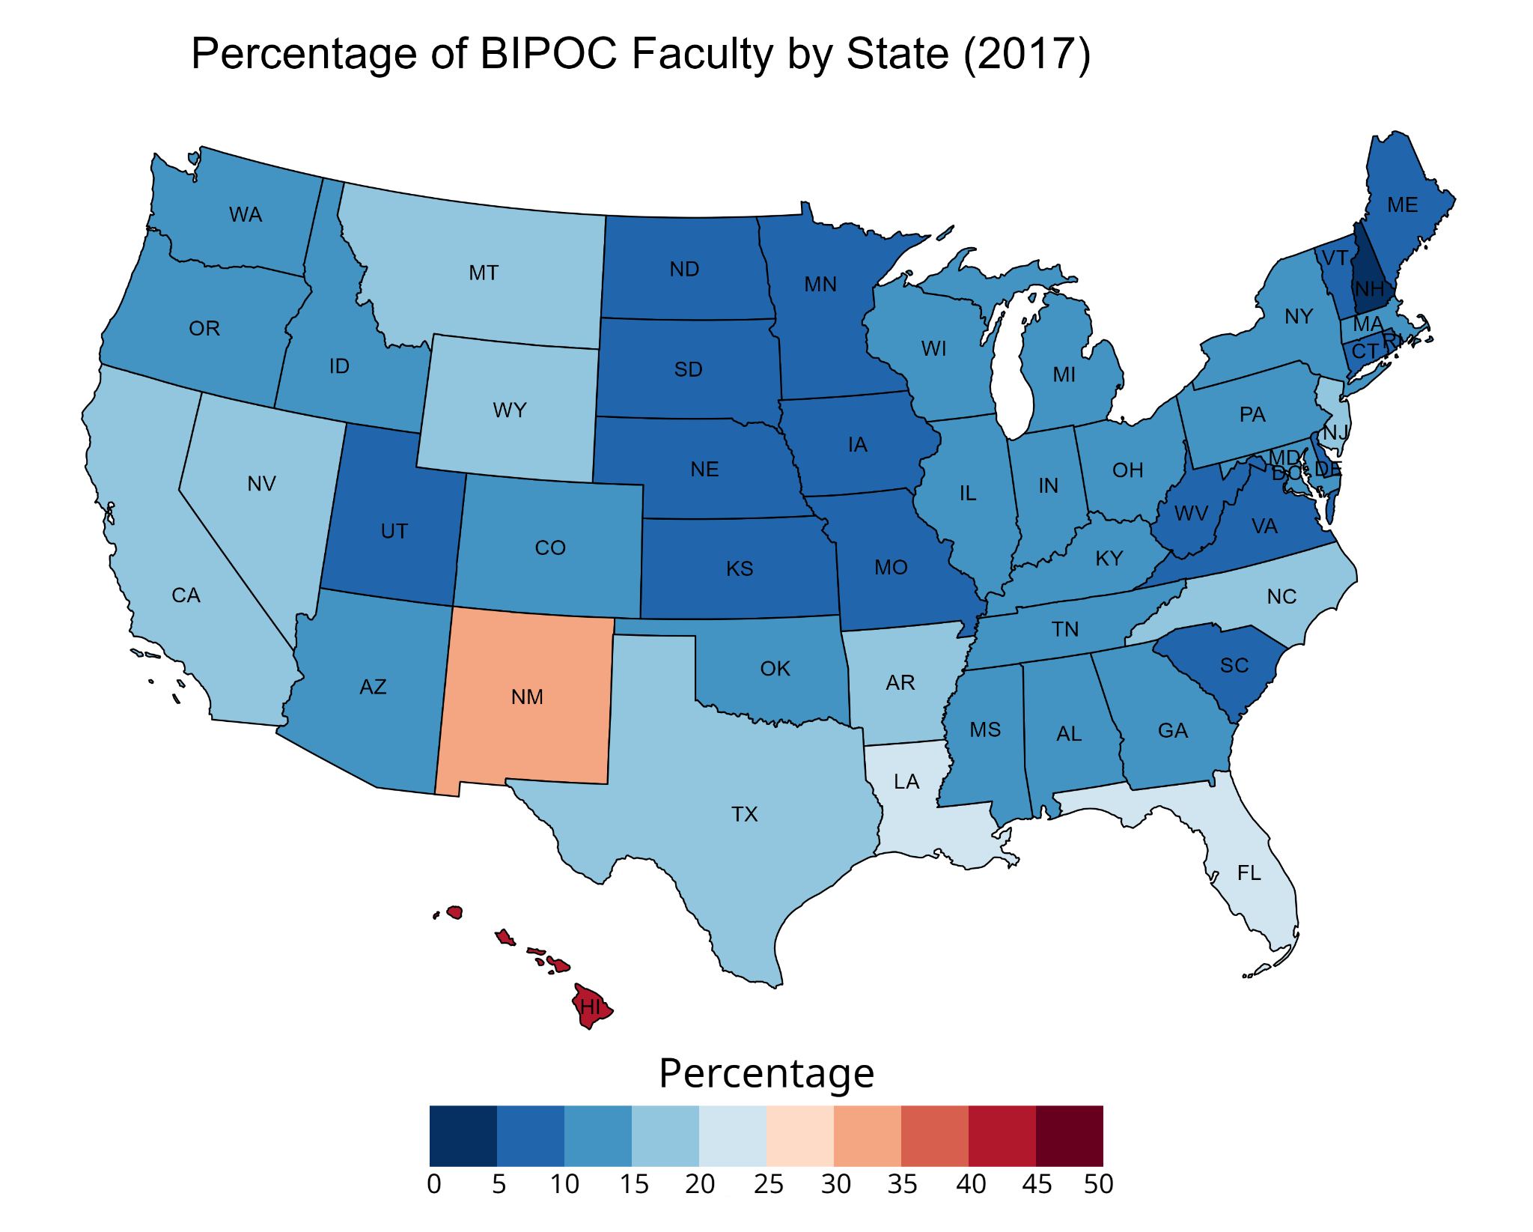

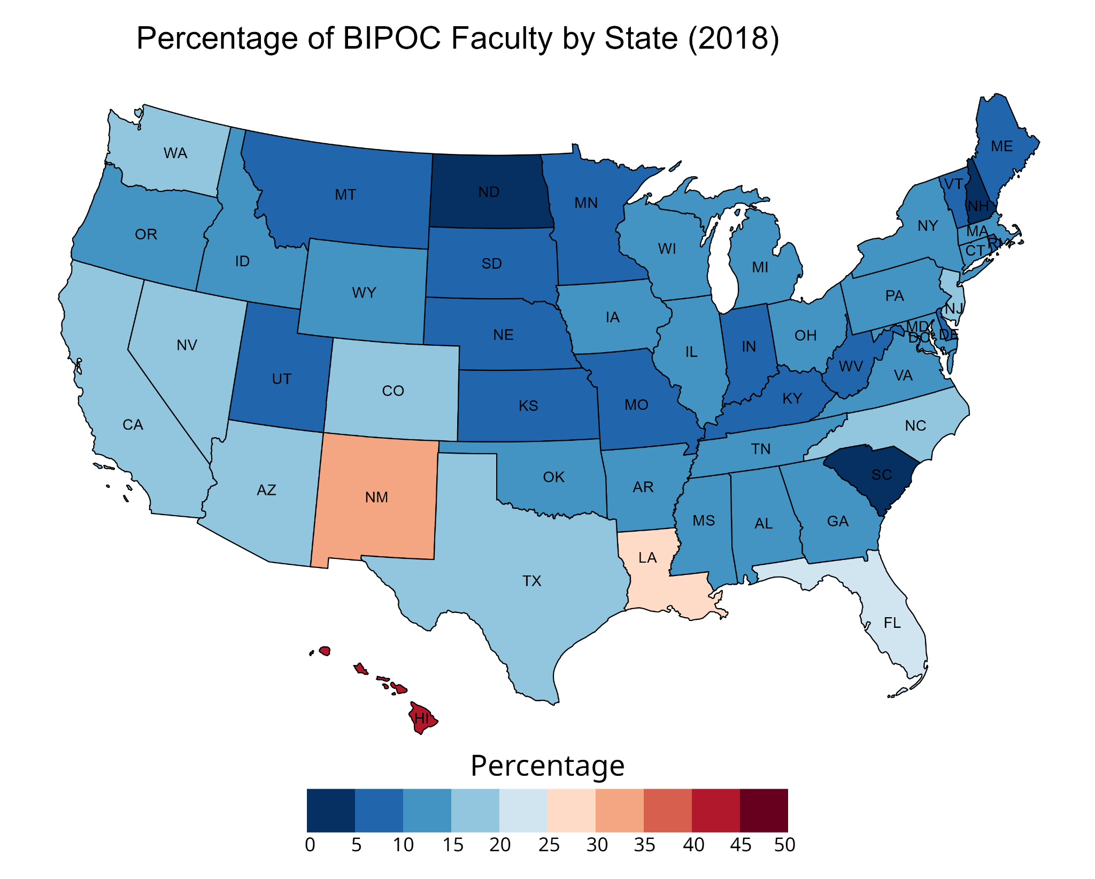

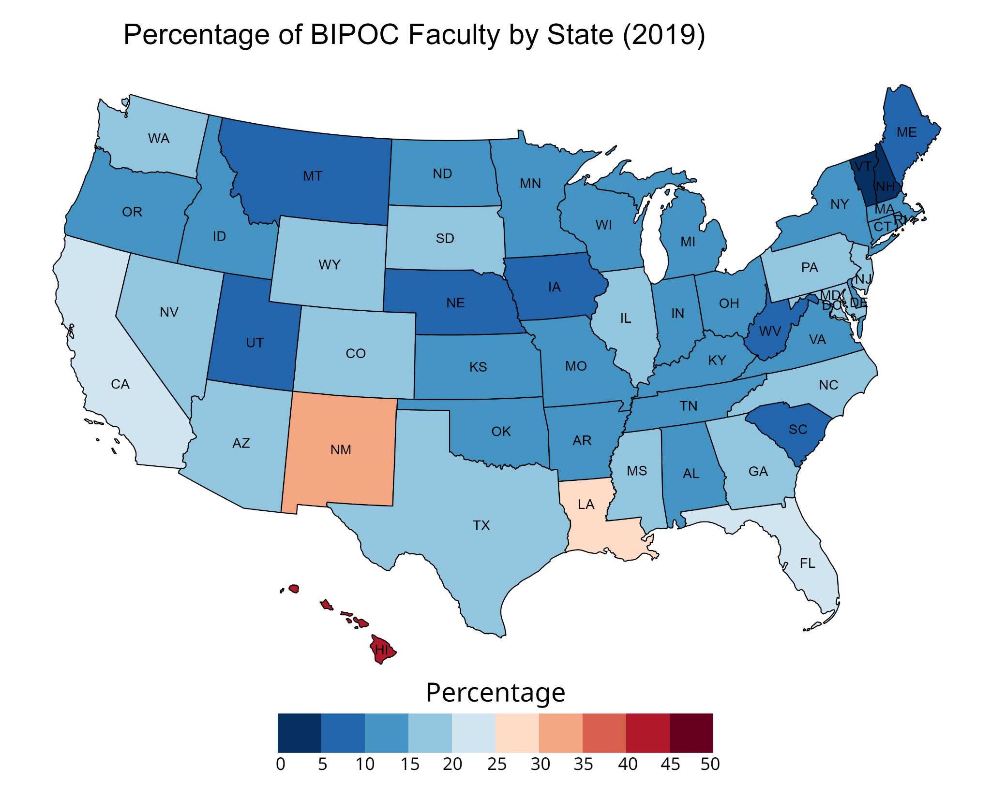

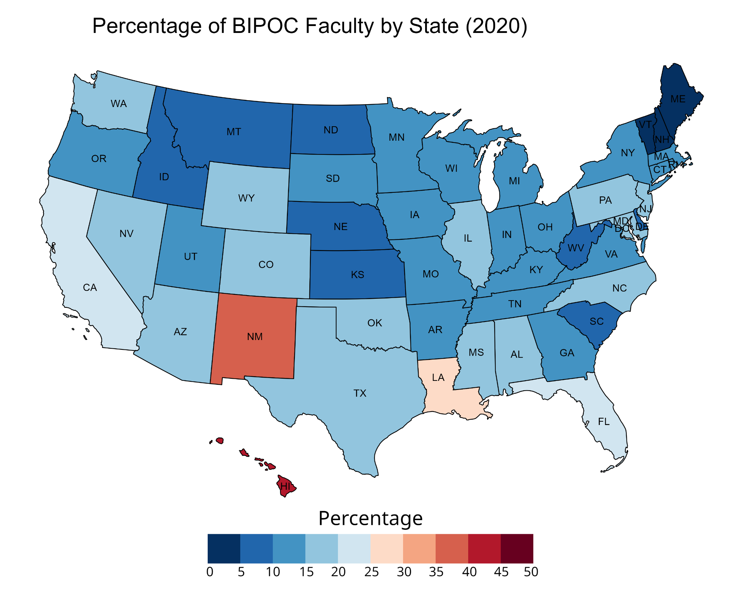

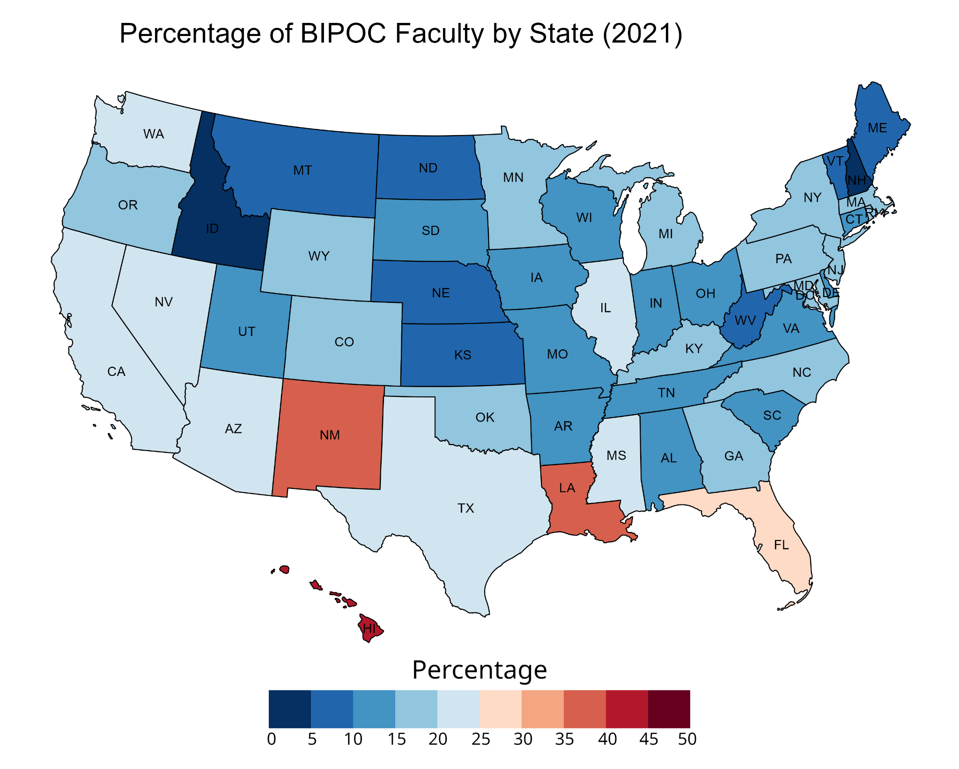

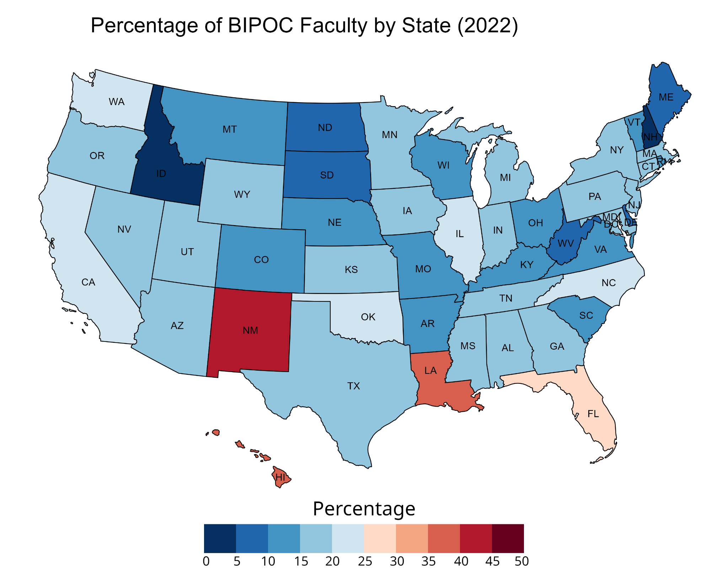

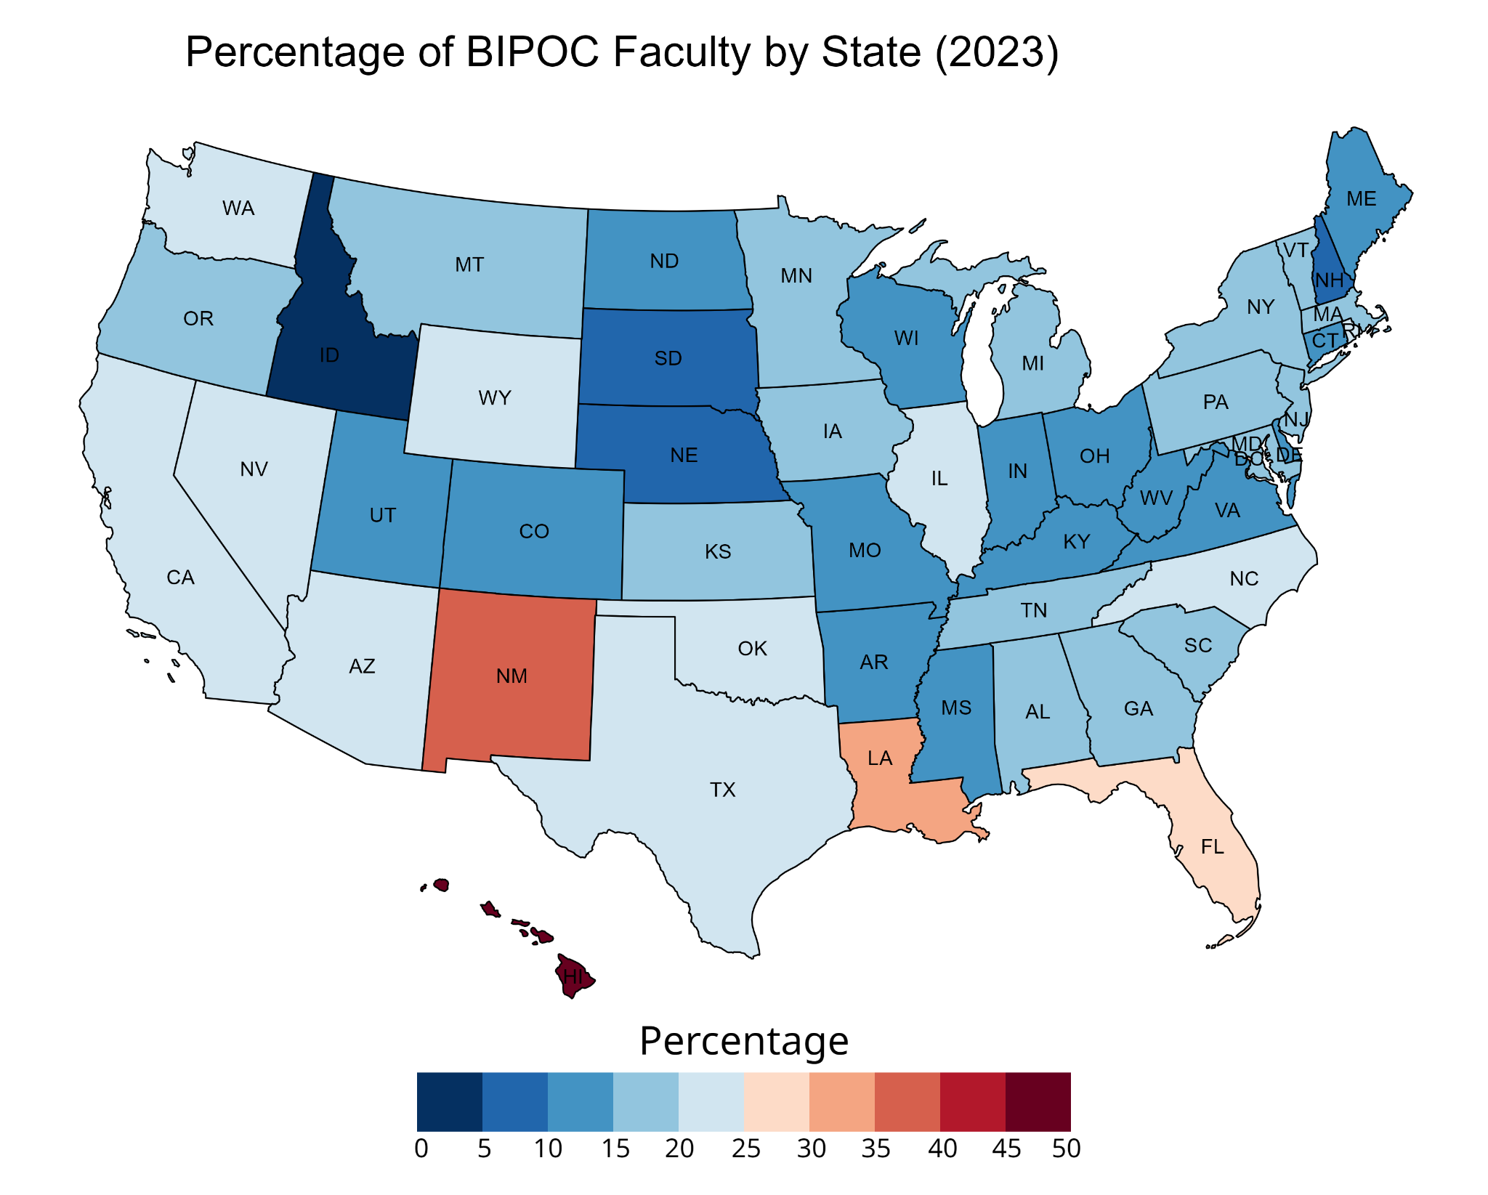

## 

## Appendix E: Detailed Maps for gender identity data (women) for Faculty Data

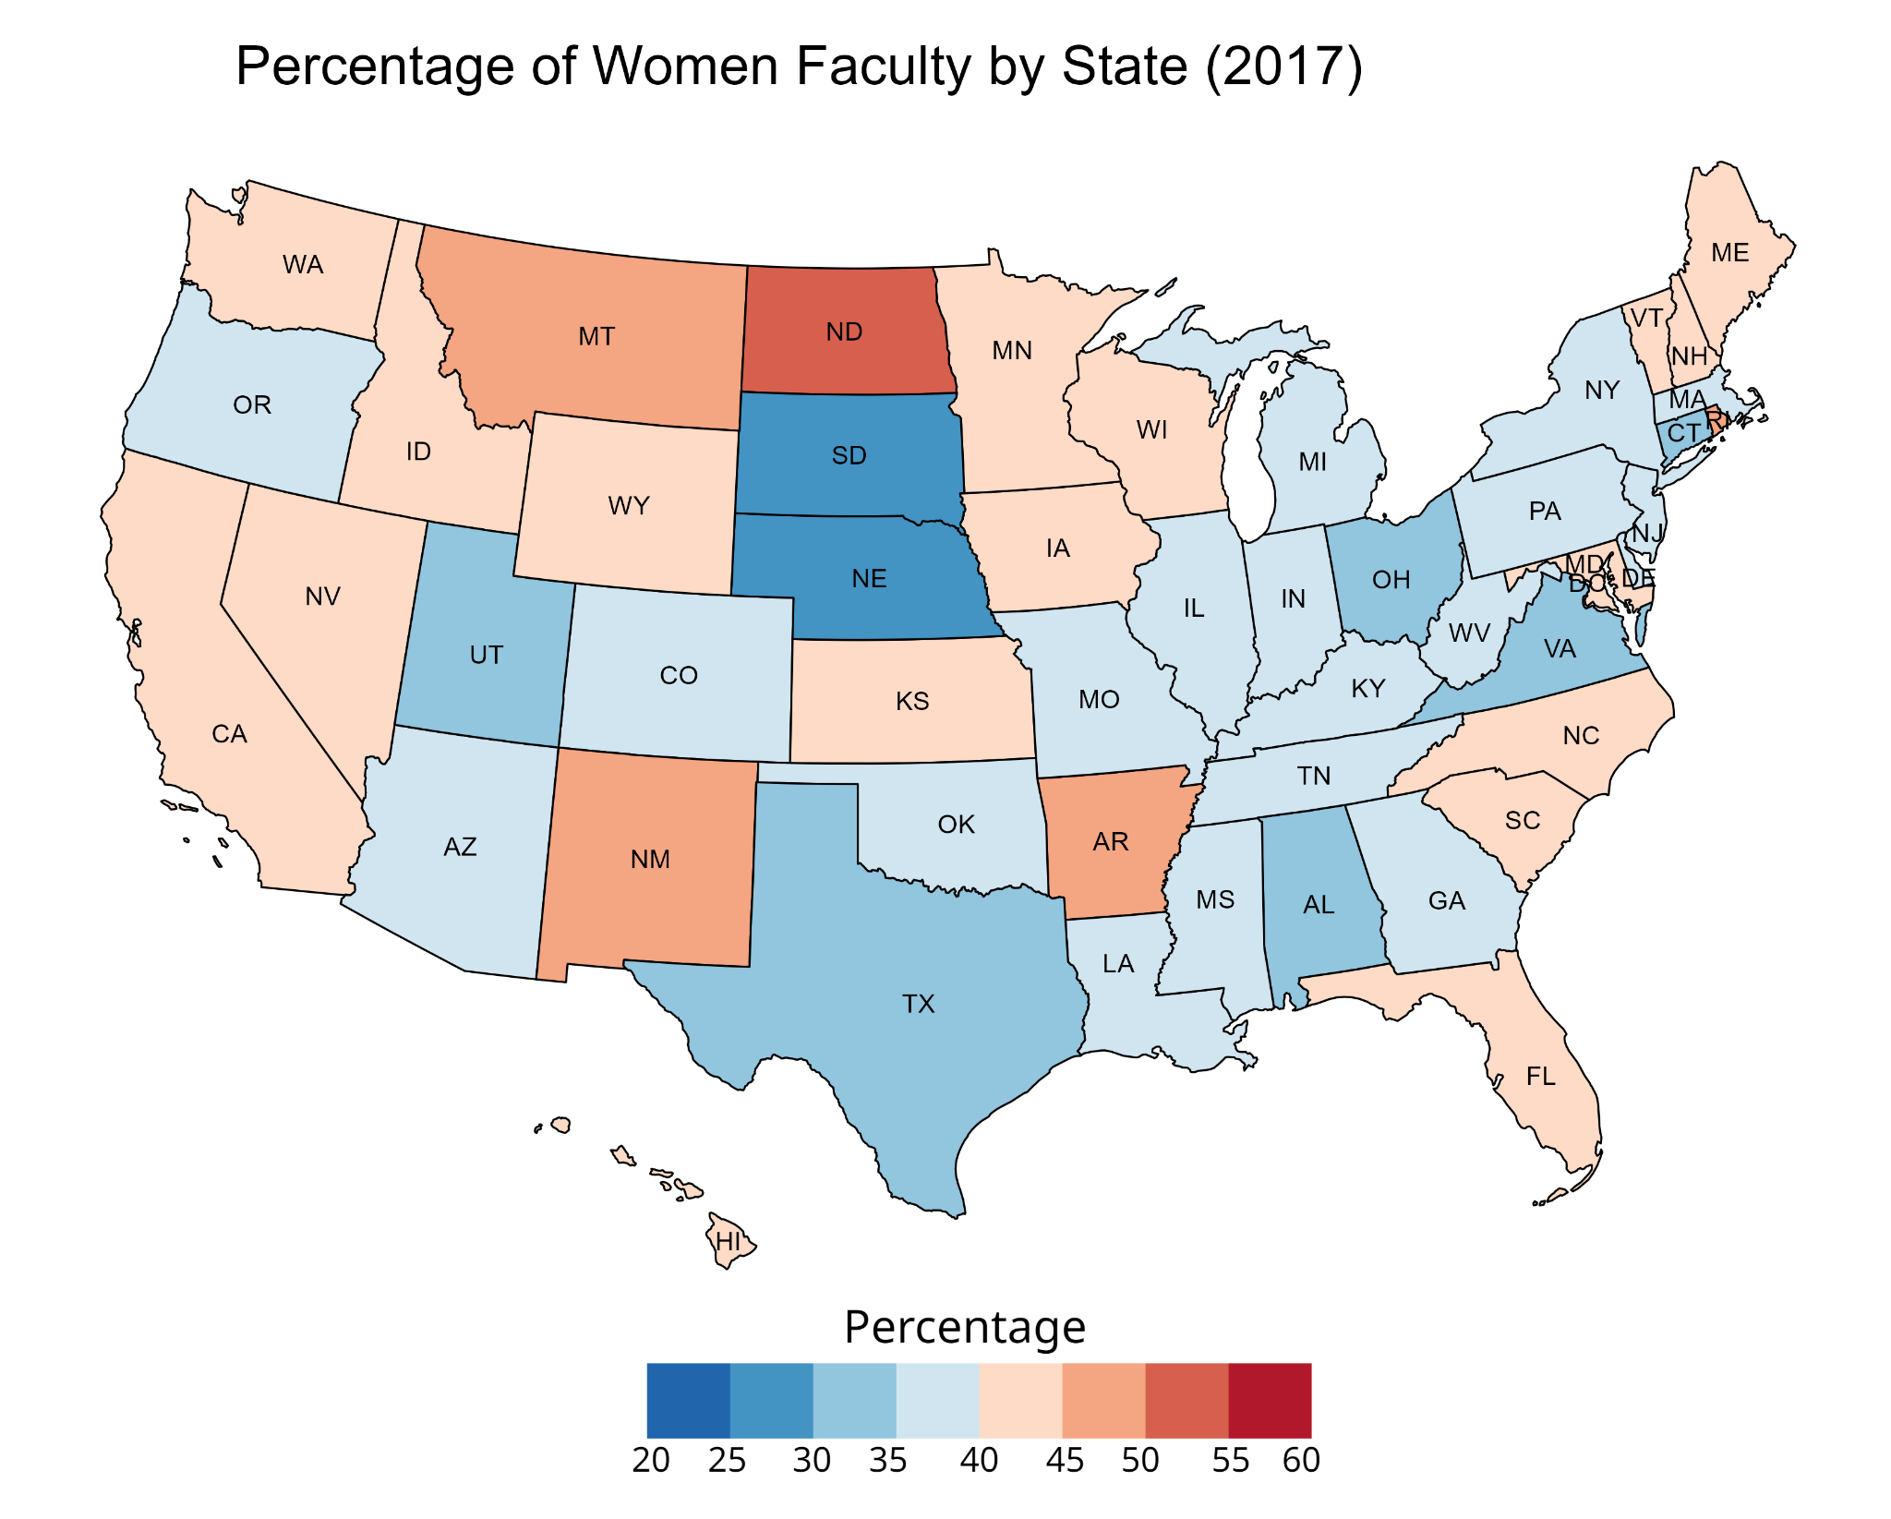

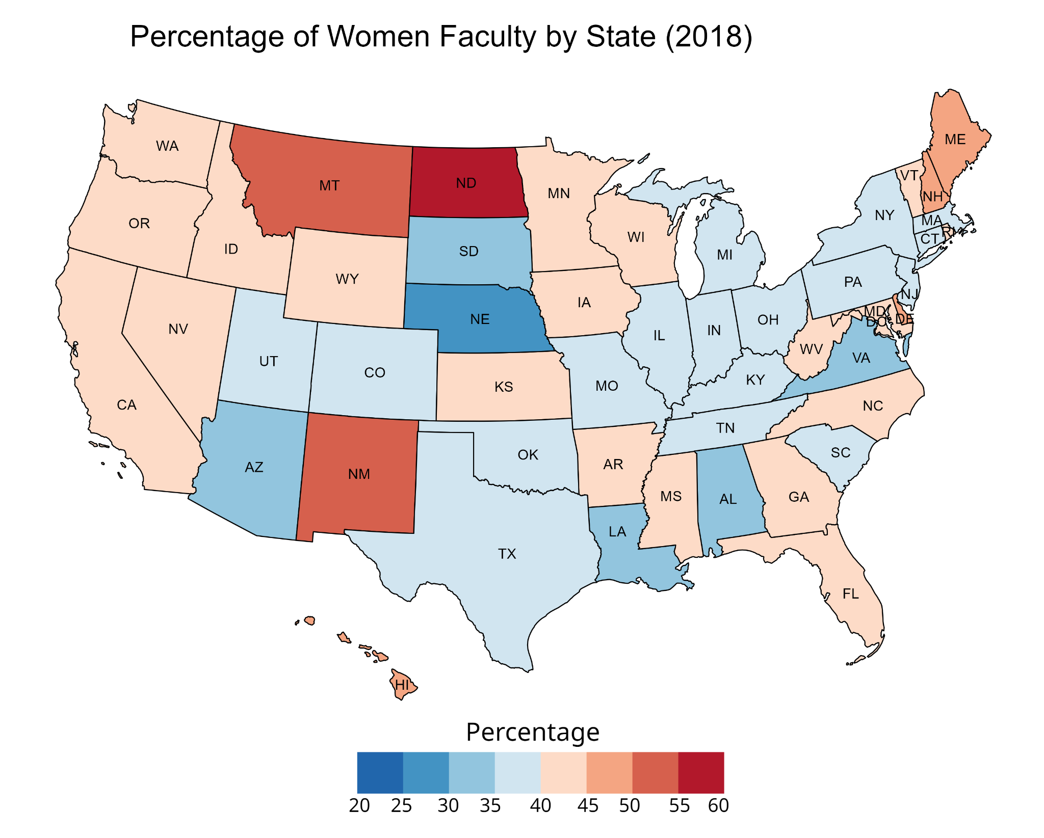

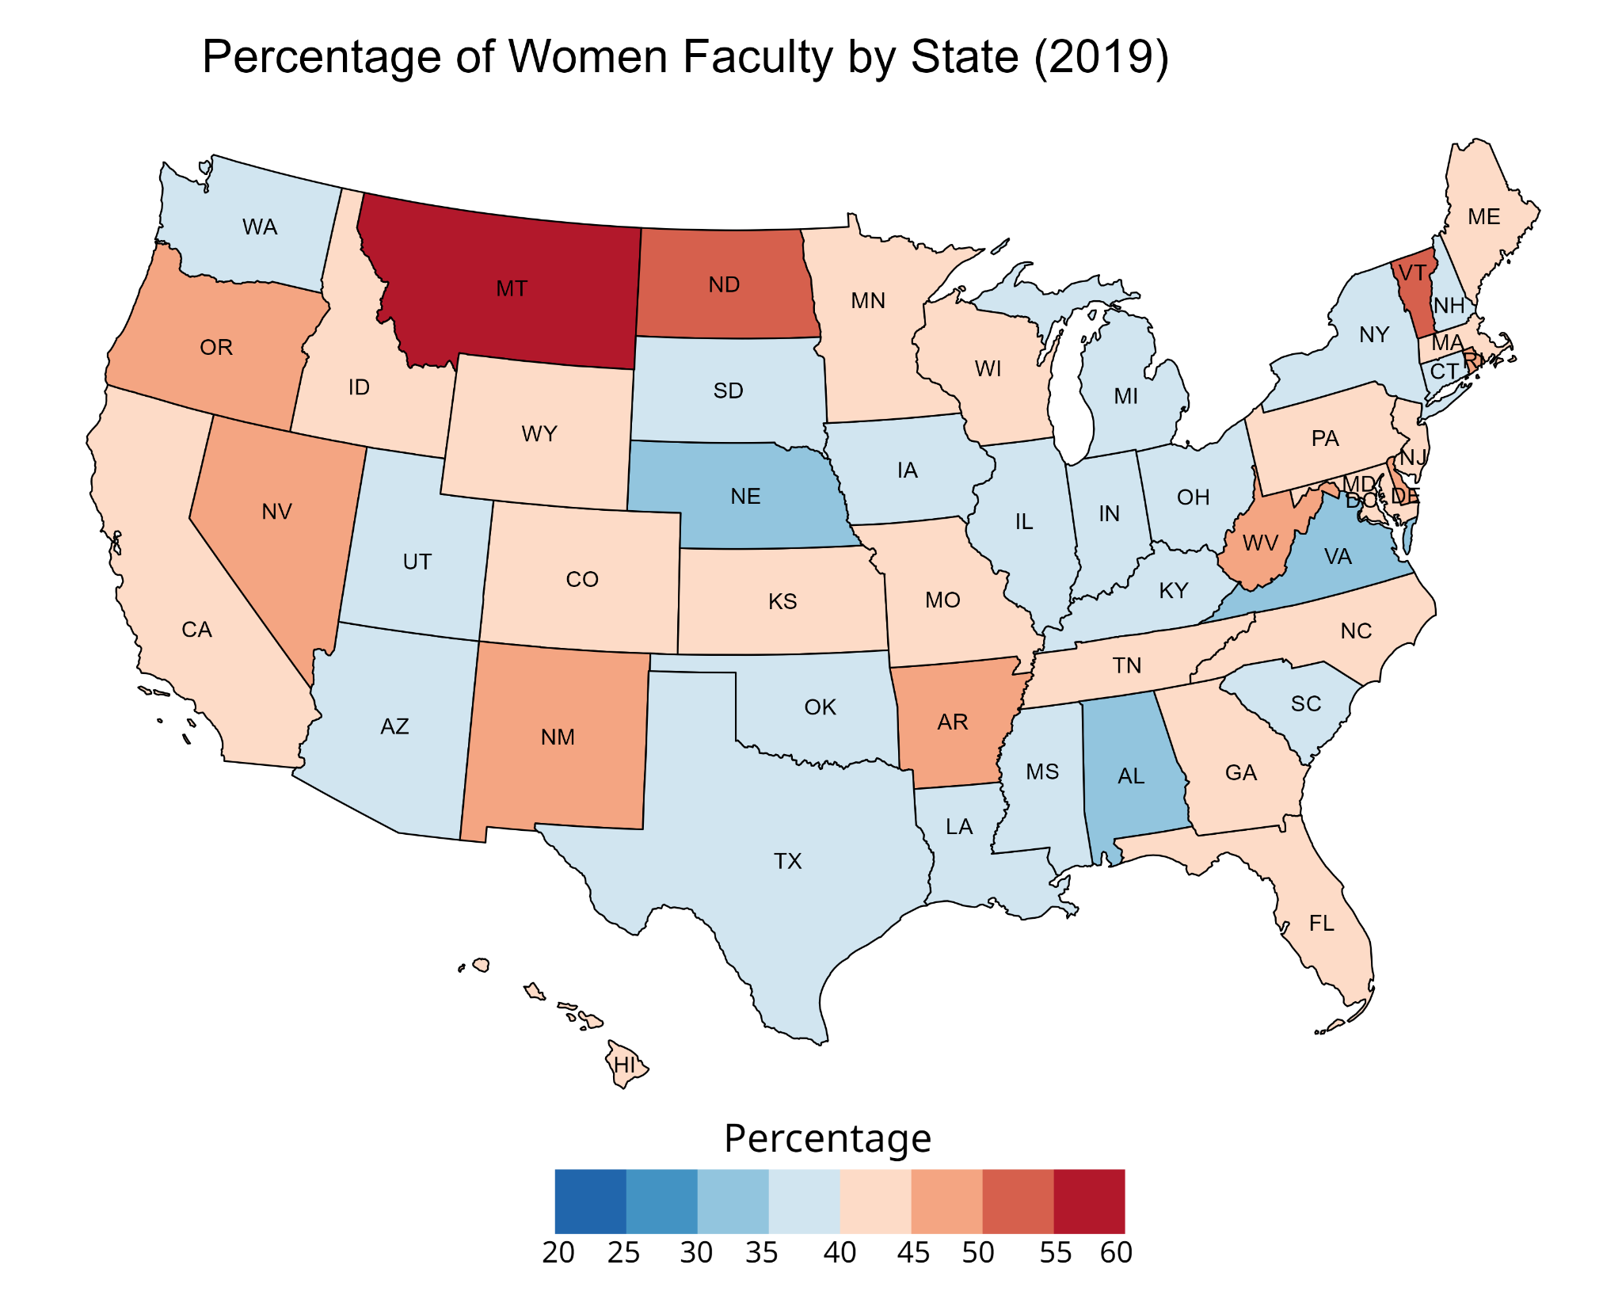

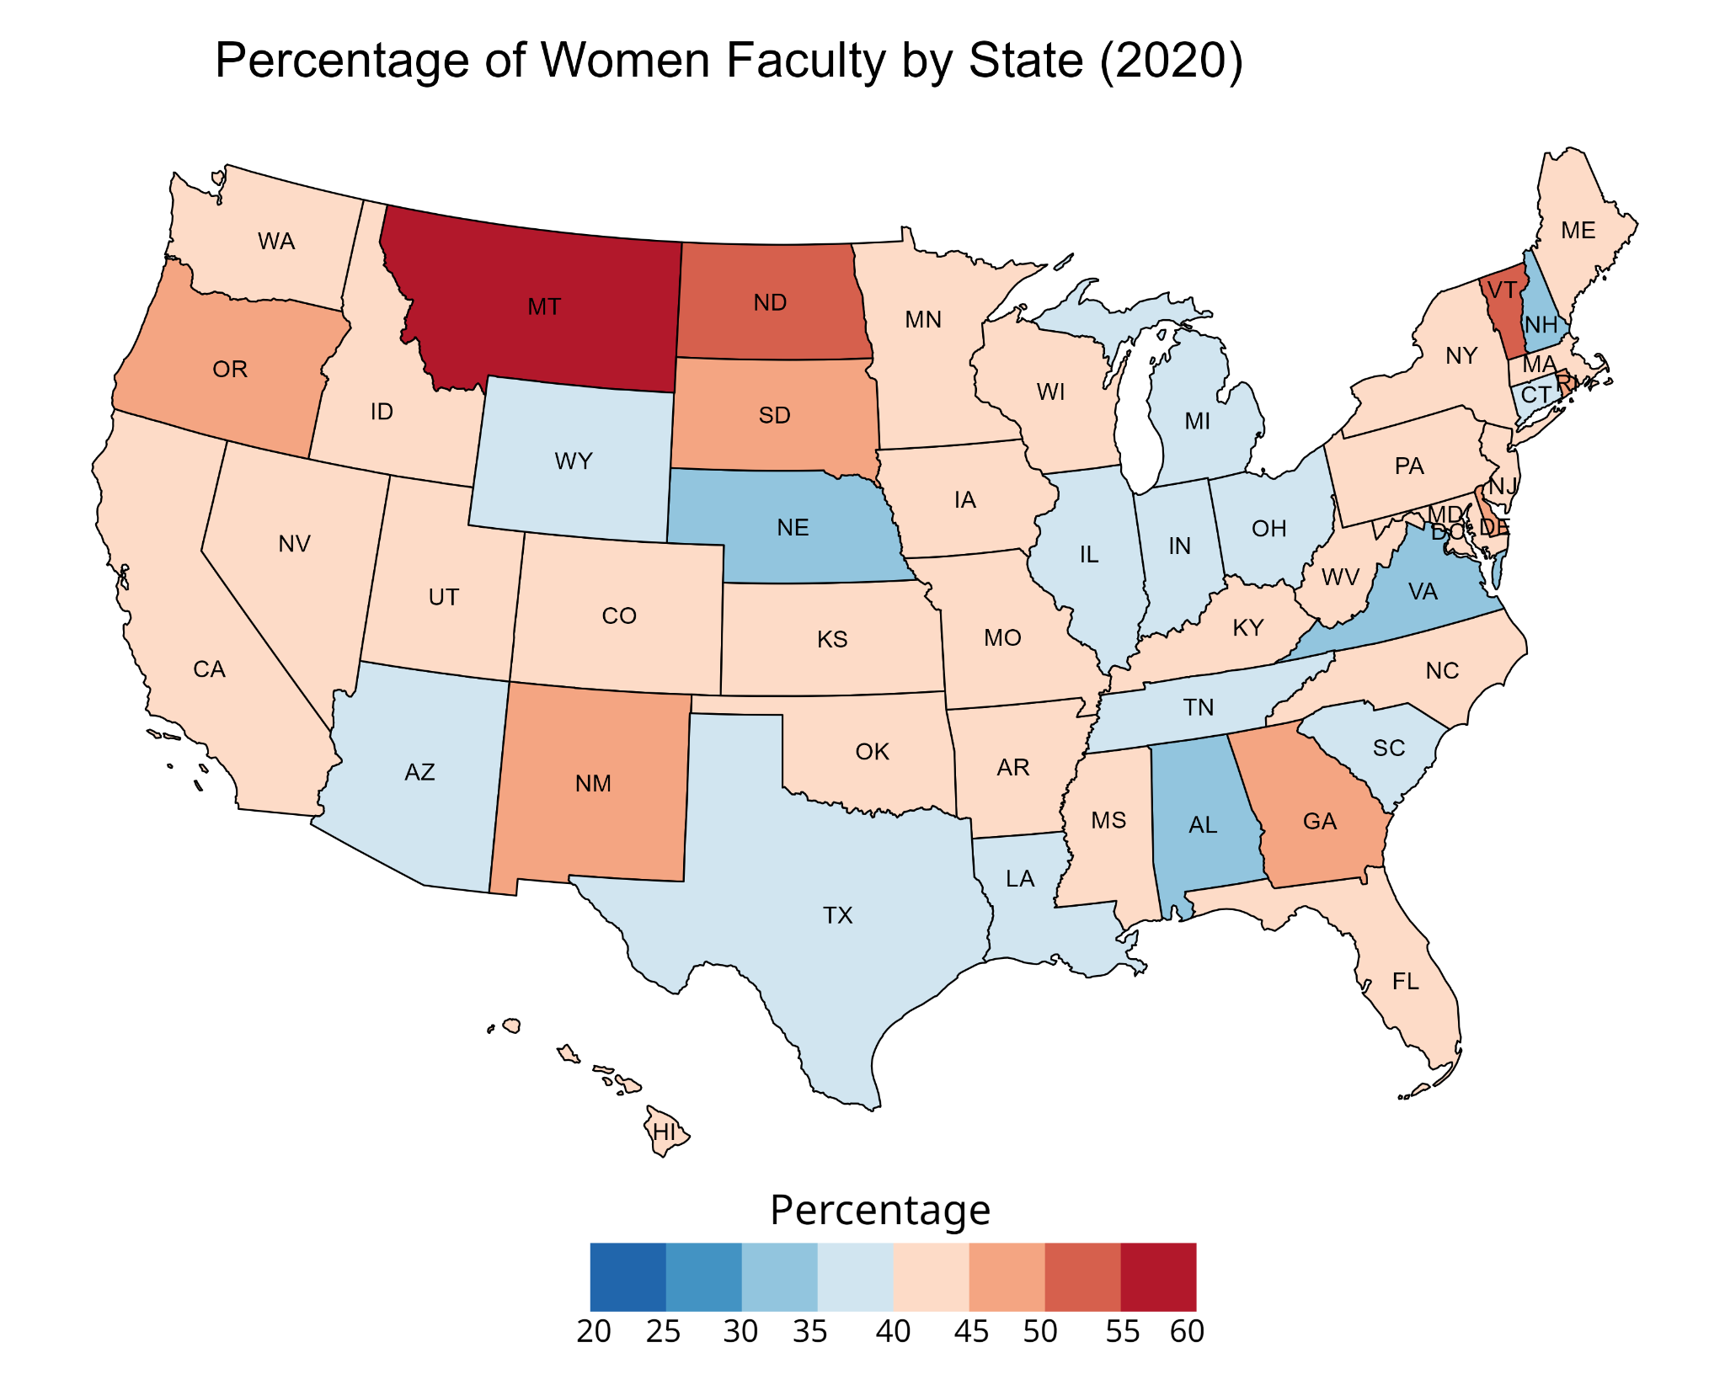

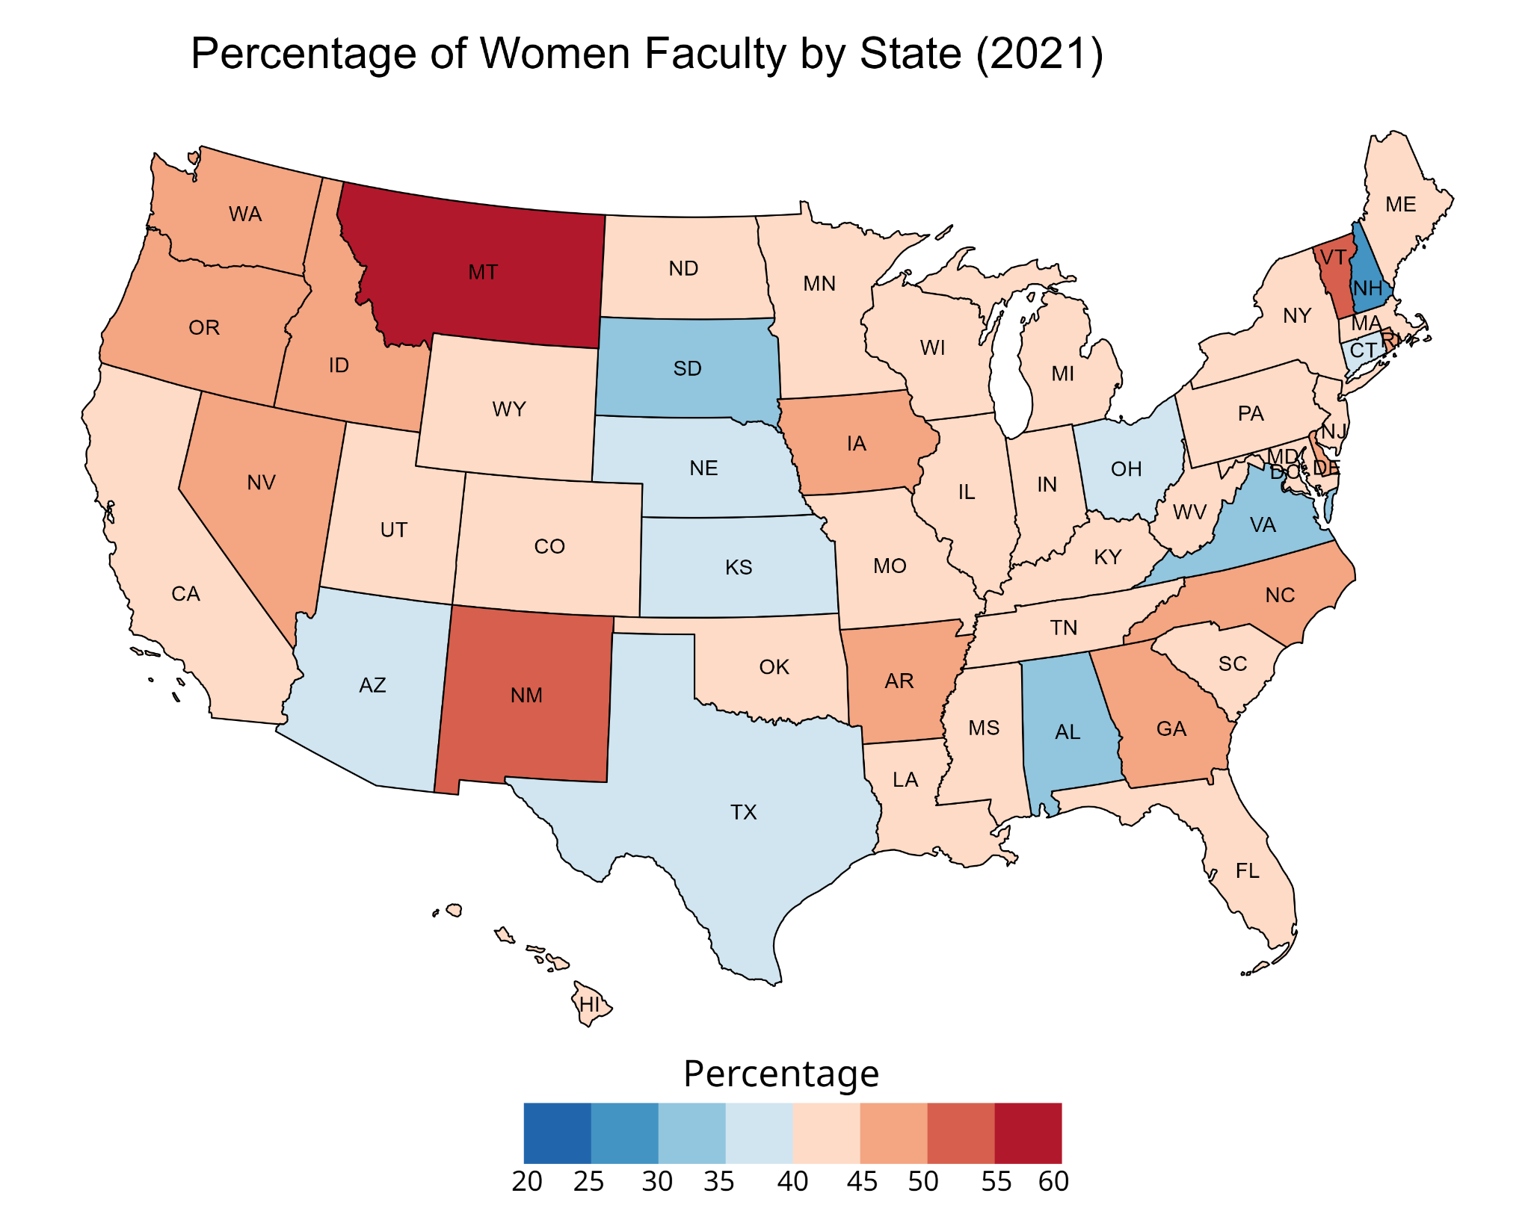

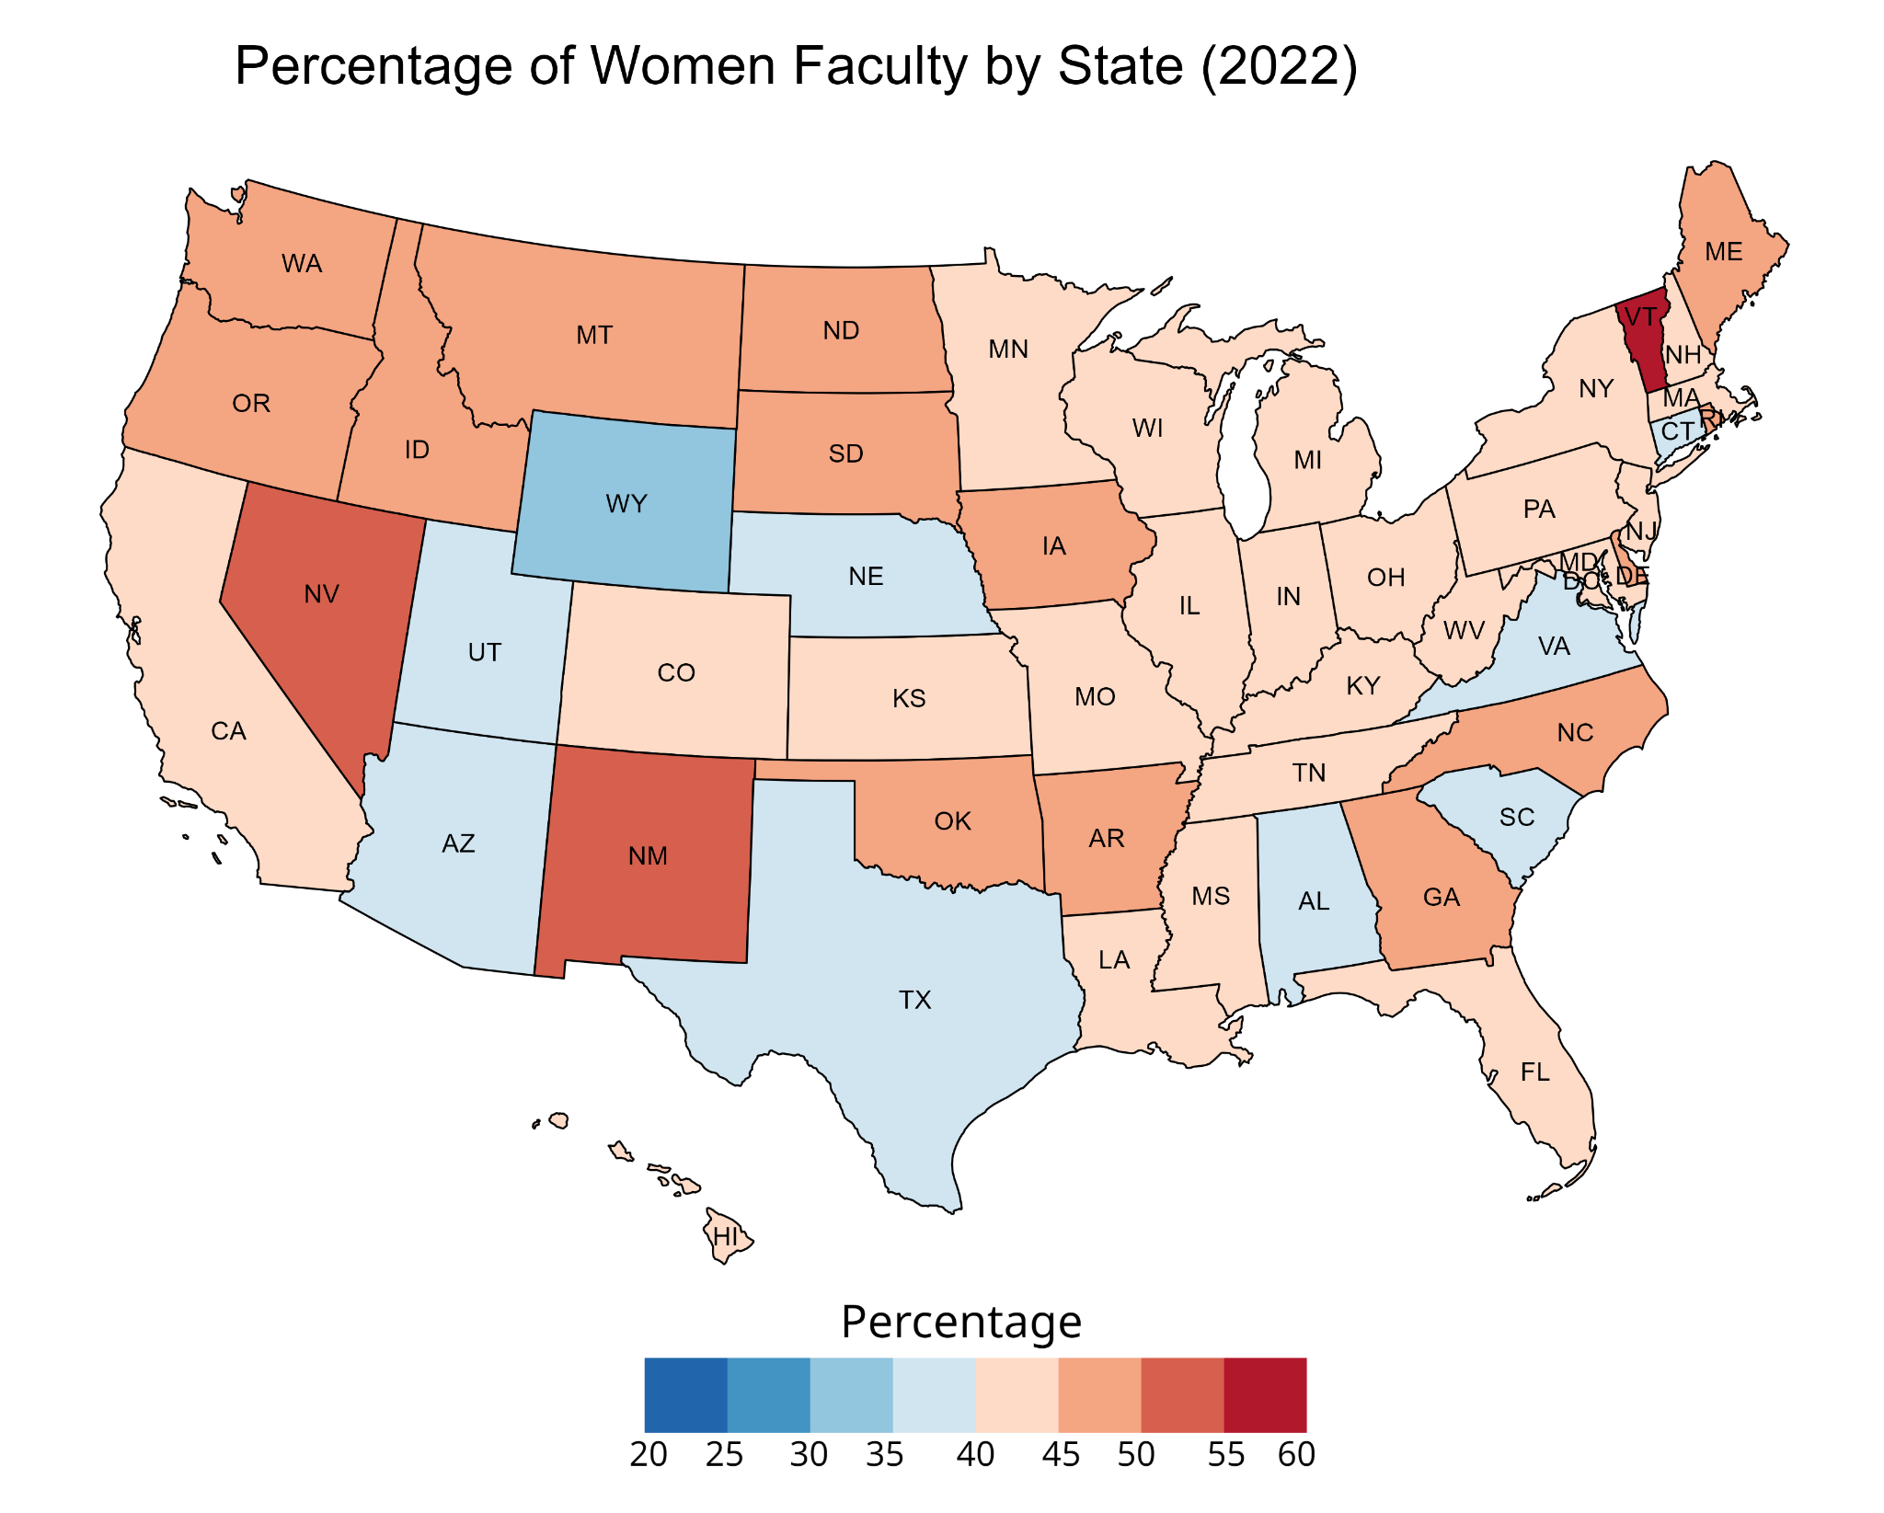

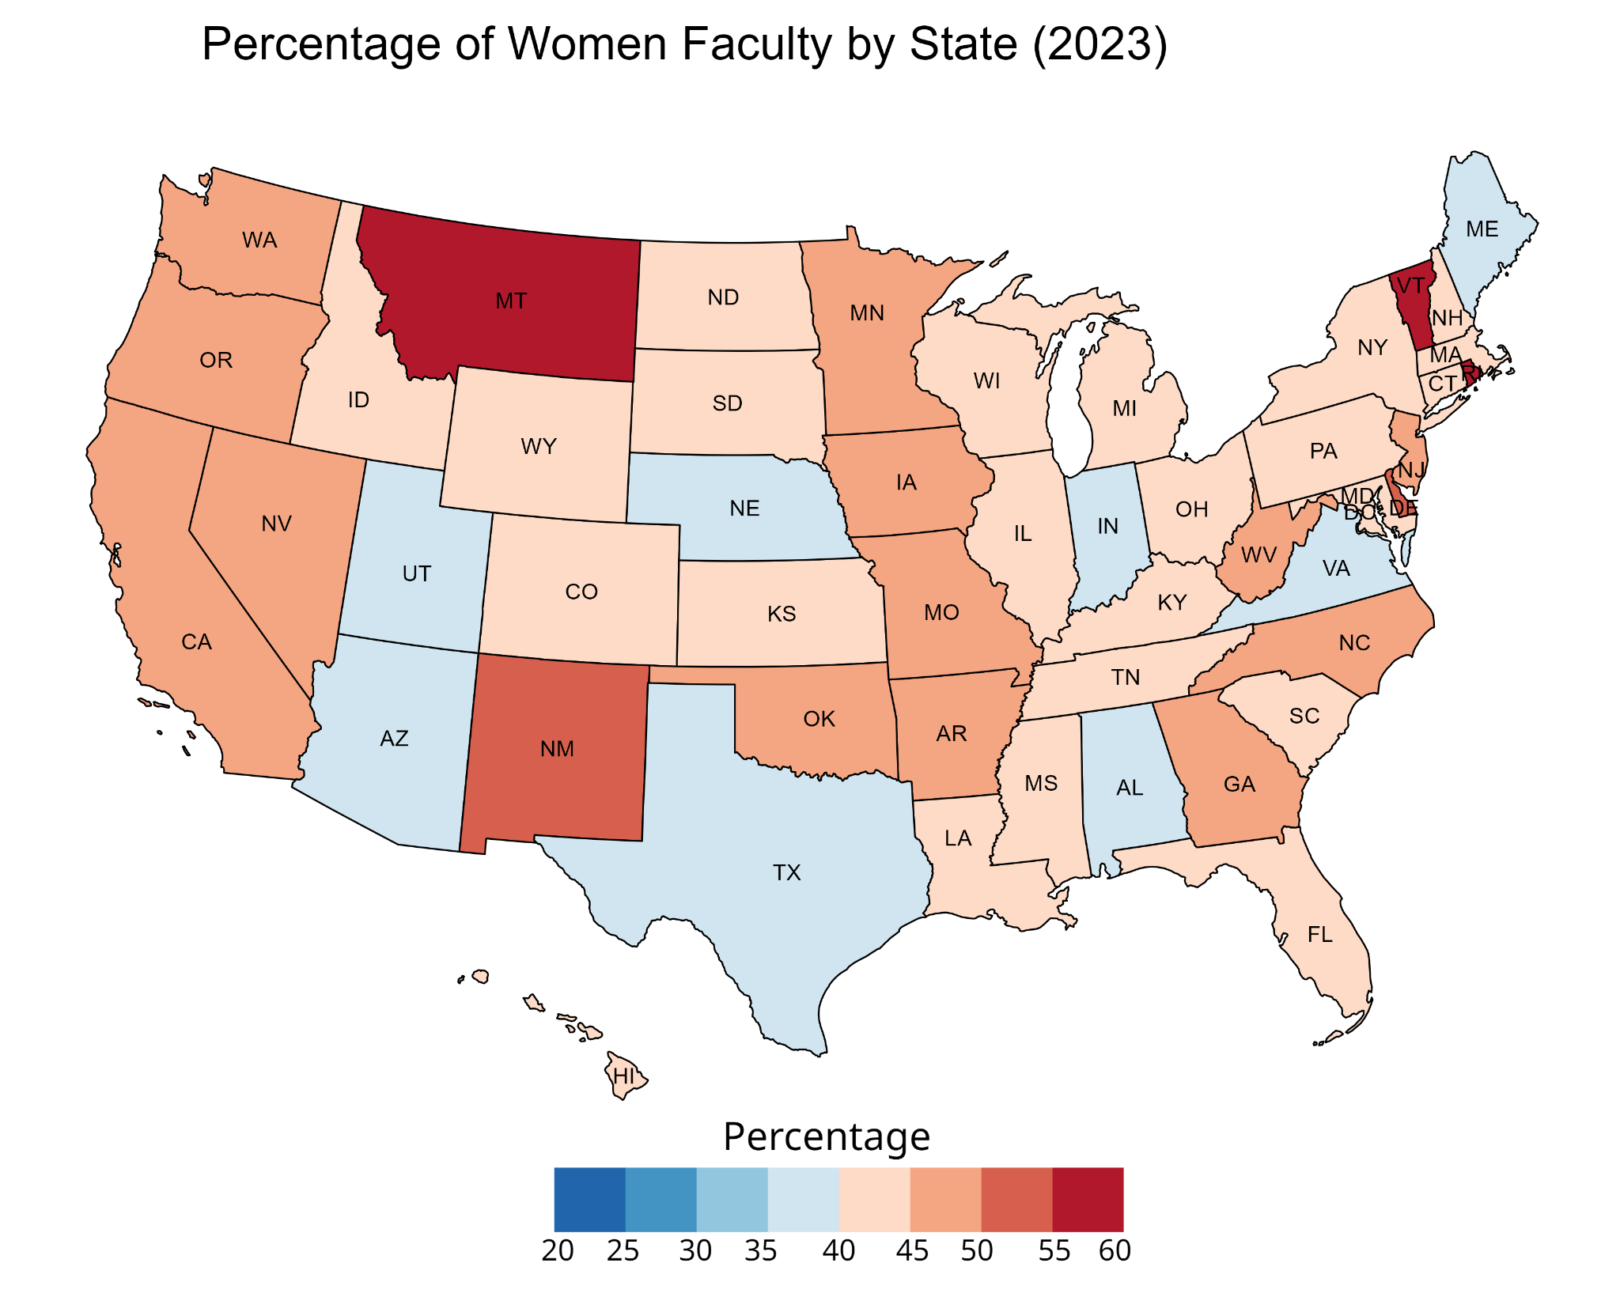

## 

## Appendix F: Methodology (Continuation)

For this study, we say that the student and faculty populations follow a Bernoulli distribution. A Bernoulli distribution is a discrete probability distribution. It describes the probability of achieving a “success” or “failure” from a Bernoulli trial. A Bernoulli trial is an event that has only two possible outcomes (success or failure). For example, will a coin land on heads (success) or tails (failure)?

As mentioned above, KL divergence is a non-symmetric metric that measures the relative difference in information represented by two distributions (Bauckhage, 2014). It can be thought of as measuring the distance between two data distributions, showing how different the two distributions are from each other. As long as our data has a cumulative distribution, known as CDF, we are able to use the KLD technique. A Cumulative Distribution Function (CDF) is a probability distribution that deals with continuous and discrete random variables.

For each school, the KL divergence was calculated to measure the difference between the student and faculty distributions across the years of data. If the distance is zero, then this means that the distributions are exactly the same. The farther away the KL divergence is from zero, the larger the gap between the distributions.

The KL divergence from distribution P(x) to distribution Q(x) is defined as DKL​(P∣∣Q)=∑ ​P(x) ln(P(x) / Q(x)), where P(x) is the student proportions and Q(x) is the faculty proportions for the ethnicity or gender variables used. For example, the ethnicity variable, x can be either BIPOC or white for both the student and faculty proportions. The proportions are calculated for each year of data, resulting in a total of seven proportions for both students and faculty (one for each year from 2017 to 2023). The KL divergence calculation will capture the cumulative differences in the distributions of the ethnicity categories between students and faculty over the range of data available.

Since there is a natural logarithm in the equation for KL divergence a proportion of zero would cause the KL divergence calculation to be undefined. To address this issue, we added a small constant (ϵ) to each proportion before normalization to ensure that no proportion is ever zero allowing for meaningful KL divergence calculations. This process is defined as Pnew​=(P+ϵ)/∑(P+ϵ)​, where ϵ = 1e-10. For example, if we were to compare the distribution of student and faculty BIPOC, we take the proportion of student BIPOC, Pstudent-BIPOC​ and add ϵ to ensure no proportion is zero. But we must normalize this proportion so that Pstudent-BIPOC​ plus Pstudent-white​ sum up to 1, since ethnicity is represented as a binary variable. So, we take the new student BIPOC proportion, Pnew​= (Pstudent-BIPOC​ + ϵ) / [(Pstudent-BIPOC​ + ϵ) + (Pstudent-white​​ + ϵ)]. This would ensure that the new proportion is valid for the KL divergence calculation.

## 

## Appendix G: Kullback–Leibler divergence distance plots for student-faculty ethnicity profiles by state

The figure shows the Kullback–Leibler divergence distance between the distribution of student BIPOC and the distribution of faculty BIPOC in US law schools by state from 2017-2023. The calculated Kullback–Leibler divergence distances treated gender as a binary variable for this figure. Idaho and New Hampshire have distances considerably larger than all the other states, as Idaho had a distance calculated to be about 9.66 and New Hampshire had a distance of about 2.75. Comparing this to the state with the third largest KLD distance (South Carolina) whose distance was calculated to be about 0.18, we see that this is considerably smaller than the 2.75 and 9.66 distances calculated for the states of Idaho and New Hampshire respectively.

## 

## 

## Appendix H: Kullback–Leibler divergence distance plots for student-faculty gender profiles by state

The figure below shows the Kullback–Leibler divergence distance between the distribution of student and faculty gender profiles in US law schools by state from 2017-2023. The calculated Kullback–Leibler divergence distances treated gender as a binary variable for this figure.

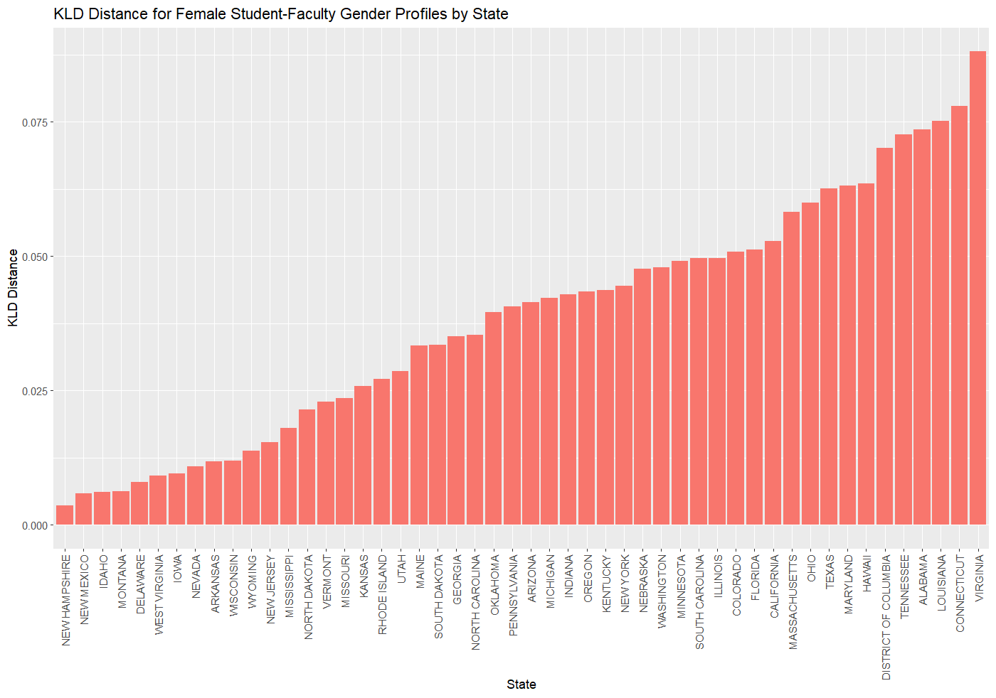

## Appendix I: Kullback–Leibler divergence distance plots for student-faculty gender profiles including the AGI gender category

### Schools with the 10 highest and lowest KL-divergence distance:

The figure below shows the top 10 and bottom 10 schools for the Kullback–Leibler divergence distance between the distribution of student and faculty gender profiles, where the AGI gender category is included in the calculation. The list of schools that show up in the top and bottom 10 schools differ significantly from the list of schools that show up in the analysis that treated gender as a binary variable. The results here indicate that the low populations of AGI students and faculty significantly affect the results of the KL-divergence distances calculated.

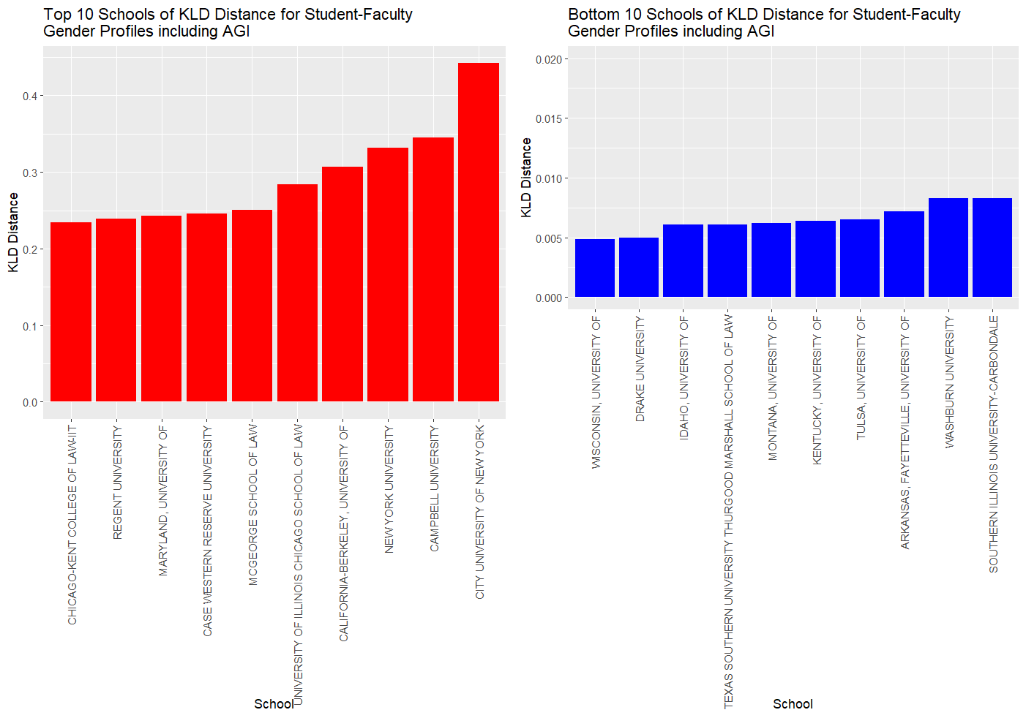

### 

### 

### KL-divergence distance by state:

The figure below shows the Kullback–Leibler divergence distance between the distribution of student and faculty gender profiles with the inclusion of the AGI gender category in US law schools by state from 2017-2023.

